RANDALL PRICE BIBLICAL MUSEUM

The artifact collection was built over 40+ years. It was first kept as a private collection (1979-1996), then displayed to the public for 11 years (1996-2007) in San Marcos, TX and then for 15 years (2008-2022) at Liberty University (as the Liberty Biblical Museum). For the past 4 years (2022-2026) it has been kept in storage in Lynchburg, VA.

Providence Records

The Collection Catalog (Asset List) contains the known source of provenance (original sites of discovery) and chain-of-custody for each item. Below is a profile of the dealers and donors that were sources for acquisition of the artifacts. This provides a brief overview and description for researchers to consider in their evaluation of individual items in the collection.

Primary Donors and Acquired Private Collections

The collection of Elezar ben Auruchin (Last Supper exhibition, Daily Life in Ancient Israel exhibition). The owner grew up in Israel collecting antiquities. In later life he became a messianic Jew and moved to Florida, exhibiting his collection in various churches as a witness to his faith. He became friends with Dr. Price in 2008 and donated his collection in 2014.

The estate of the late Rev. Al Franklin of Shasta, California (primarily fossils with some minor ancient artifacts). The owner throughout his life made trips to Israel (mostly in early 1960’s) and acquired artifacts related to the Bible. Dr. Price hunted fossils with him on private land in California. Many of these fossils he unearthed he cleaned in his own laboratory, using the fossils in Creation lectures (annually at the Shasta Bible College Alpha-Omega Conference). Al also acquired fossils from the large fossil and gem shows in Tucson, Arizona. The bulk of his collection (now owned by Dr. Price) has remained in exhibition at Creation Hall at Liberty University.

The late Gordon Franz collection (coins, small artifacts). The owner was an archaeologist in Israel best known for his discovery of the silver amulet at Ketef Hinnom in 1979. He was an associate of the late Israel archaeologist and professor Dr. Gabriel Barkay and taught at the American Institute of Holy Land Studies (Jerusalem) and at Grace Theological Seminary. His coin collection was purchased from world-wide dealers and his antiquities came primarily from excavations in which he served as Area Supervisor that were retired them from the field inventory after registration.

Museum Deaccessions

Cincinnati Bible Museum, Cincinnati, Ohio, curator/owner George Sparks (various artifacts from ancient Israel and Egypt). George Sparks may be contacted at: <holyland915@gmail.com>

Auction Houses

Ancient Resources, Glendale, California. Gabriel Vandervort, proprietor. Auction house for well-provenanced collections coming from noteworthy collections and galleries throughout the US and Europe. It provides provenance and chain-of-custody for each piece offered for bid. A number of important items of Egyptian, Sumerian, Babylonian and Greco-Roman origin were acquired from this source including the papyri from the Hamdy Sakr London collection (originally from Alexandria) that was last owned by a Virginia private collector. Access at: ancientresourceauctions@yahoo.com

Israel Antiquity Dealers and Shops

Lenny Wolfe, Israeli private collector and dealer. Lenny is an expert in ancient Israel artifacts, especially coins. Acquisitions were various items such as crucifixion nails, lead ballistia and other small items.

Fares Antiquities, Christian Quarter, Old City, Jerusalem (large portion of the collection comes from this dealer). Fares Wazwaz, proprietor, obtains his artifacts both from regular IAA auction sales in Tel-Aviv and from Palestinians digging in the Palestinian territories (usually in connection with housing or business construction), however, also from local tombs. Until items are brought into his licensed shop in Jerusalem and registered with the IAA they are not offered for sale. Dr. Price has personally checked his computer for listed items and observed his retiring items sold from his database once reported to the IAA. On some occasions he has given him the original IAA registration number which has been included with my descriptions. Dr. Price has worked with him for 20 years and developed a relationship of trust. He has received from him the local provenance of many of the artifacts he has acquired. At Dr. Price’s advice Fares removed artifacts from his shop which were questionable. To his credit, he refunded Dr. Price on a number of important items were purchased but later through research were questioned. Fares had a want list for items and sought to acquire wanted items from other dealers for Dr. Price. The extensive oil lamp collection was built over a 15-year period with Fares assistance. Phone number of Fares Wazwaz to confirm purchases: +90 537-021-9529.

Mt. of Olives Antiquites, Mt. of Olives, Jerusalem. Mohy Sweike, proprieter (Roman amphora, Roman Tenth Legion pavement, eight-handled Krater, bronze age stoe jars).

Pool of Siloam Antiquities, Pool of Siloam, Silwan, Jerusalem. Abraham Siam, proprieter. This small licensed antiquity shop was an early source for oil lamps and bronze age pottery. Contact number to confirm acquisitions: Abraham Siam mobile: +02 052-821-641.

Jordan Mosaic/Ceramic Shop

Located in Madaba, Jordan, this shop includes a variety of antiques and antiquities that the government permits to be sold. Here only two Roman period oil lamps and several Byzantine period glass bottles were purchased.

Lebanon Shop/Dealer

Ancient Art was a business located in Beirut specializing in the ancient art of Lebanon and Syria. My contact for acquisitions was Hassan Wehbi. He assurred us of authenticity and legality (possibly through registering items as “art” rather than “antiquities”). Items purchased from this source include Syrian (allegedly Eblaite votive statues, stone menorot and other stone and glass oil lamps and ancient glass items from the Hellenistic through Byzantine periods. To the best of my knowledge this dealer was forced to retire when the political situation affected his business.

Turkiye Antiquities Dealer

Kurdish Jewelry Shop, Van (eastern Turkiye) legally sold inscribed items such as cuneiform as jewellry. One item was acquired in 2011 from this shop ( a bronze cuneiform plaque with documentation). A month later the shop was completely destroyed in the massive earthquake that hit the city. Other shops in Turkiye were in Kurdish controlled Dogubayzit and Sanli Urfa.

Other foreign and Domestic Dealers

Bibles and manuscripts were acquired from antiquarian booksellers in Frankfurt, Dresden, Dusseldorf and Zylt (Bibelausstellung) as well as from Gene Albert, Cross and Crown Rare Bibles and Tennessee Bible Museum, Pigeon Falls, TN., The Bible Museum (Phoenix, AZ, Craig Lampe) and the Florida Bible Museum (Rev. Jewell).

Artifacts “Recovered from Dump Sites.”

Various index pottery pieces listed in the catalog were collected by Dr. Price from his excavation sites (those he directed and those he worked on from 1990-2018). These pieces after being registered cannot be kept and are usually discarded into a dump pile (or even a dumpster if available). These examples for archaeologiy students were preserved.

Artifact Receipts

The digital copies below represent a best attempt by Dr. Price to document acquisitions through the years. Obviously not every item in the collection has this documentation, but these are provided as examples of the prior chain of custody where possible. The physical receipts are also on file as well as others not included here.

For coins, most came from Colosseum Coin Exchange (now Forum Ancient Coins) or other coin dealers in the U.S. (U.S. Mint) and Europe. Several uncleaned lots of ancient coins were purchased from both Colosseum Coins and Fares Antiquities (and subsequently cleaned sufficiently to gain identification and description). The large coin hoard came from Palestinian territory (Silwan Village) discovery that included a small Roman cooking pit used as a personal bank. Because the pot and the coins were common (Judean prutot) and reported as separate items, the IAA permitted them to e sold. Dr. Price discovered the origin of the coins as a hoard and was able to connect the coins with the cooking pot as a complete acquisition. Most of the more important silver and bronze coins in the collection have coin sleeves with the name of the dealers included with coin descriptions. The physical coin sleeves have not been reproduced digitally but the physical coin sleeves have been filed and can be included with the coins at the time of acquisition.

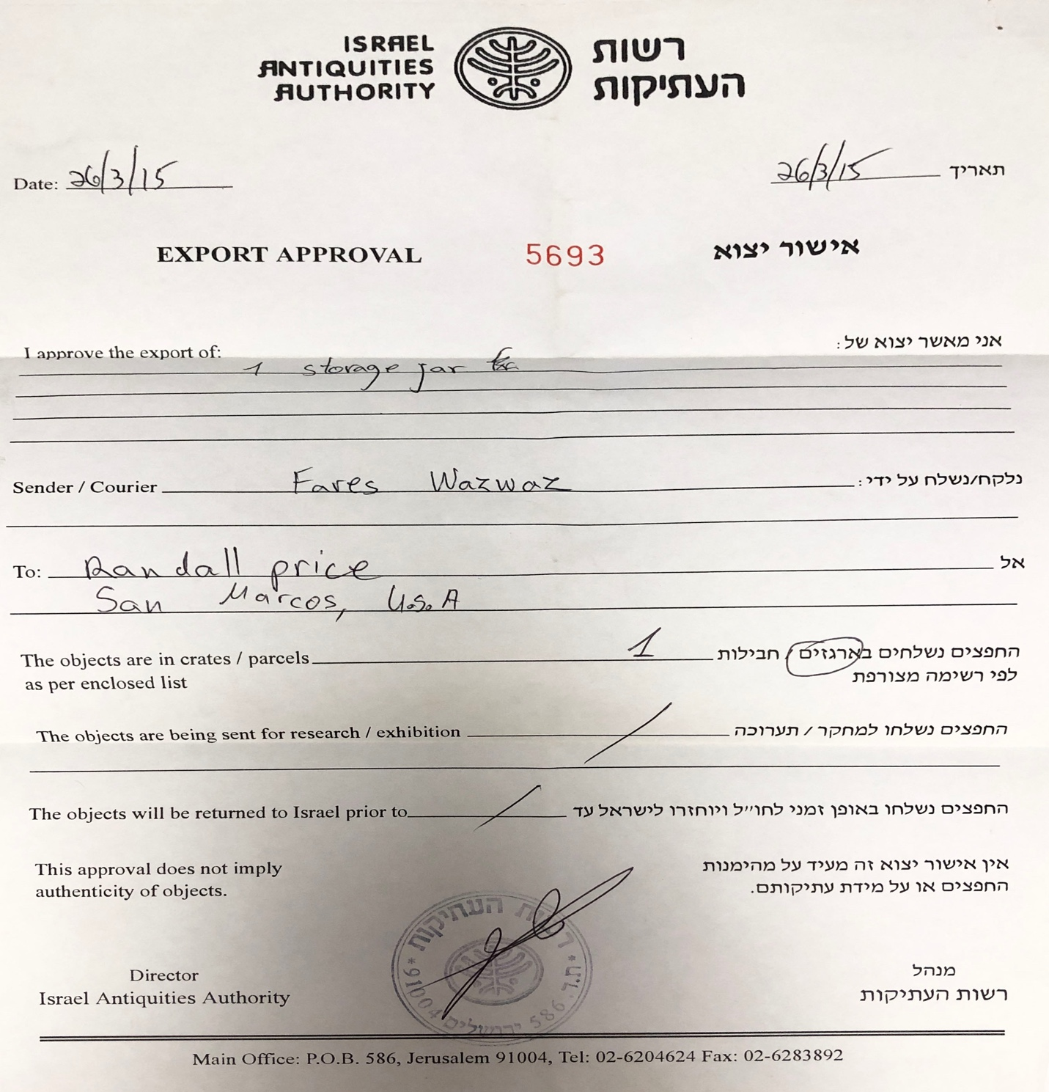
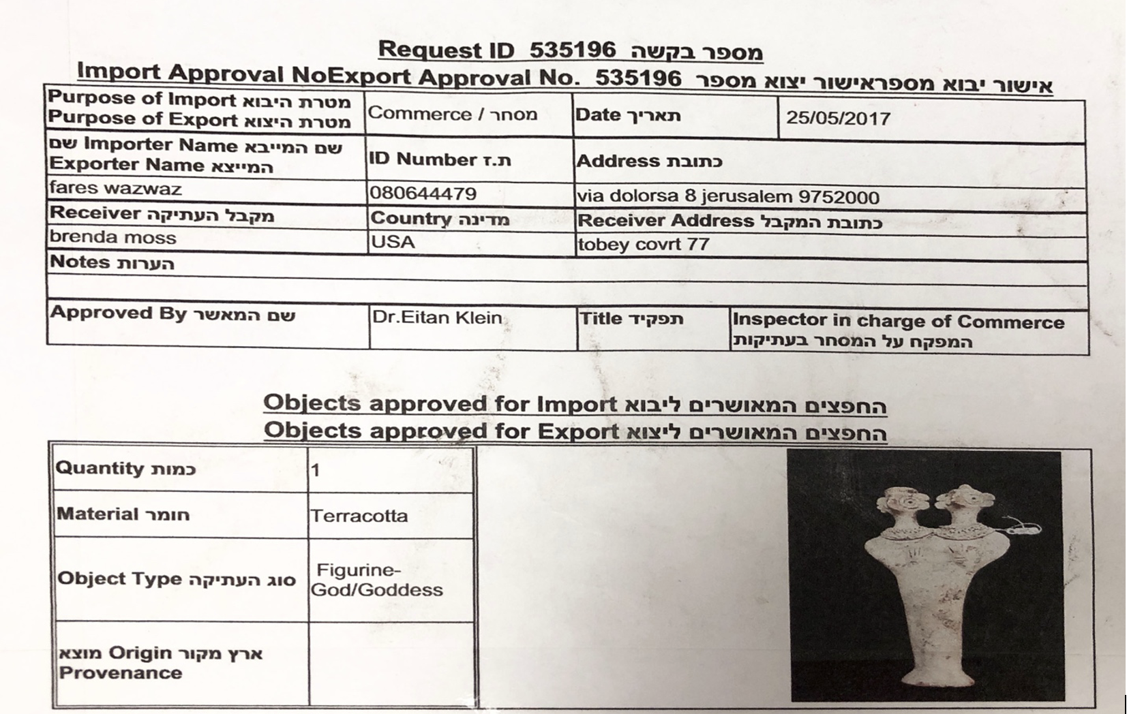

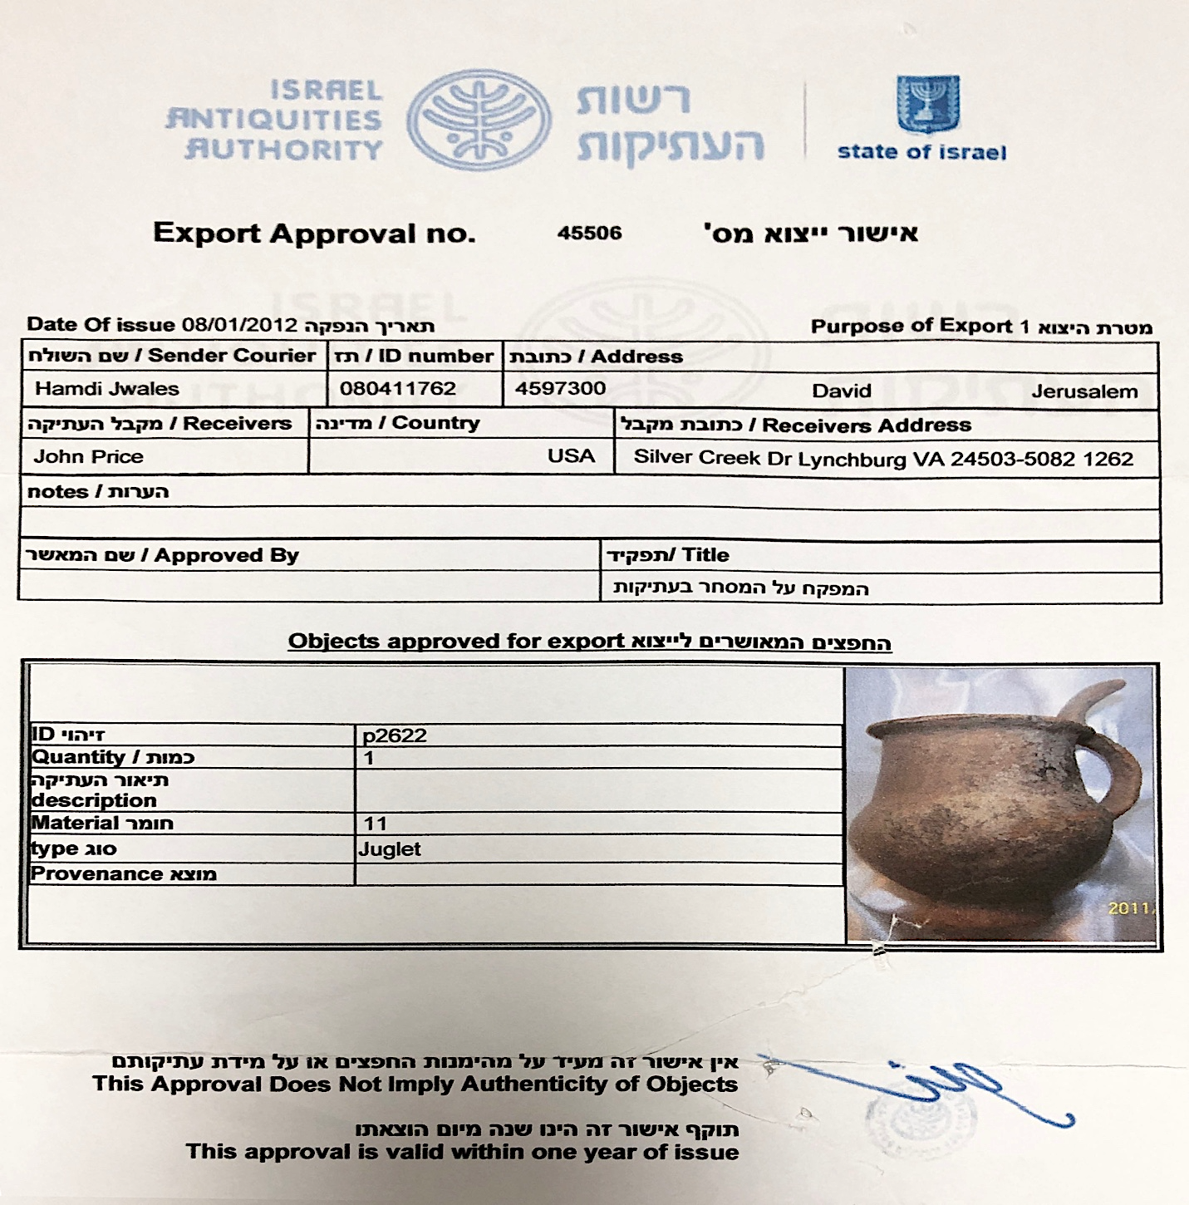

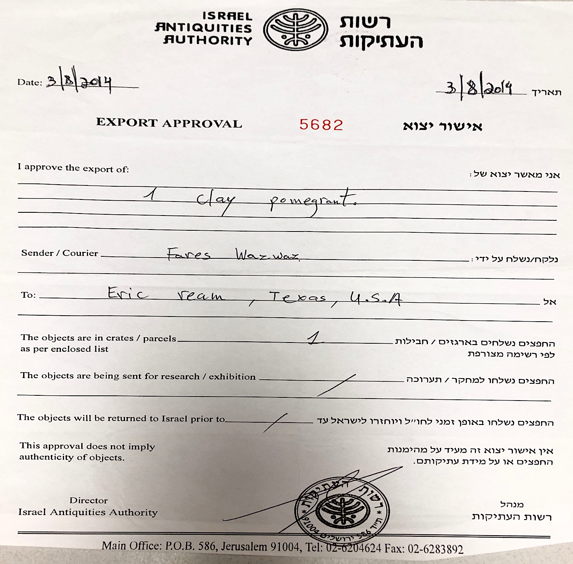

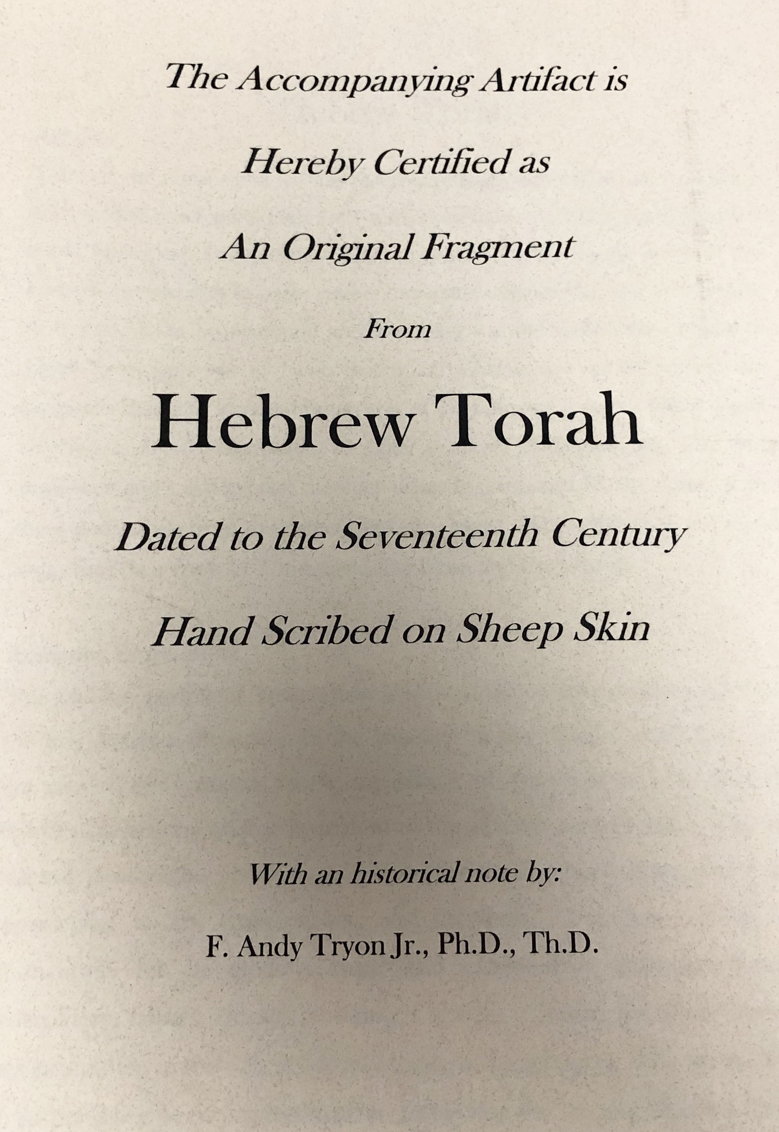

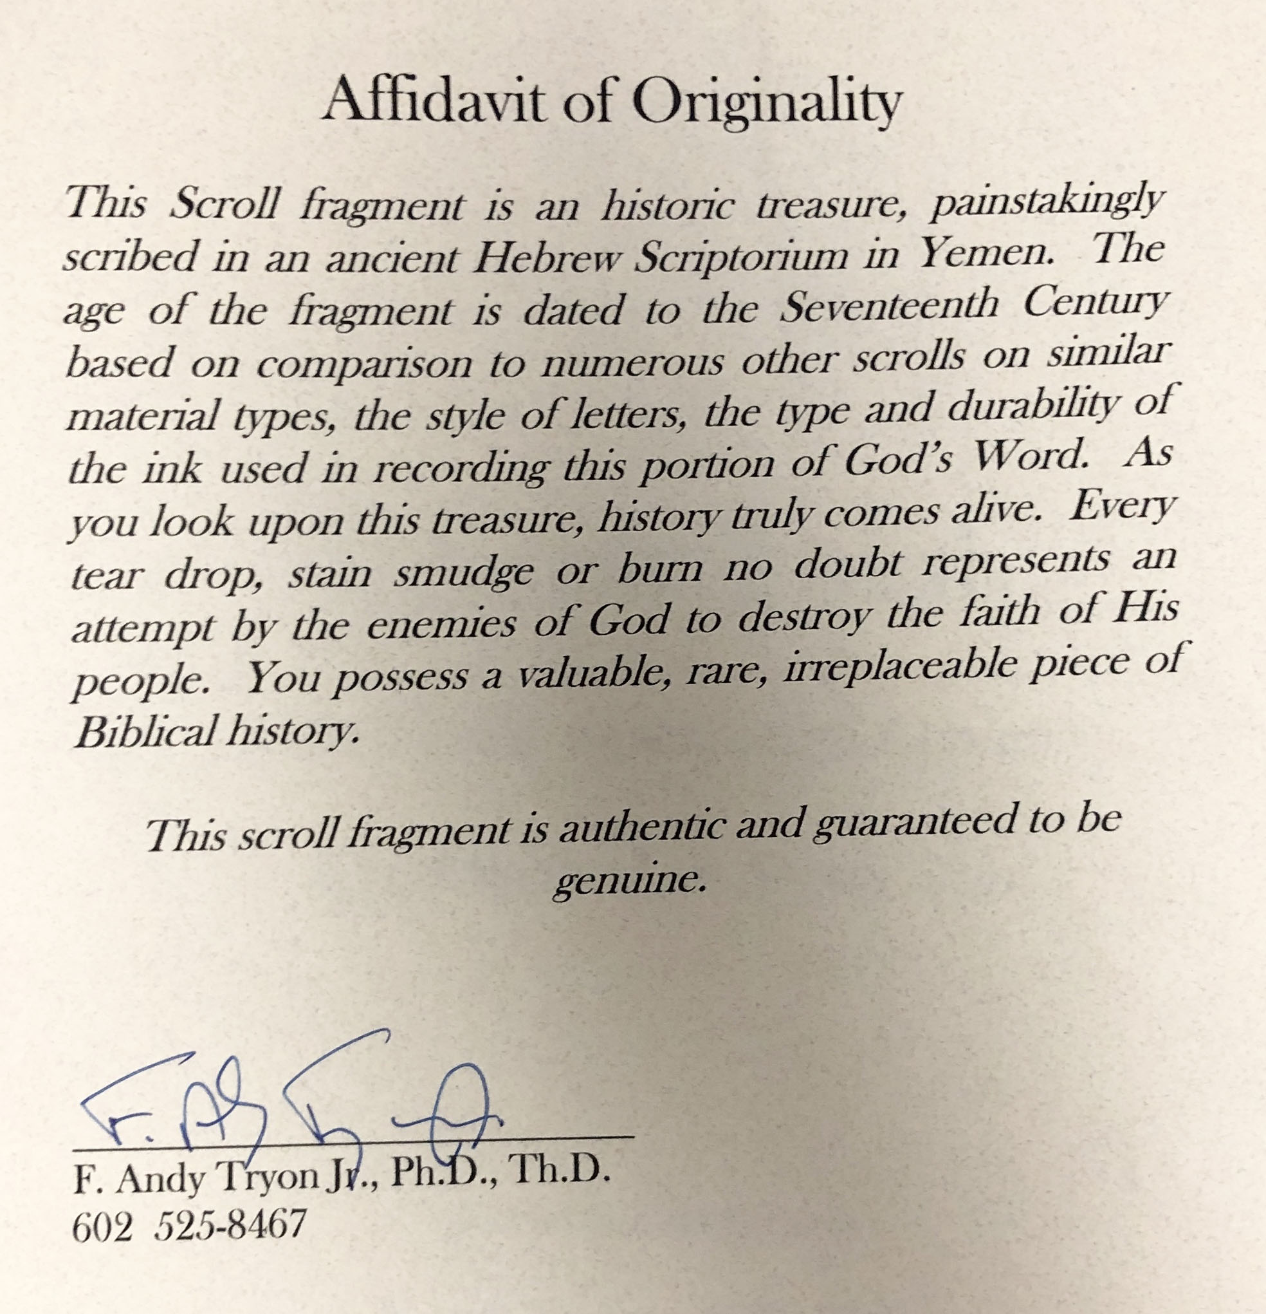
Receipt and documentation for Sephardic Torah Scroll (ca. AD 200)
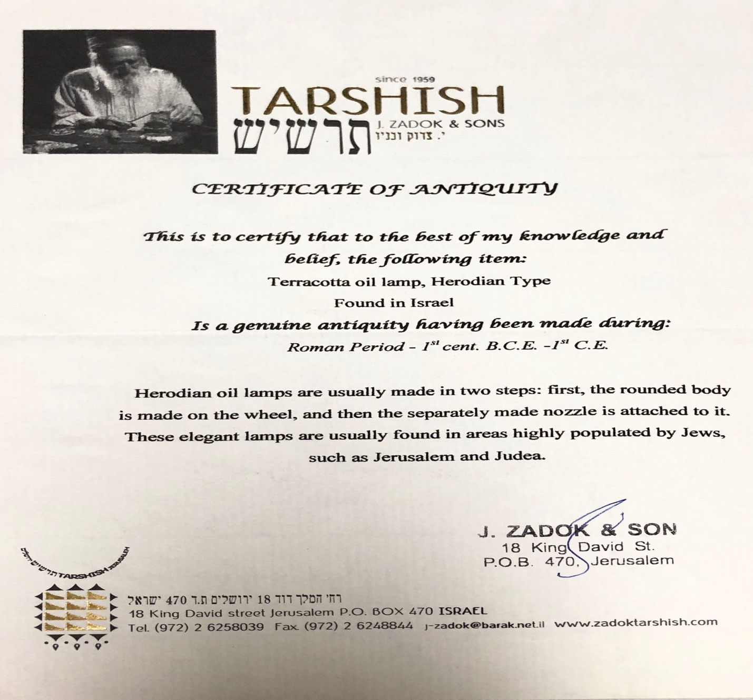

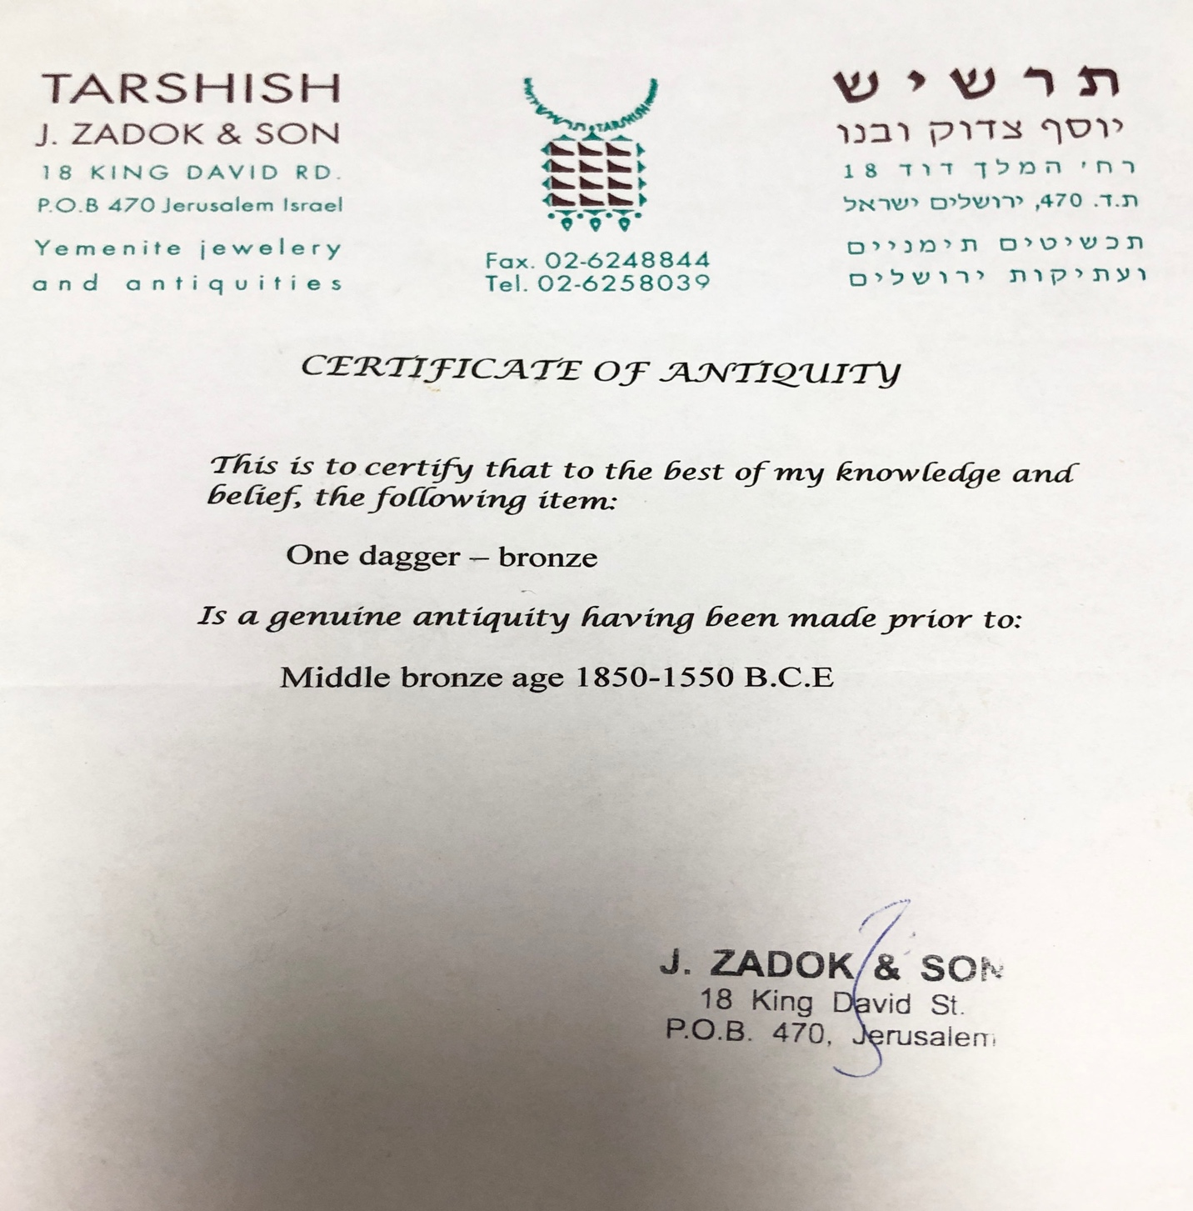

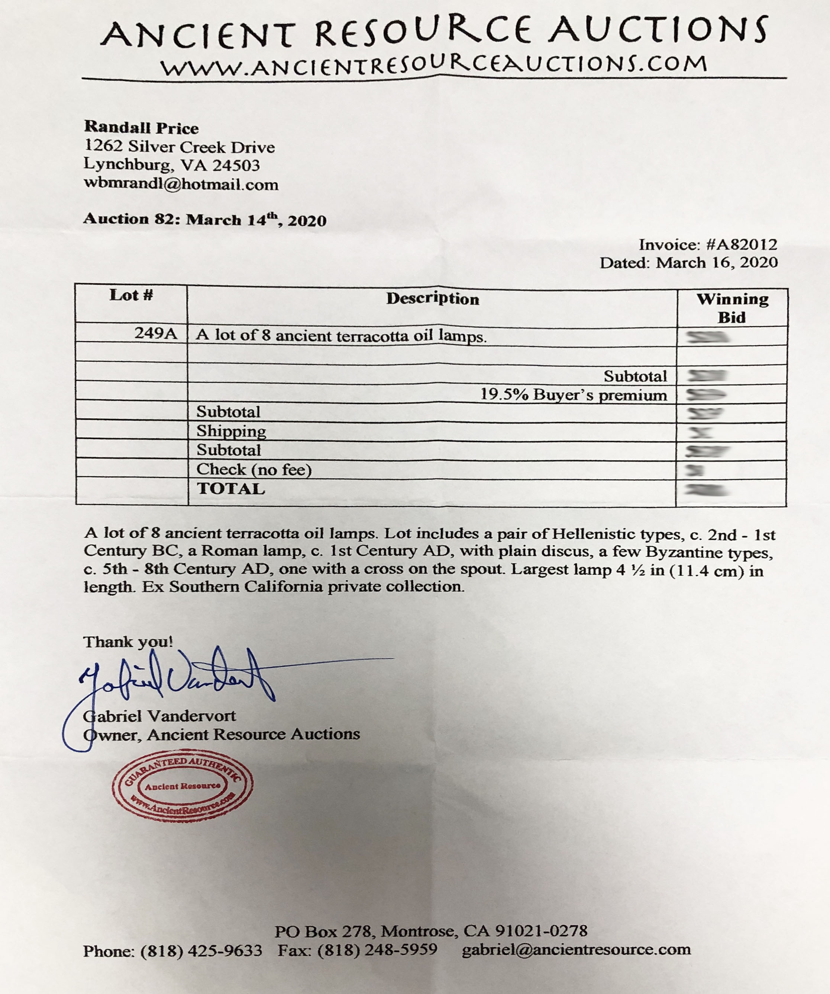

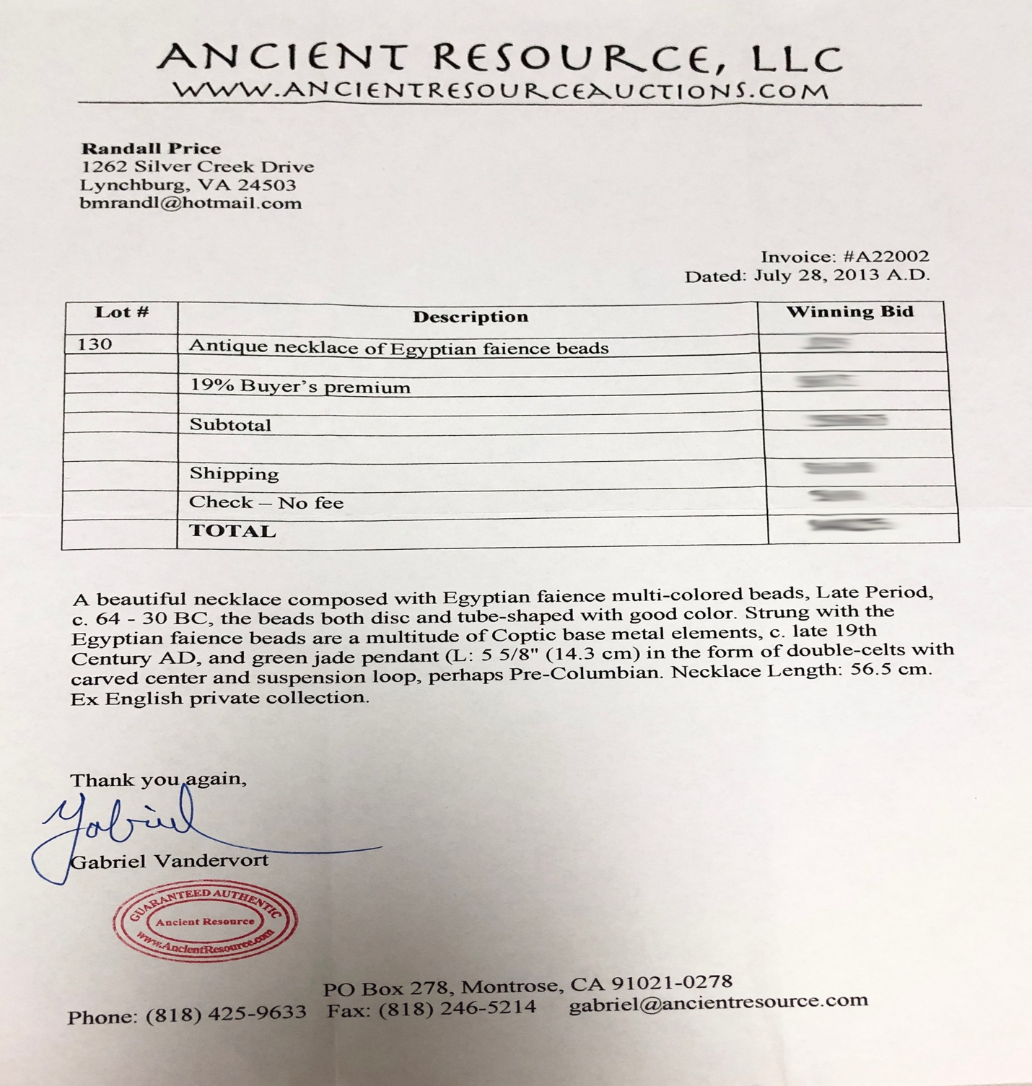

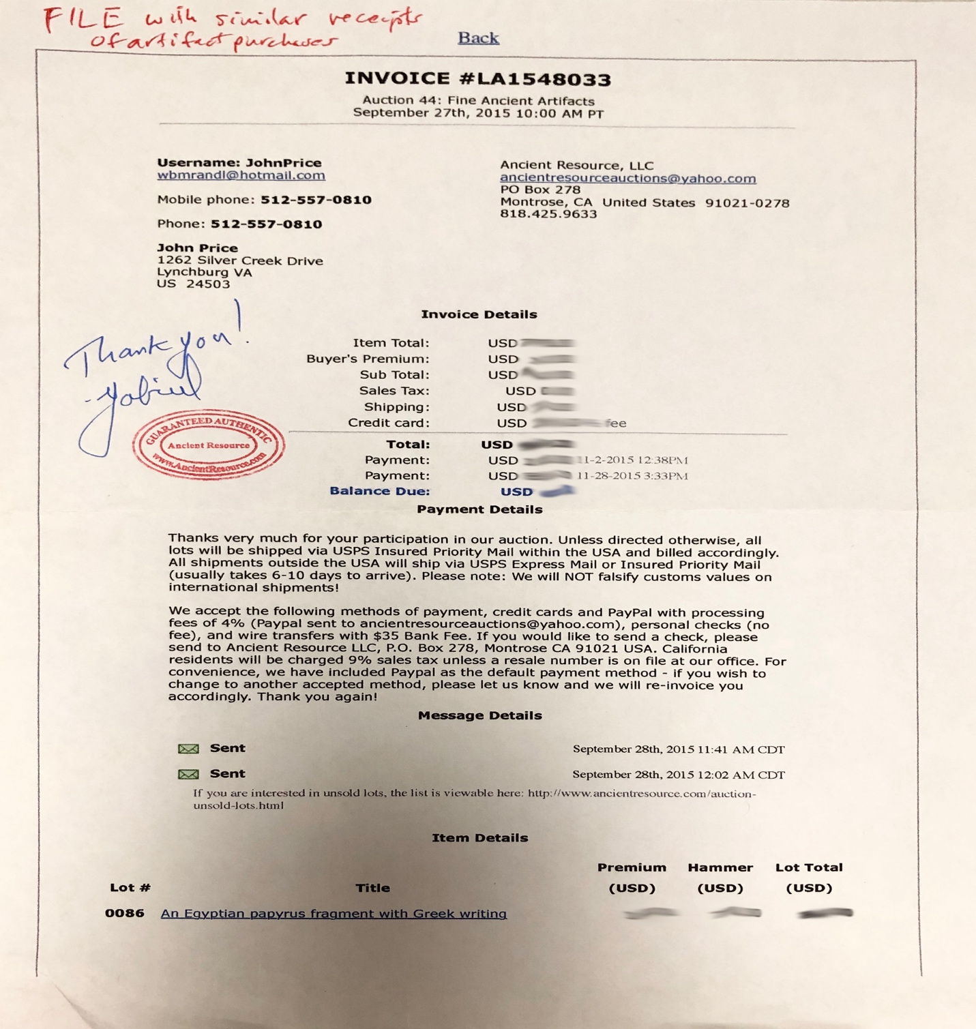

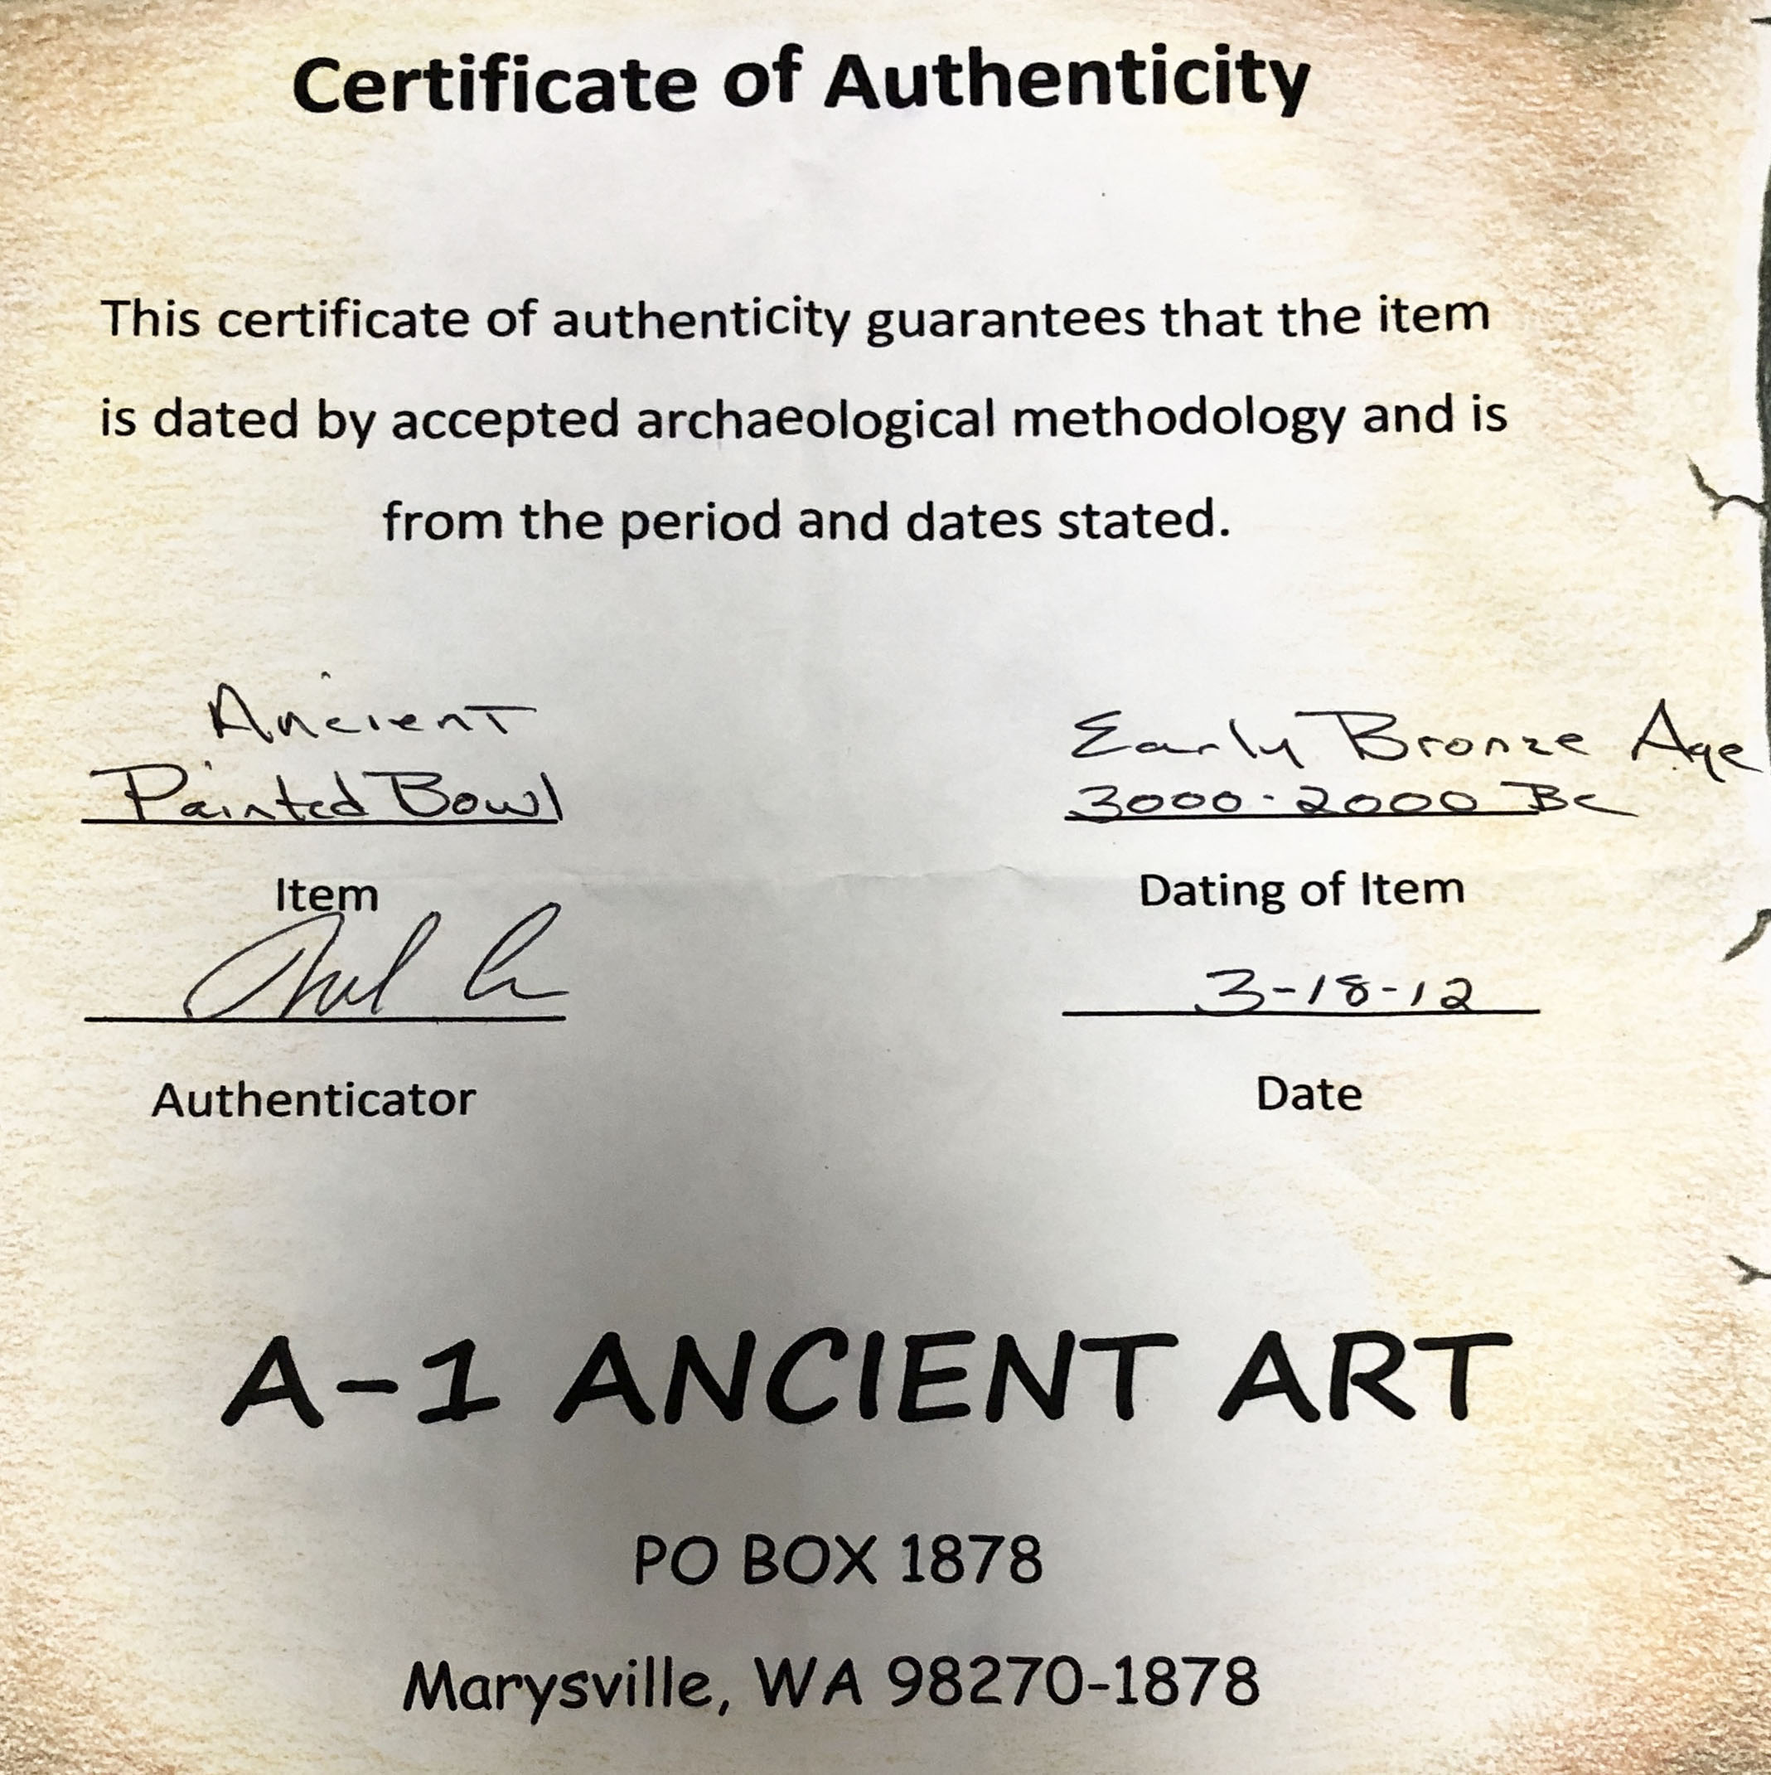

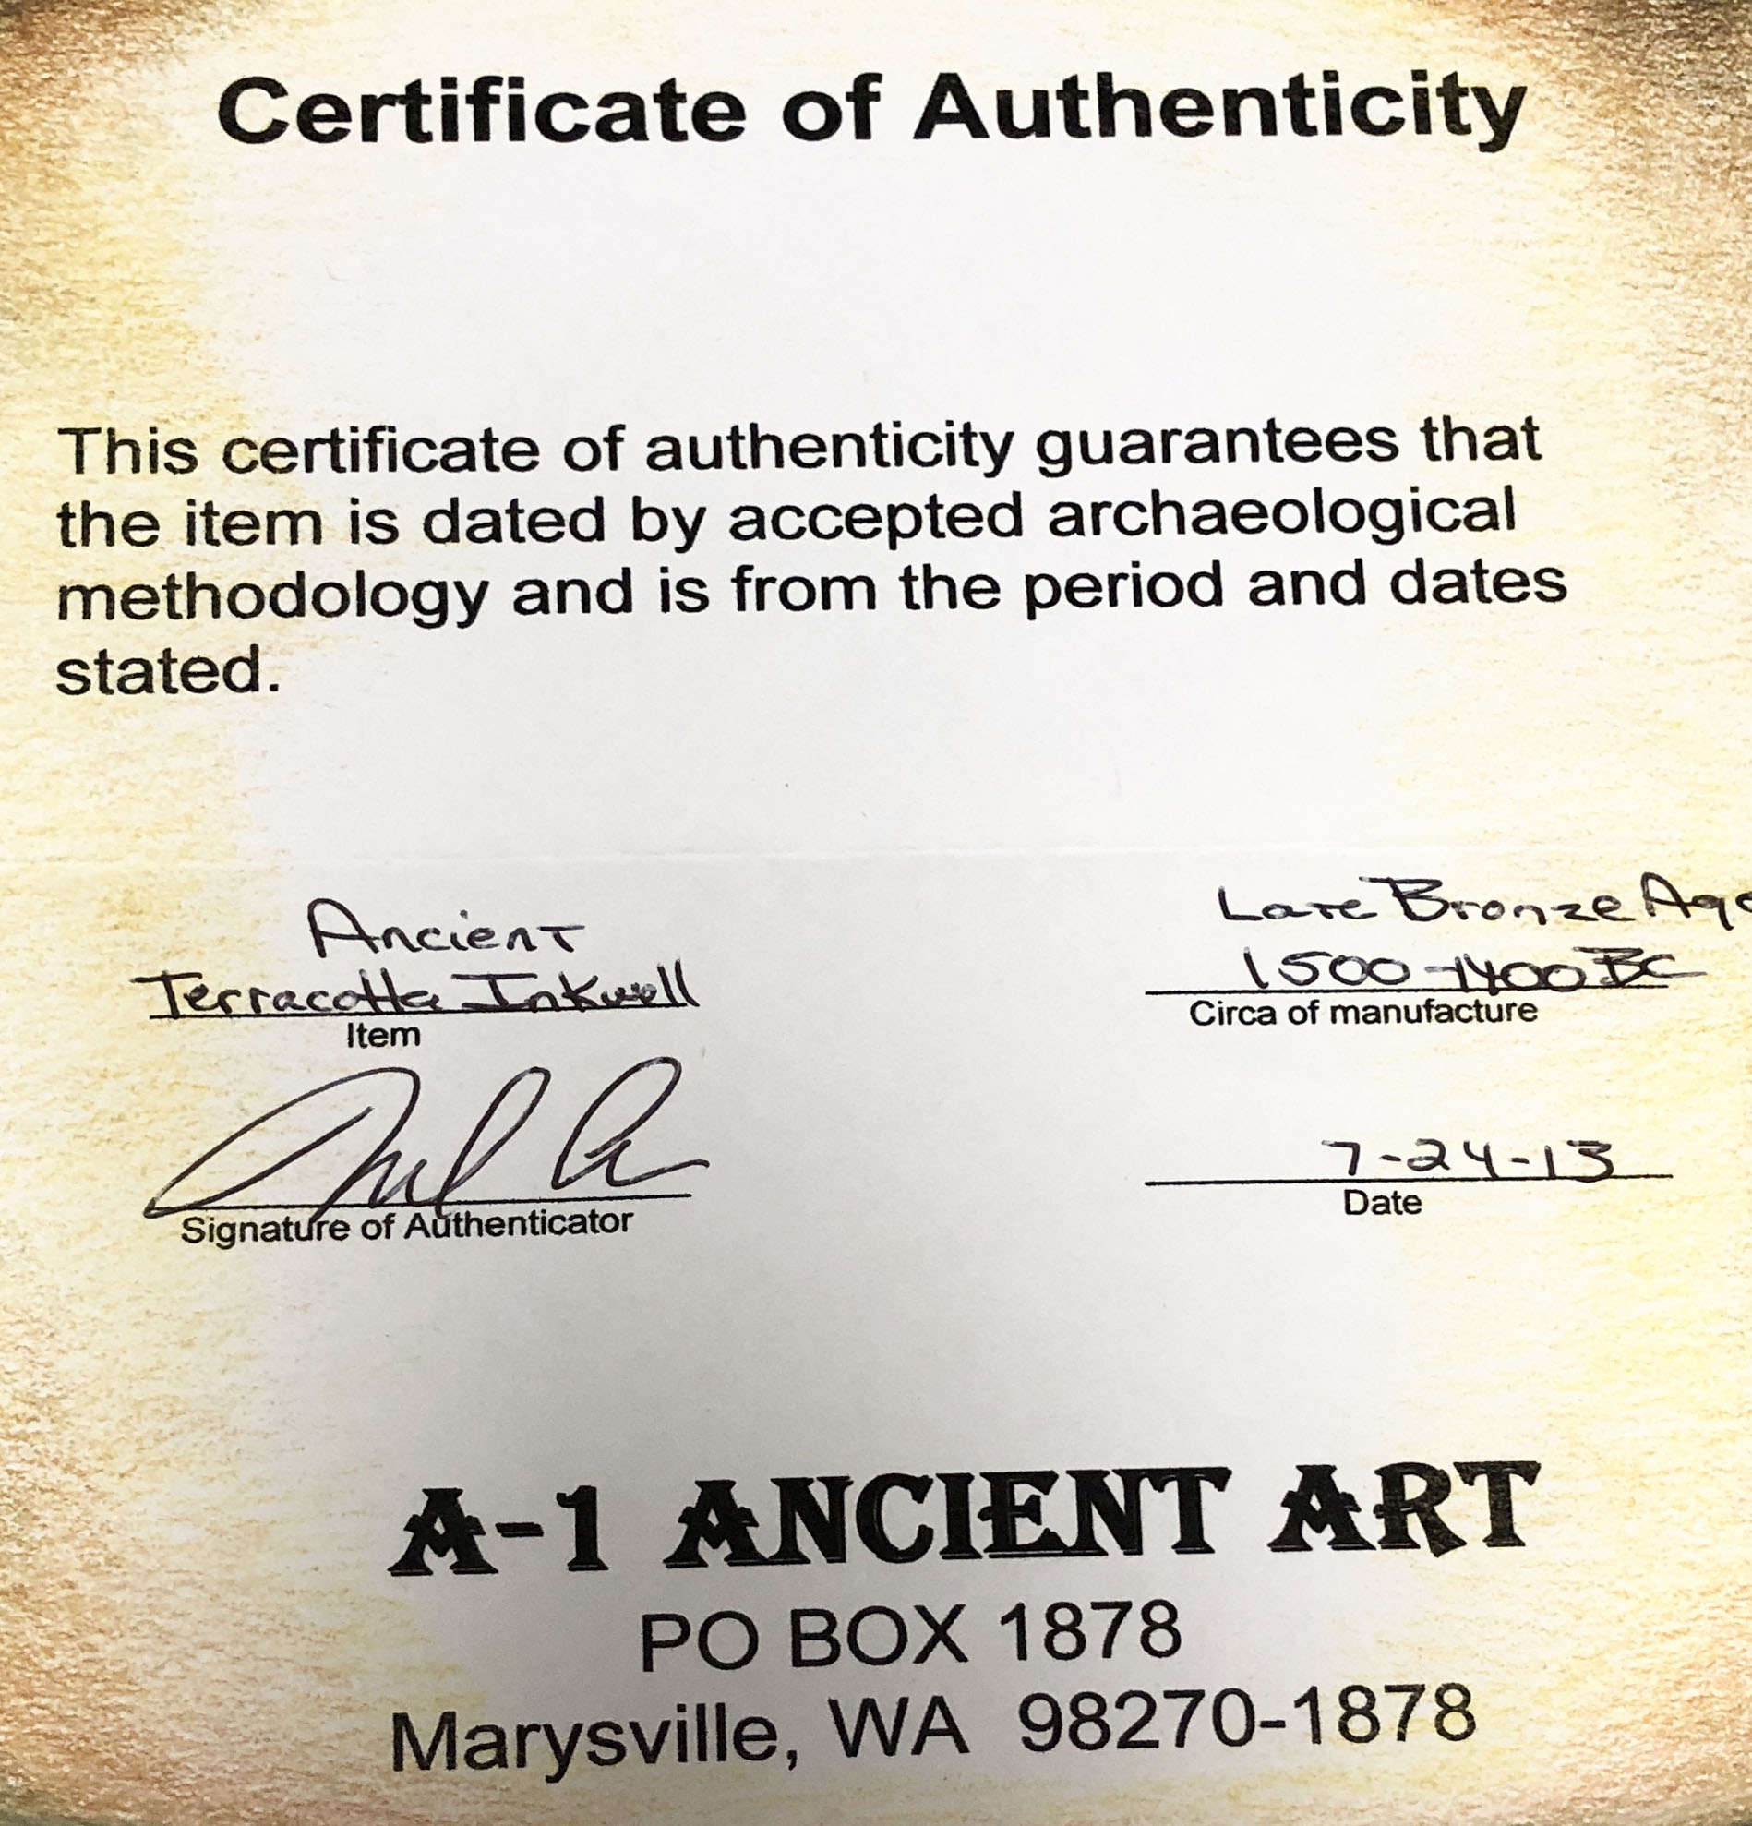

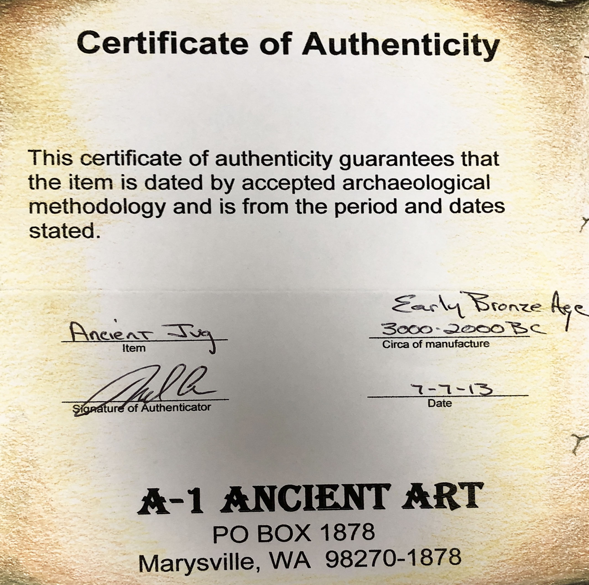

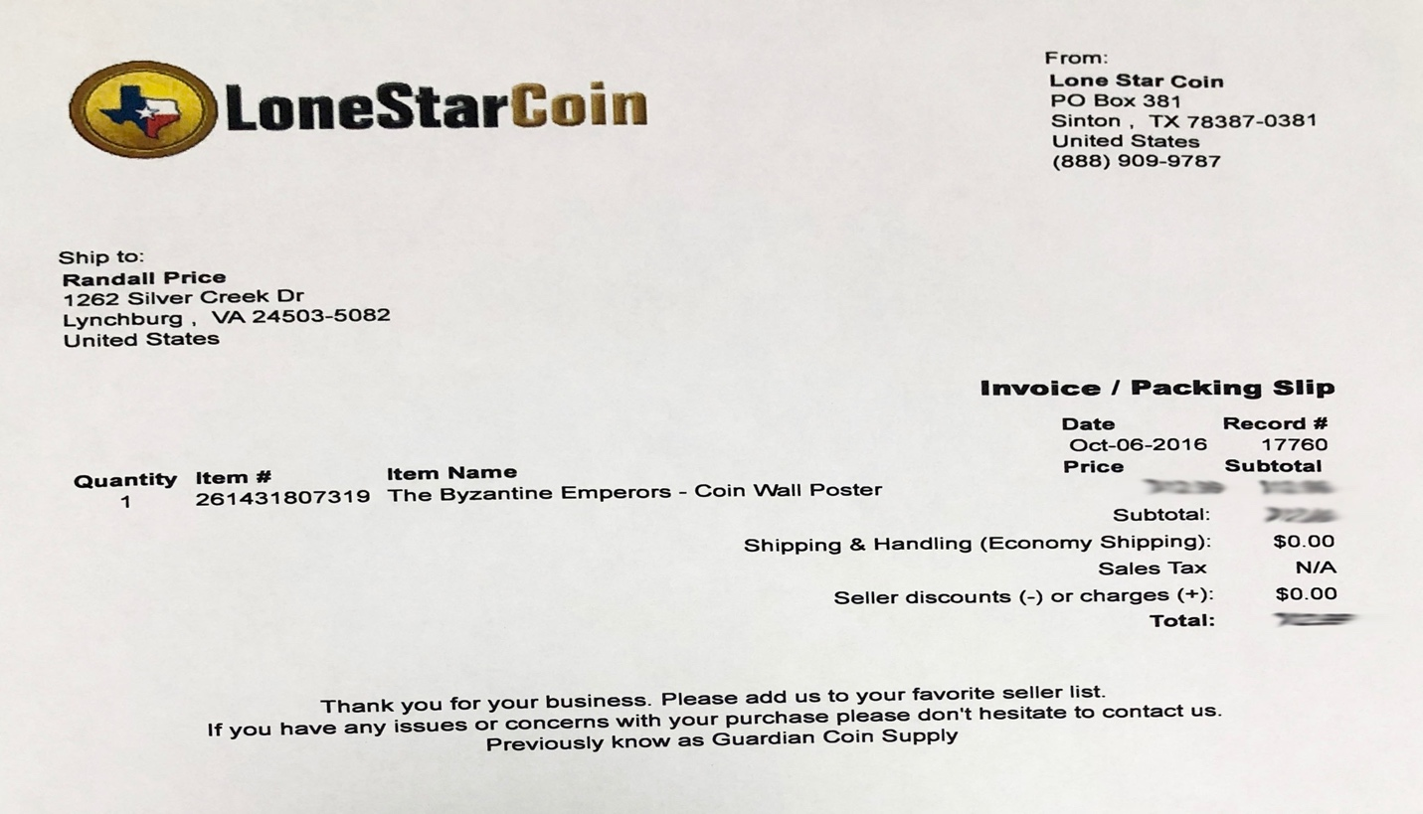

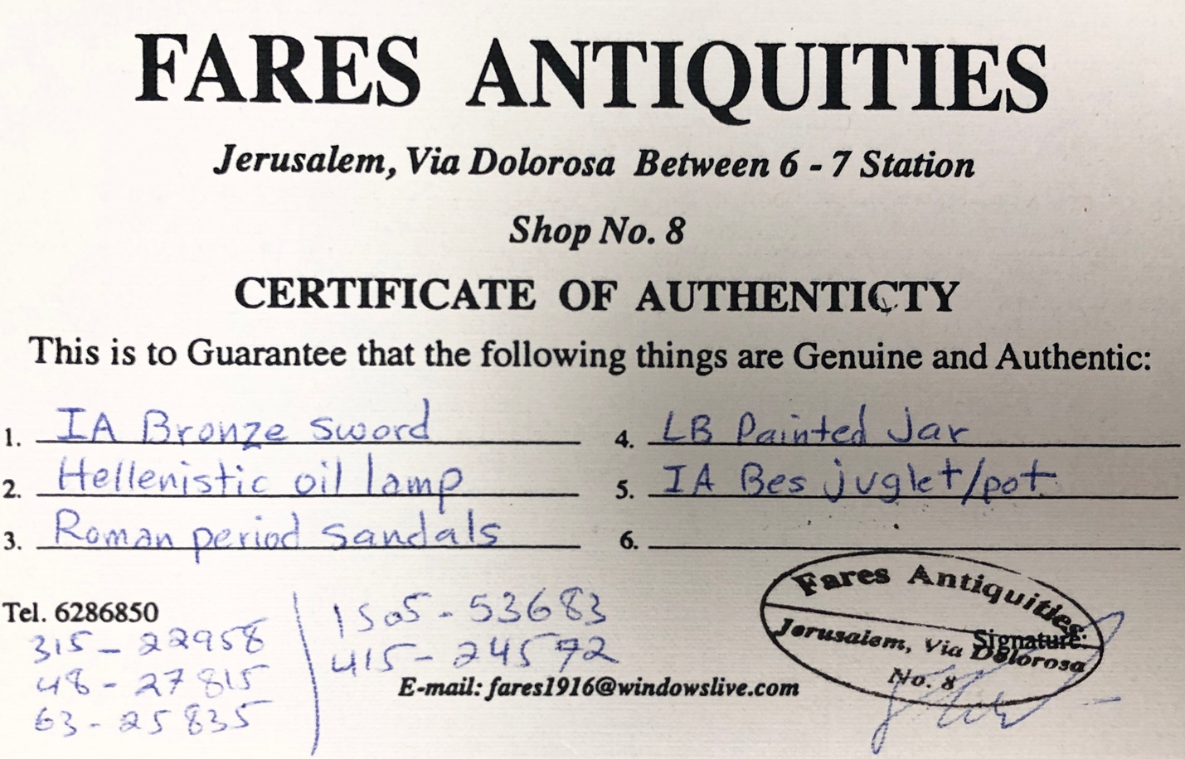
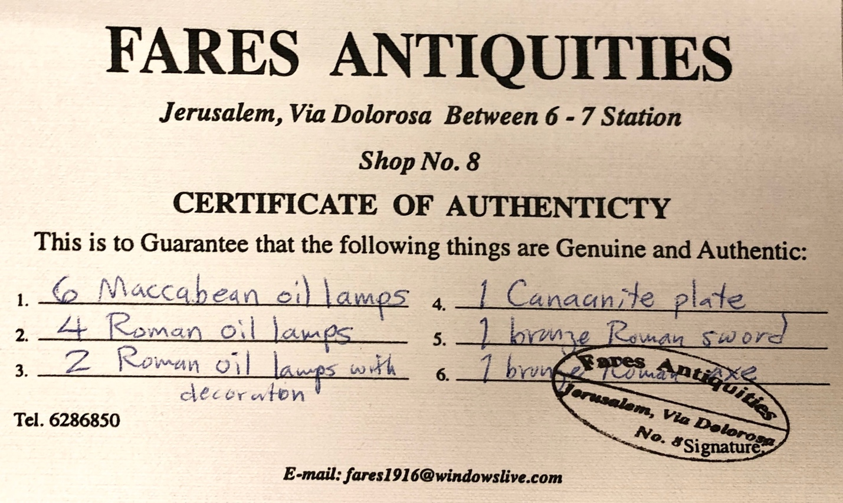

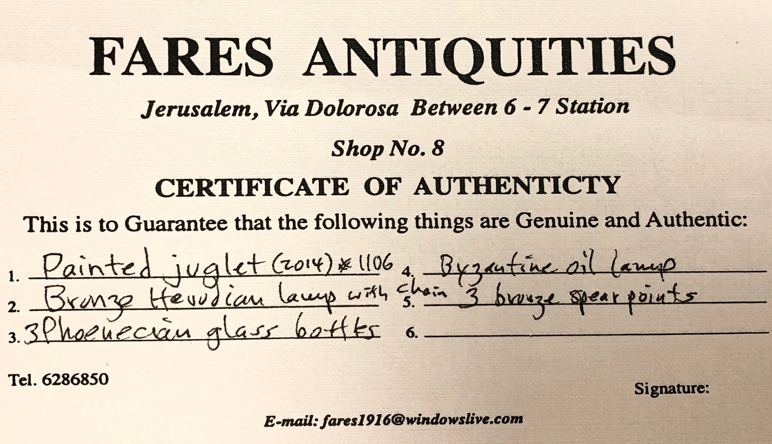
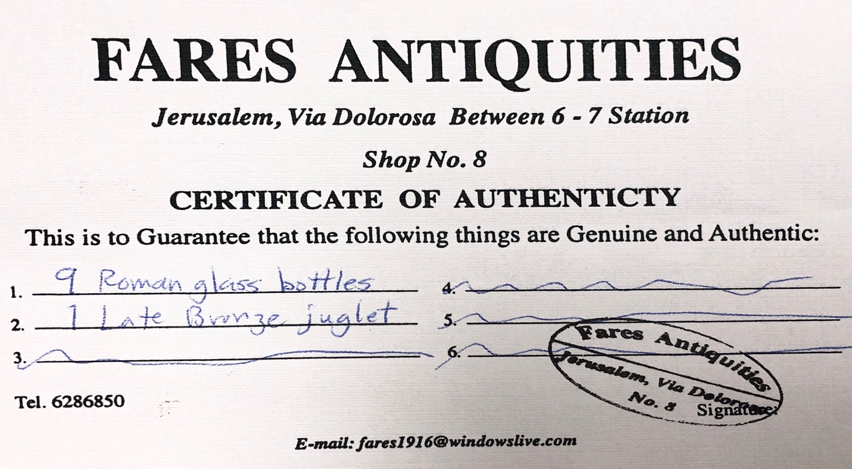

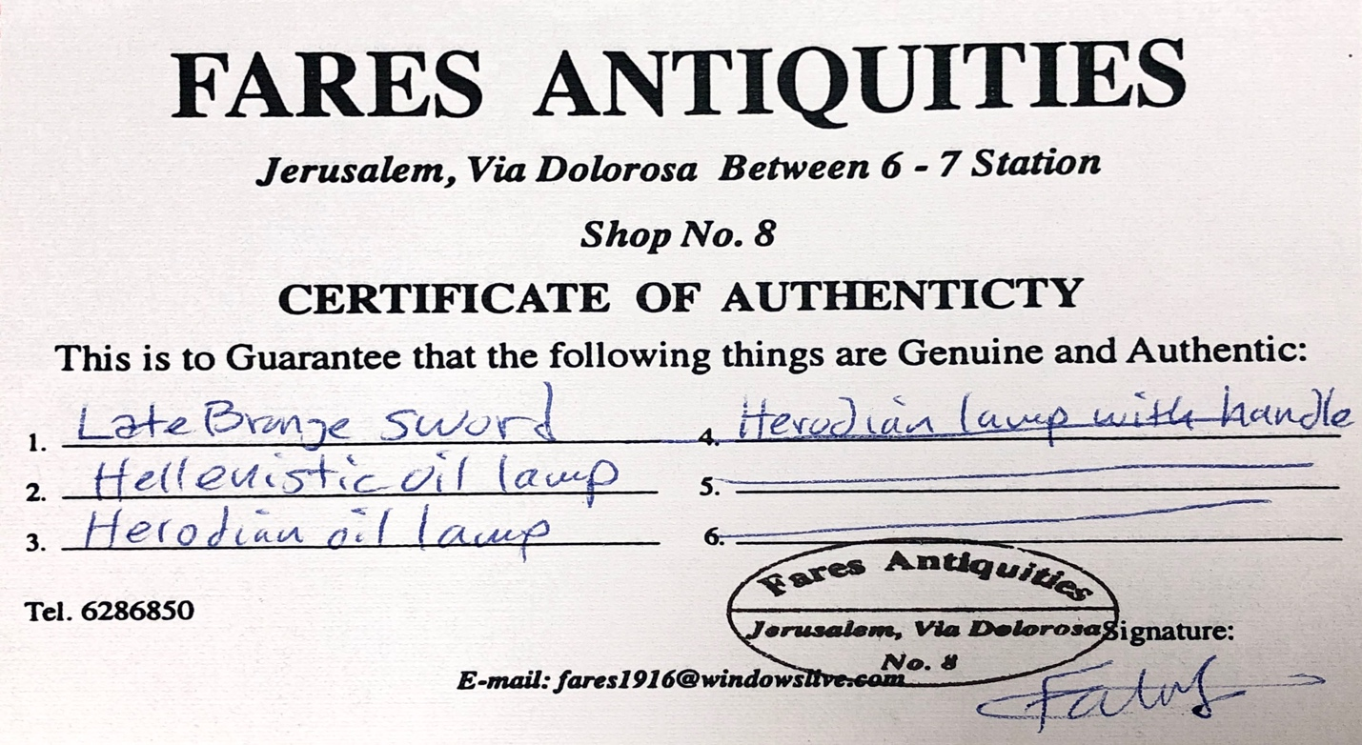
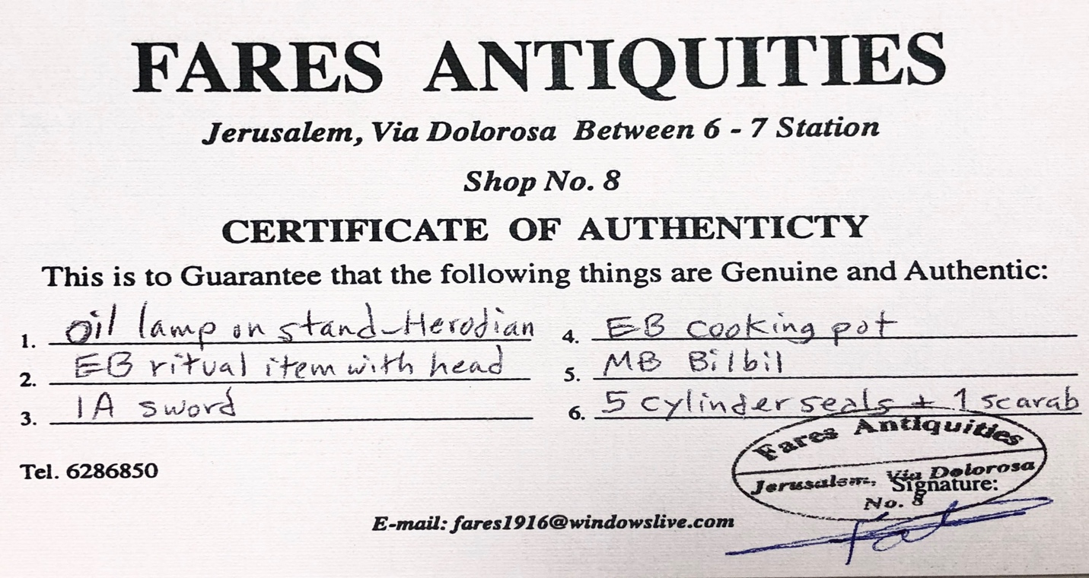

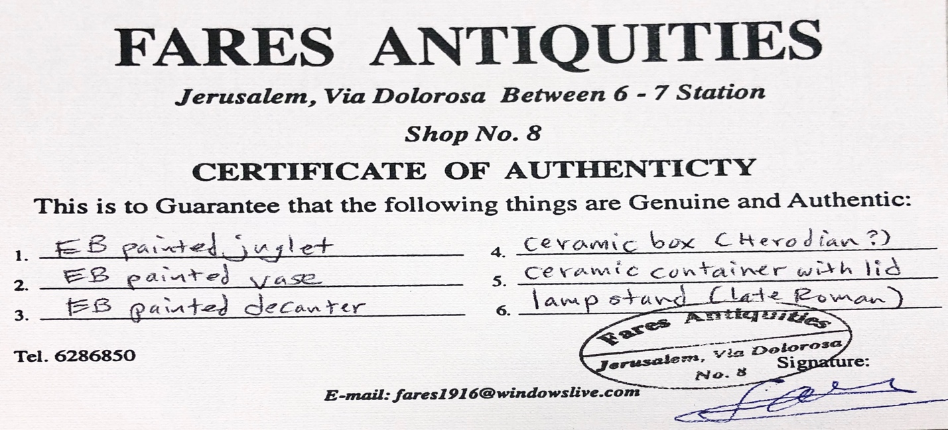

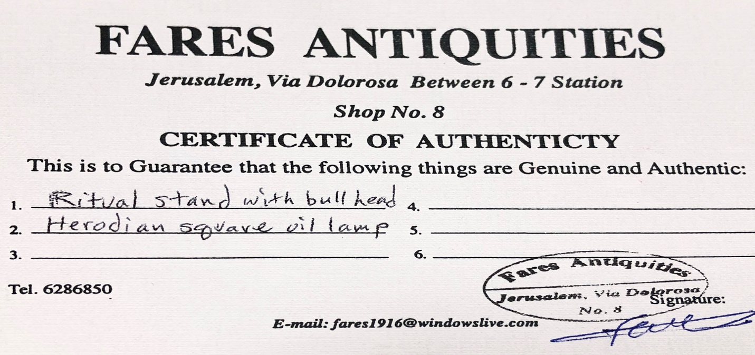

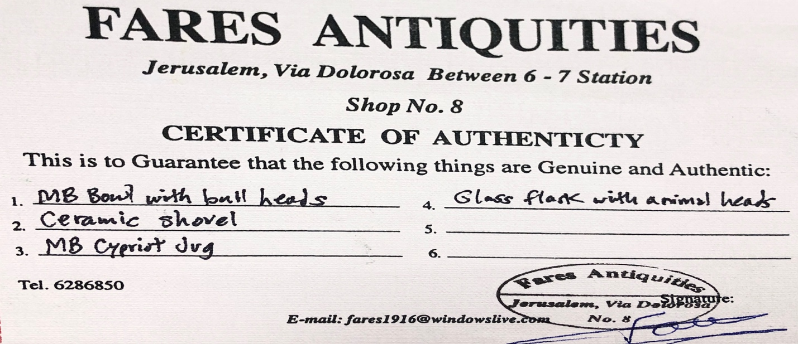
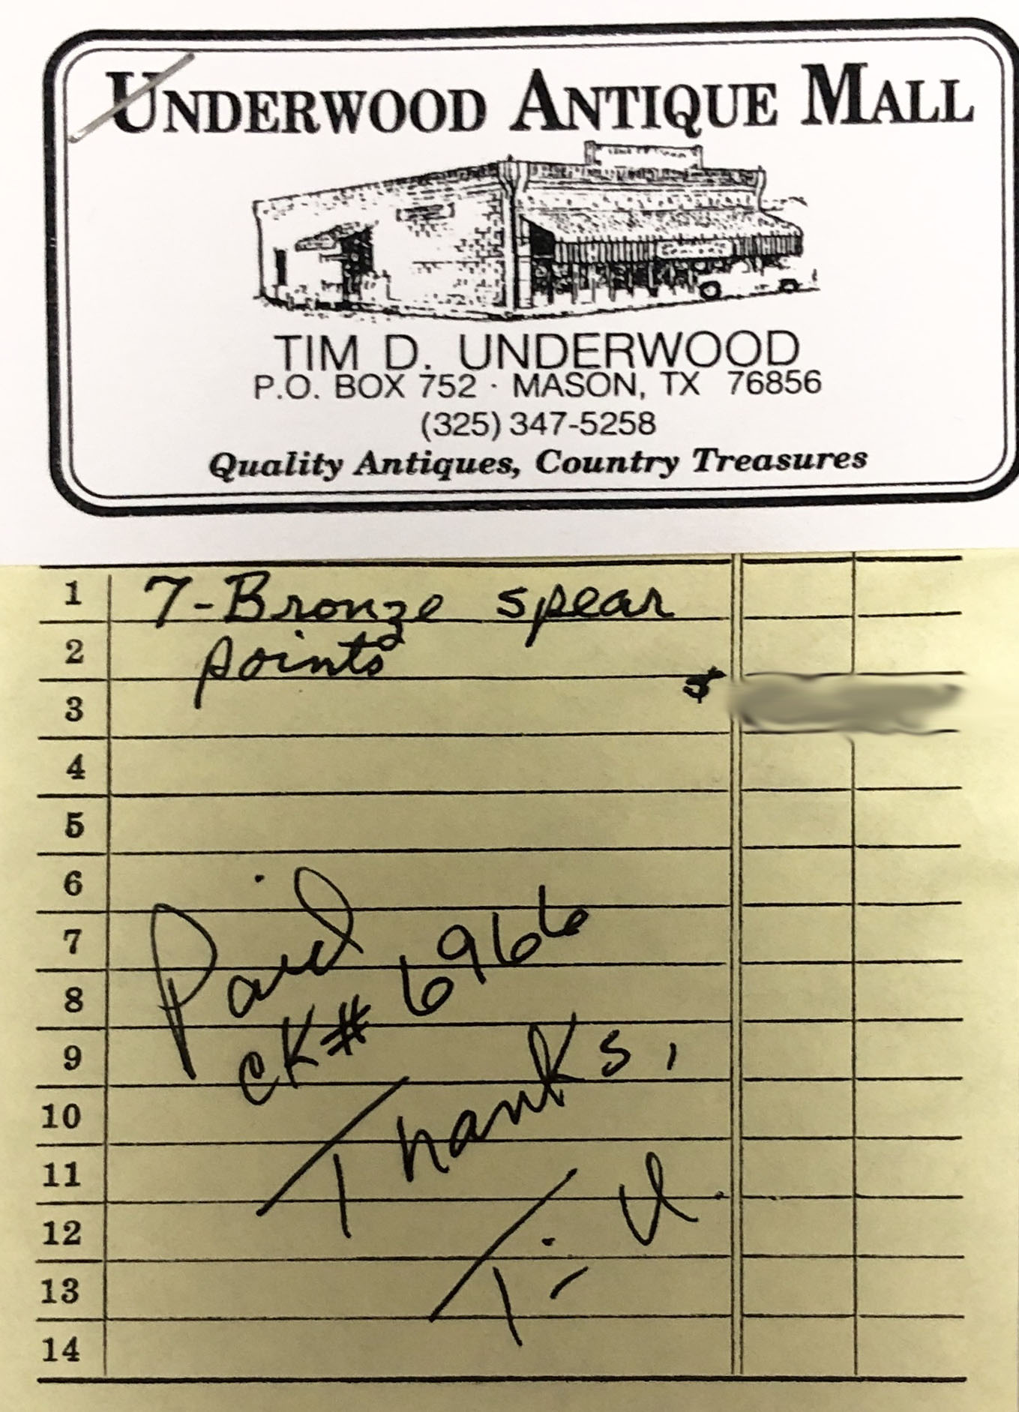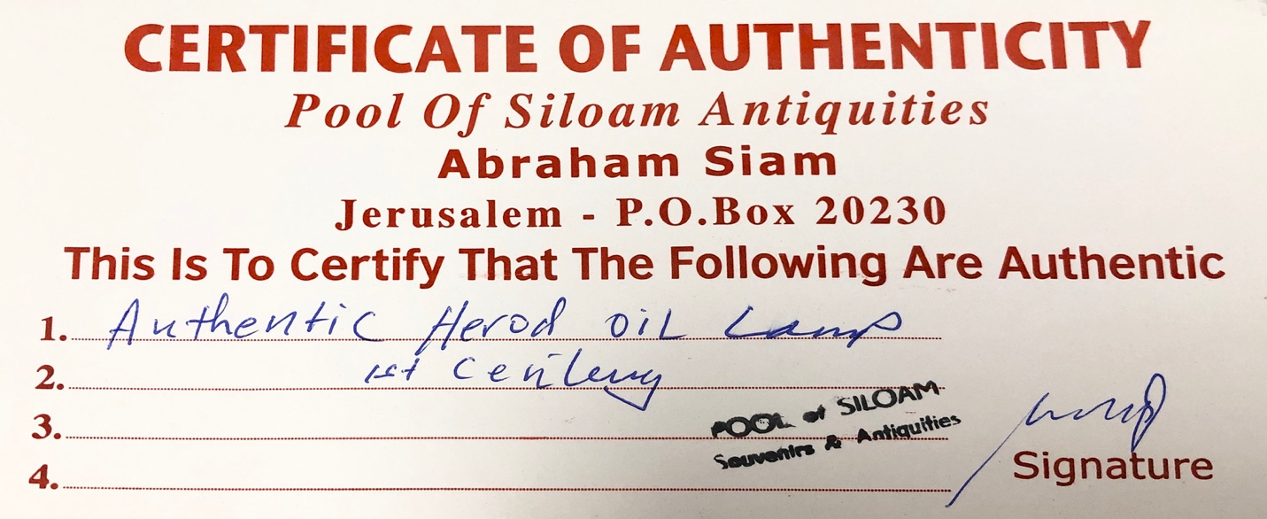

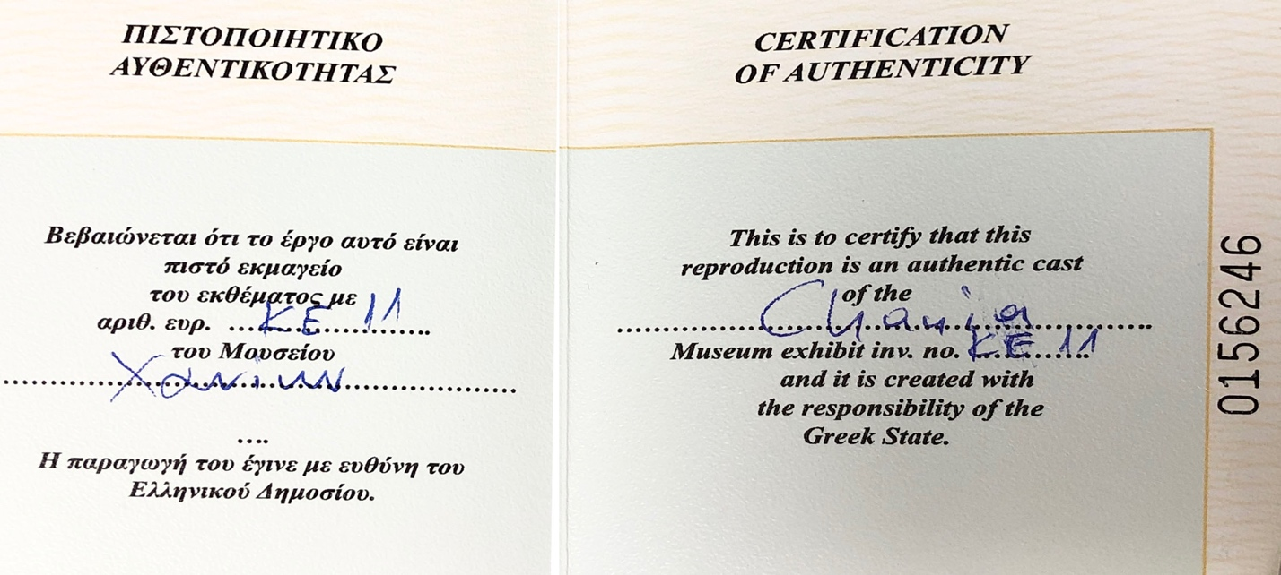
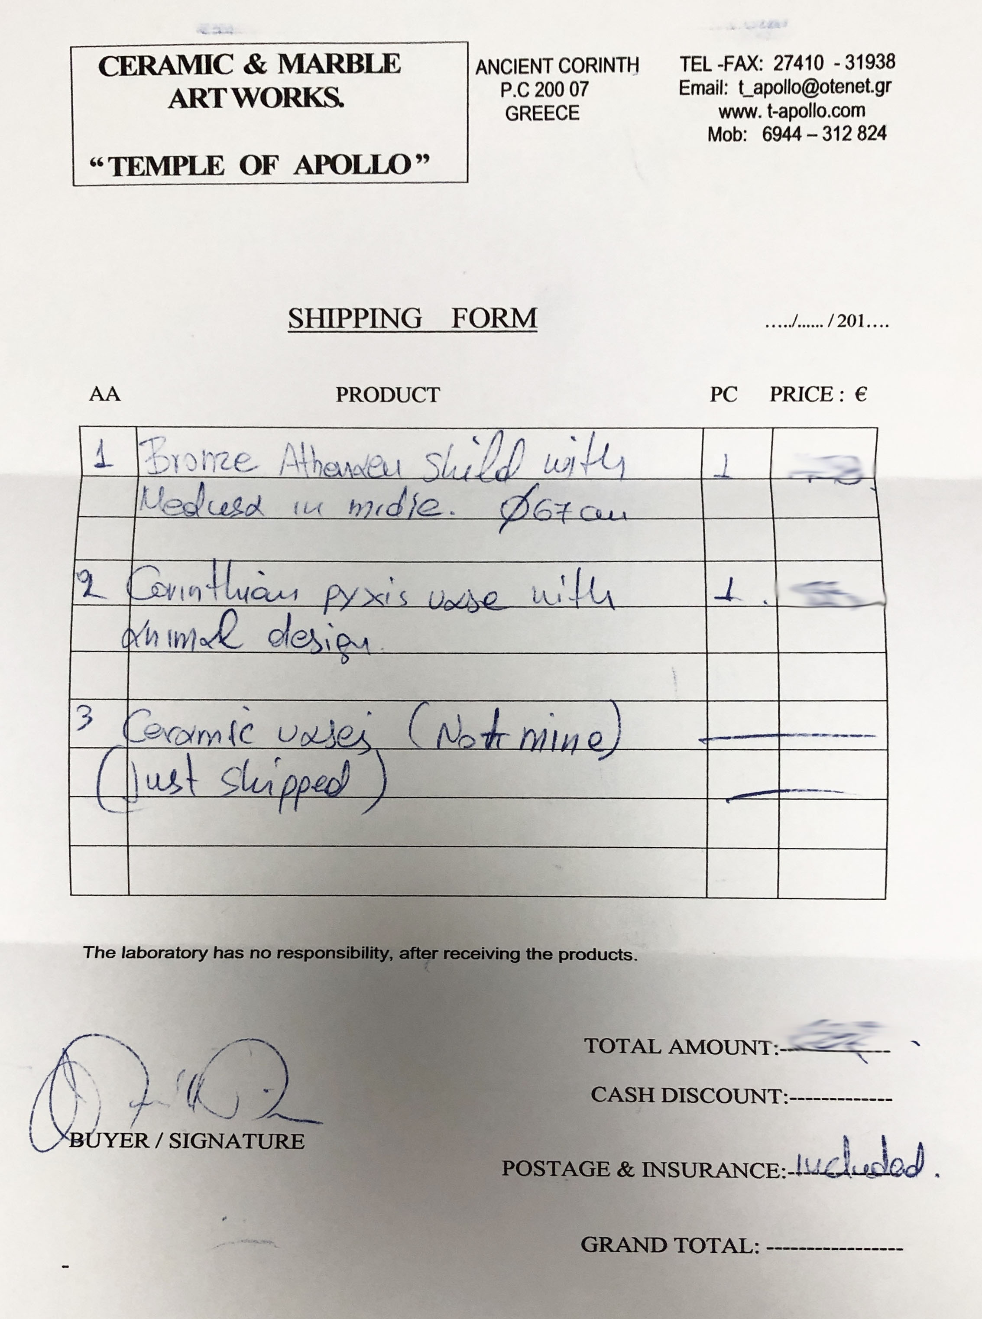

Provenance of Donated Amphora Recovered from Ancient Shipwreck by Patrick Gorman
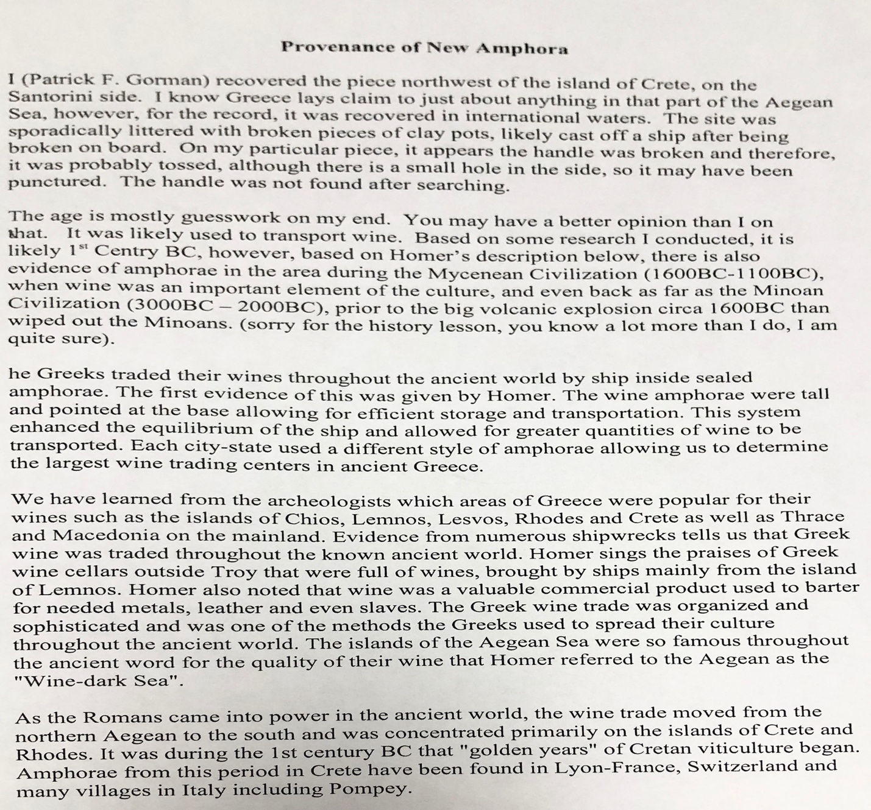

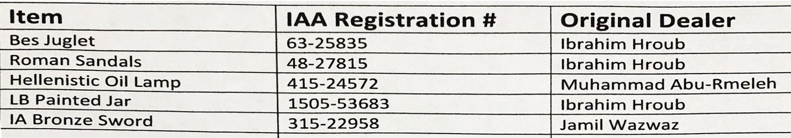
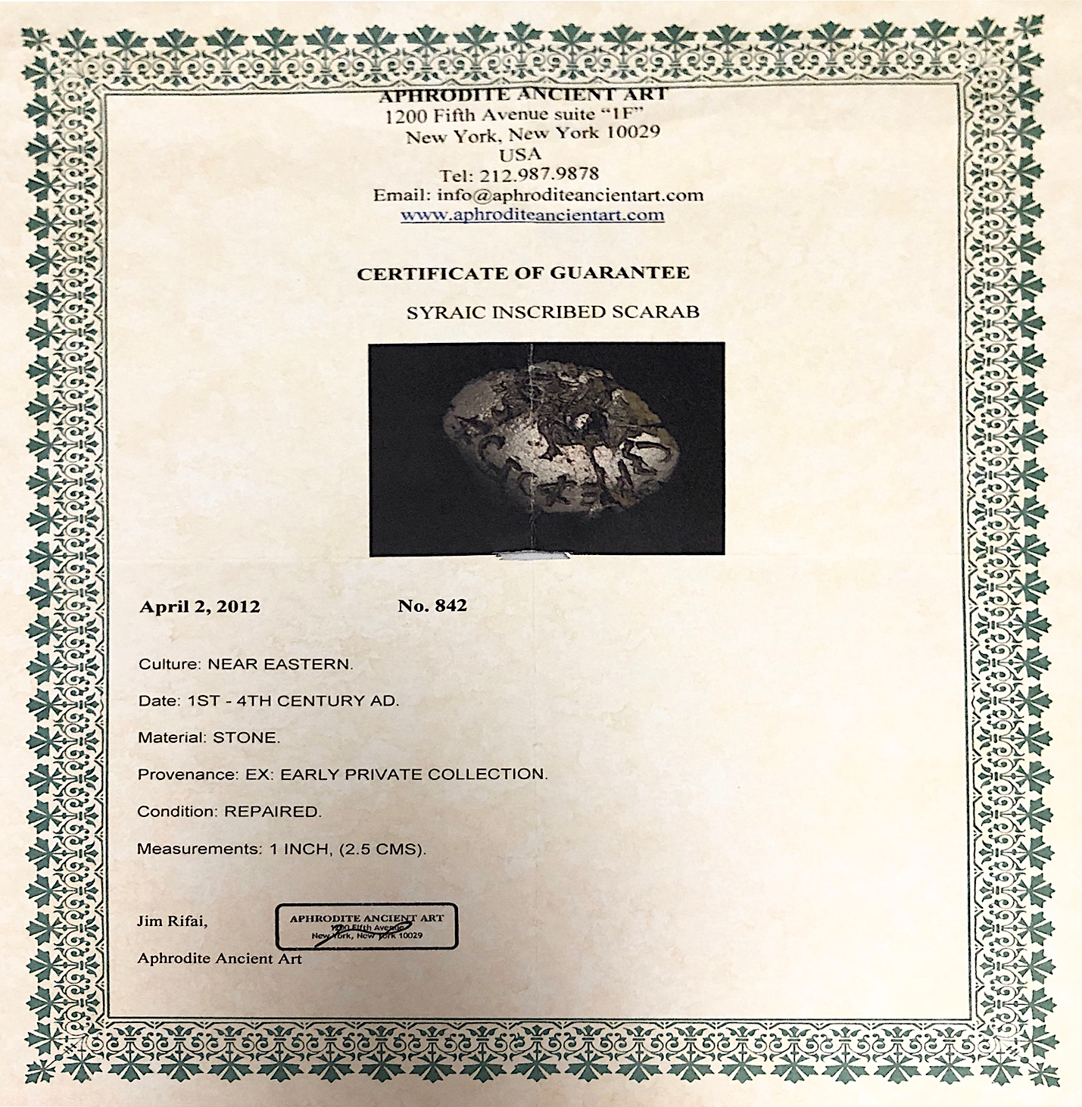
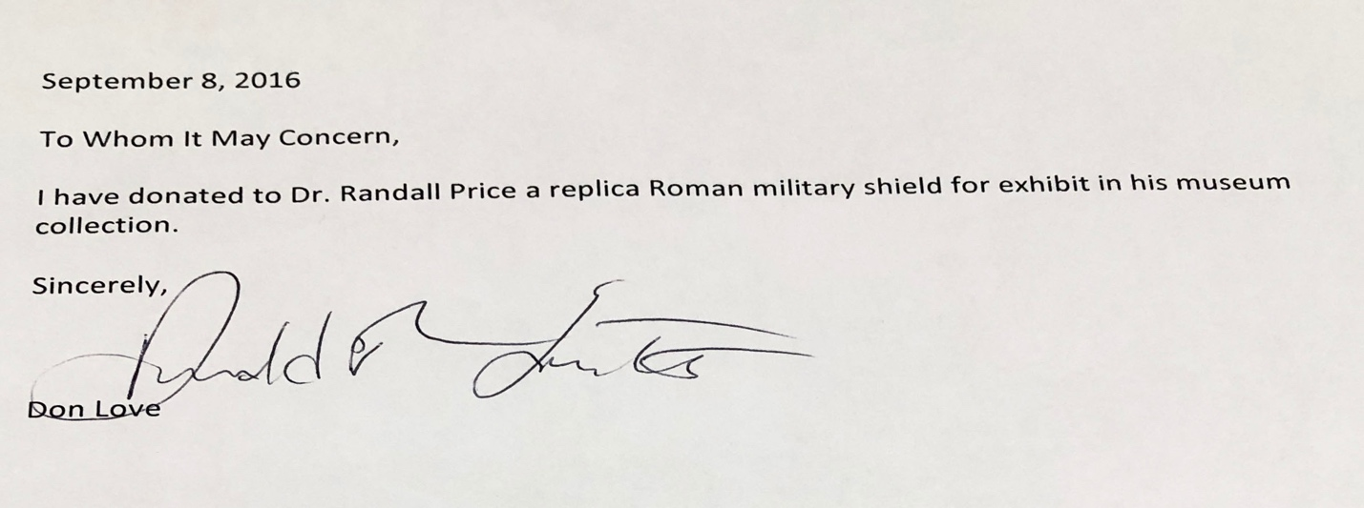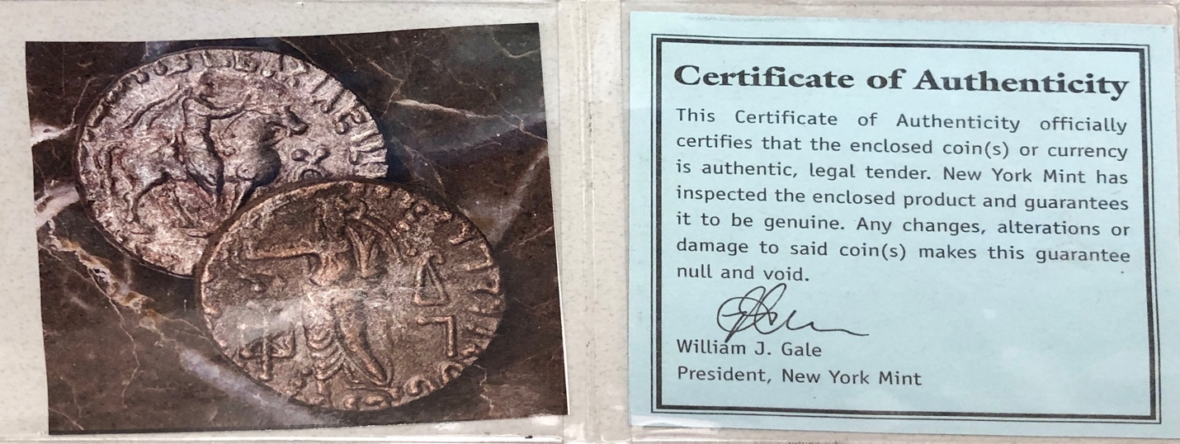

Documentation of Dead Sea Isaiah Scroll Replica Source

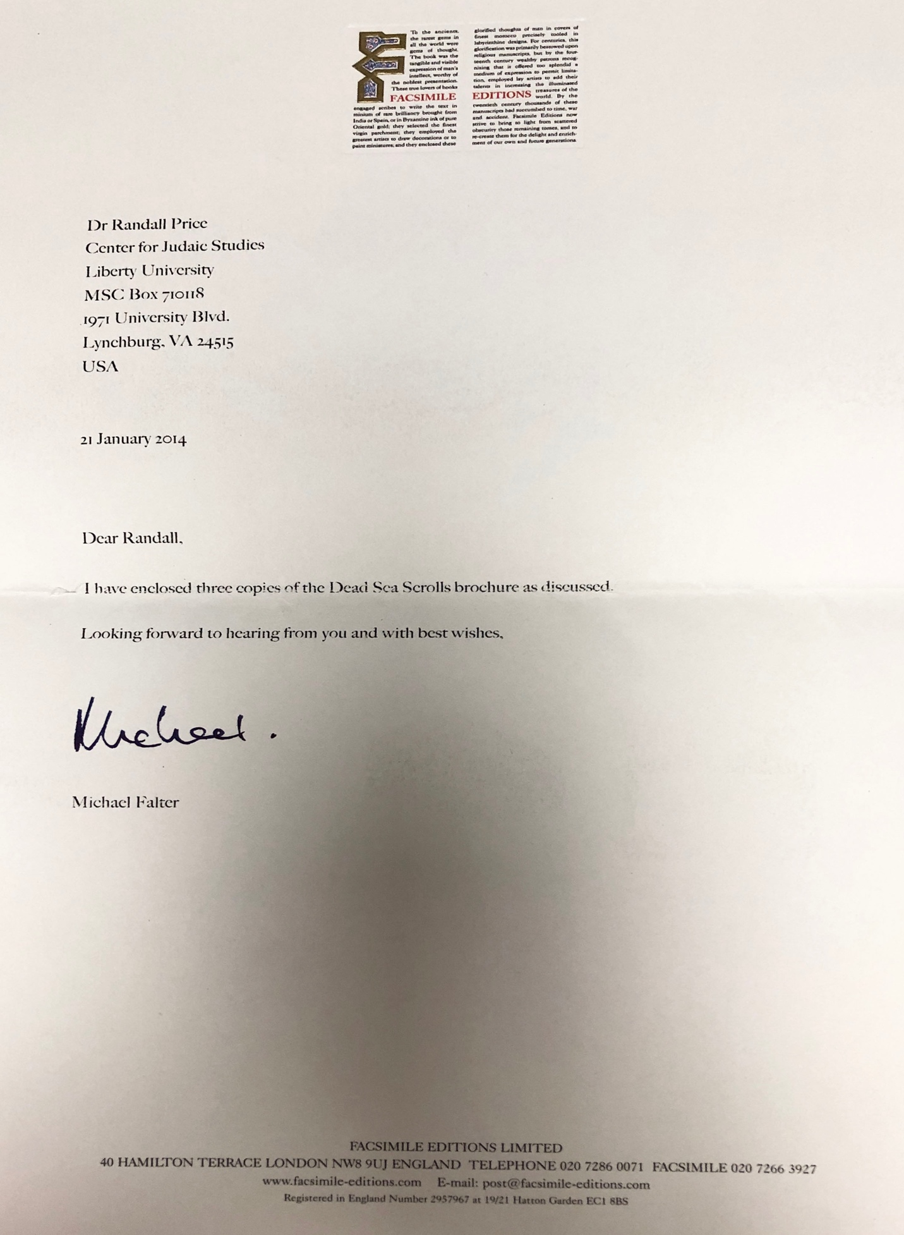

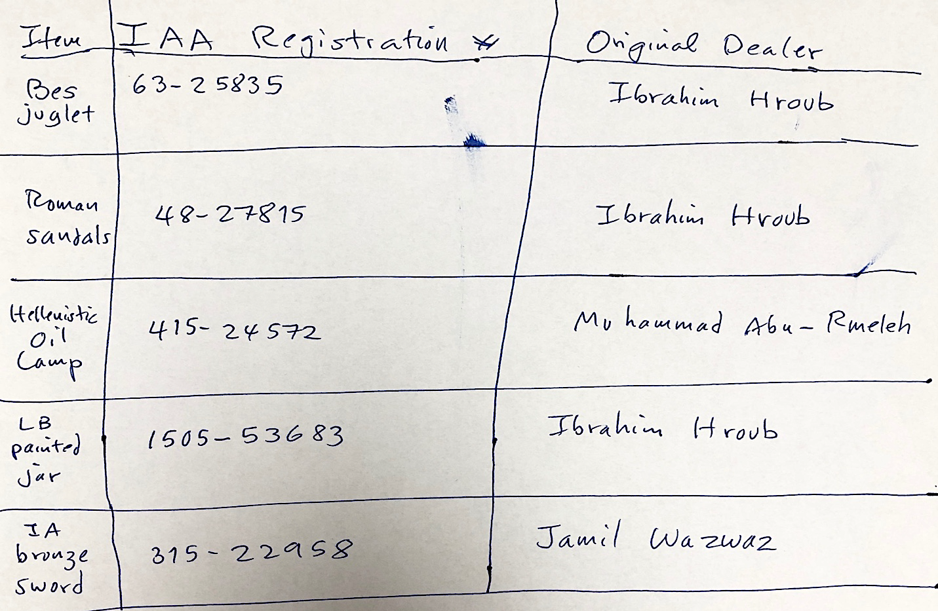

These are the IAA registration numbers and names of original sellers to Fares Antiquities from their computer for Dr. price purchases. This is example of care given by Fares Antiquities.

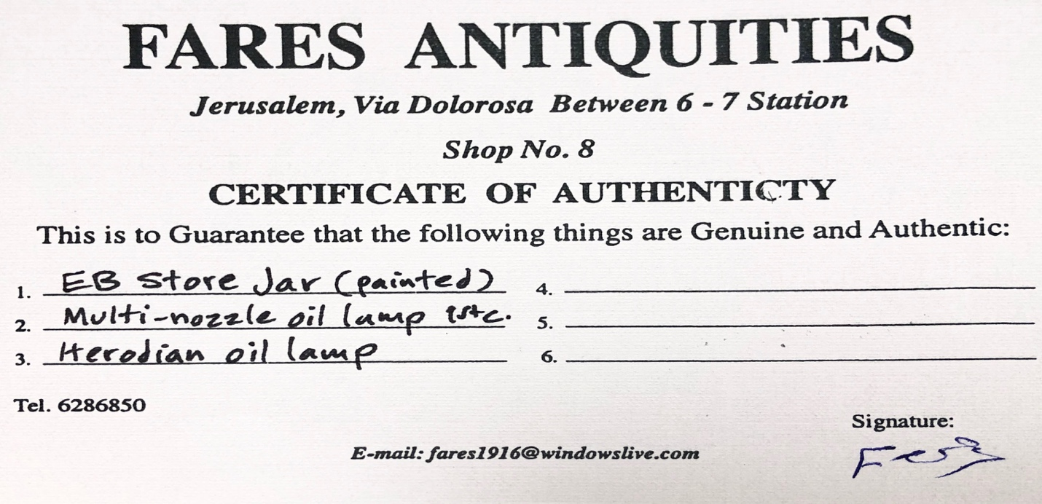

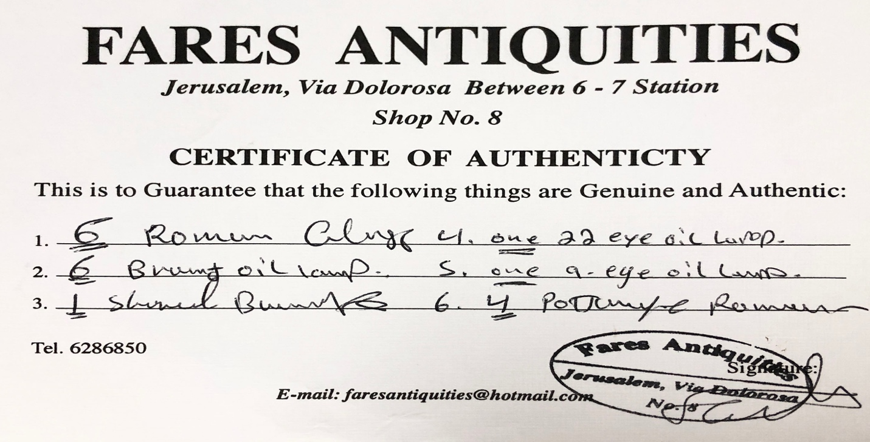
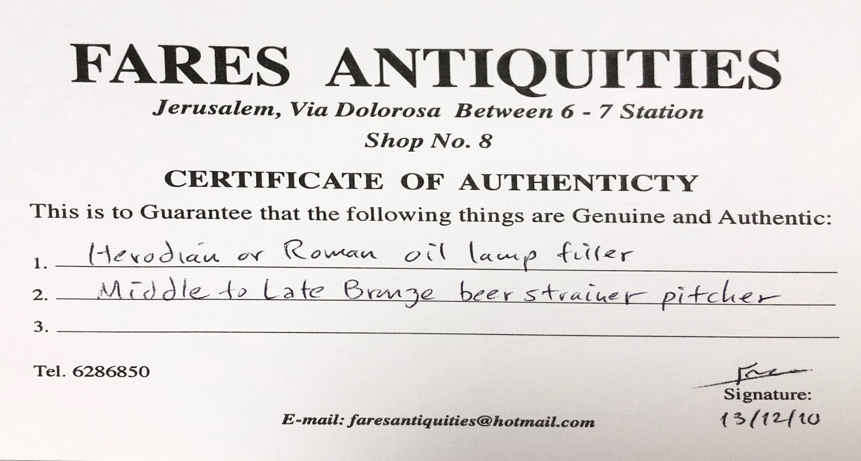

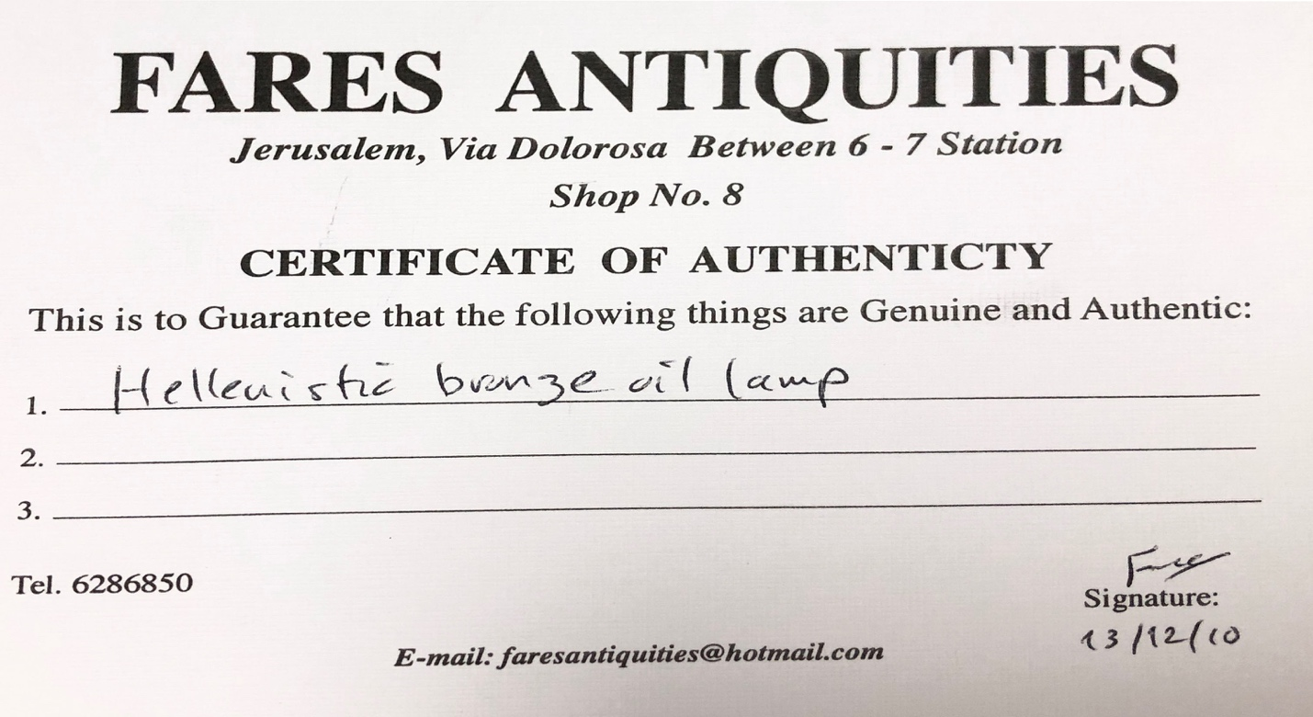
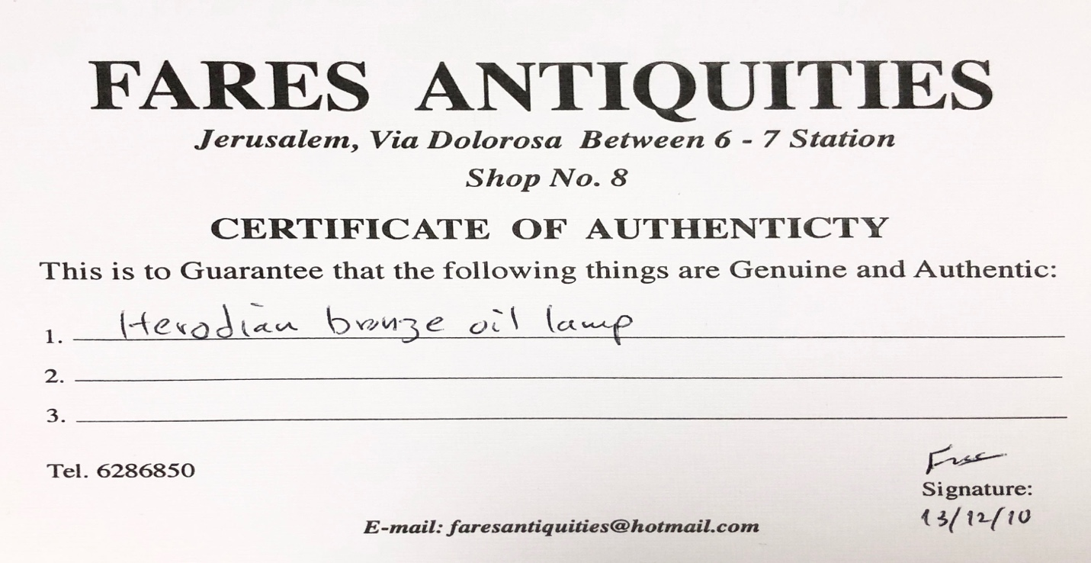

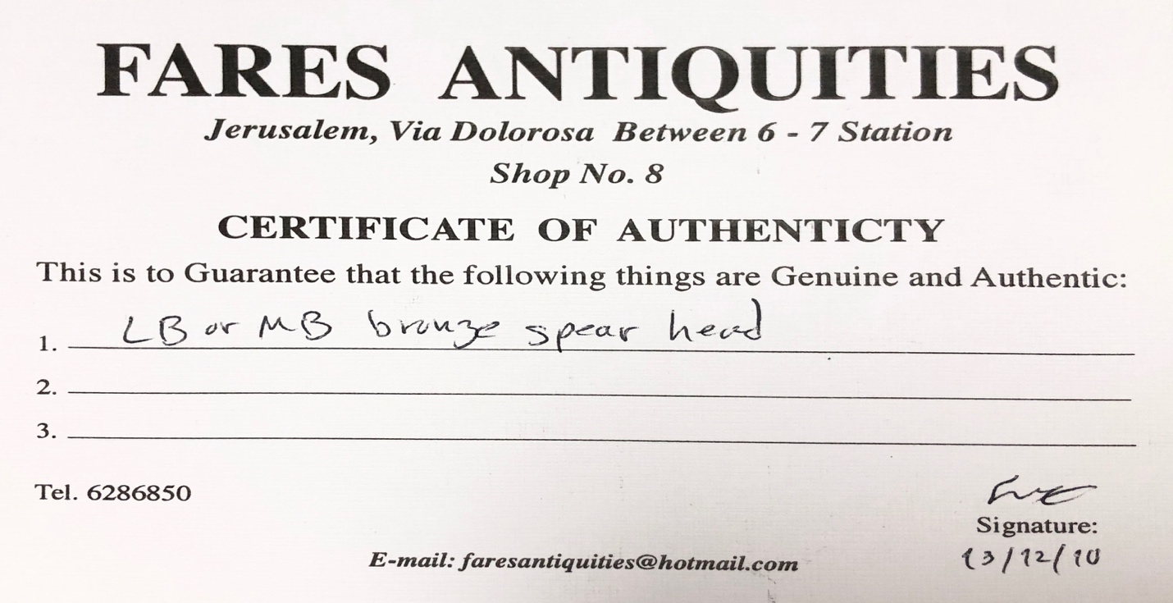

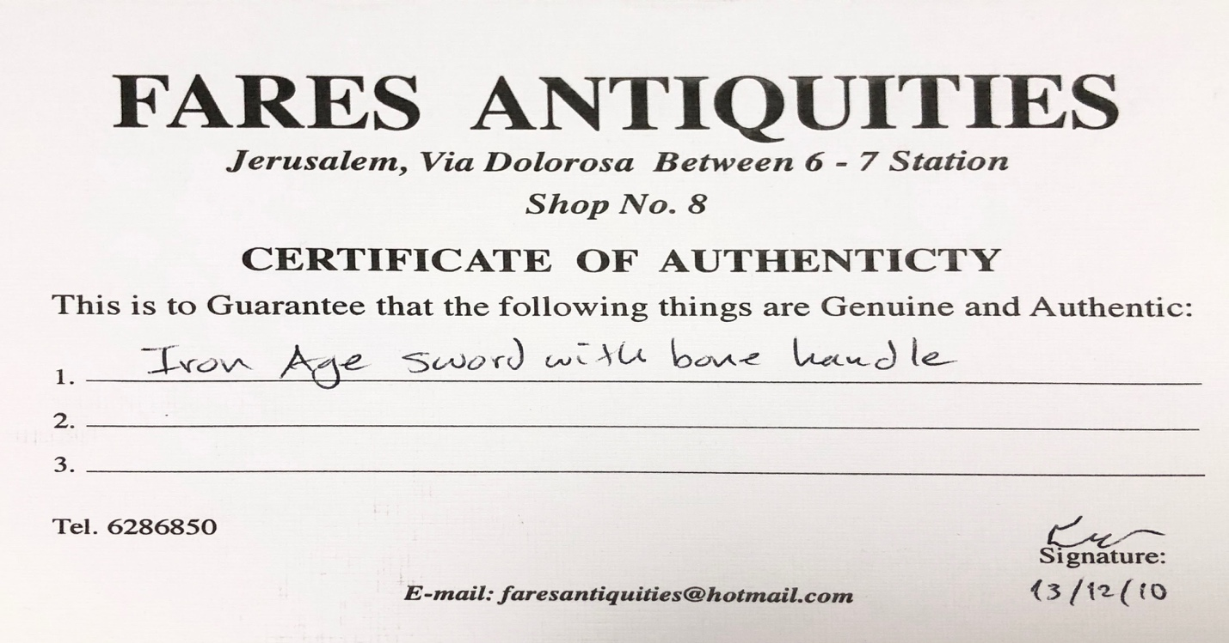

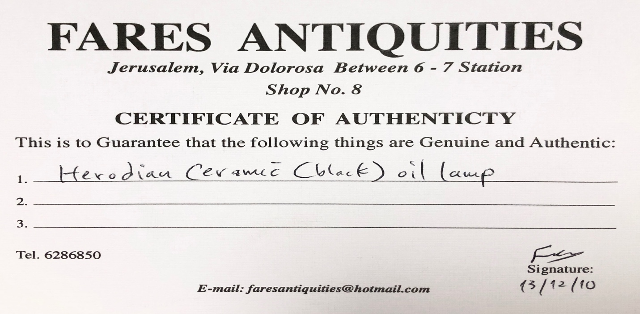
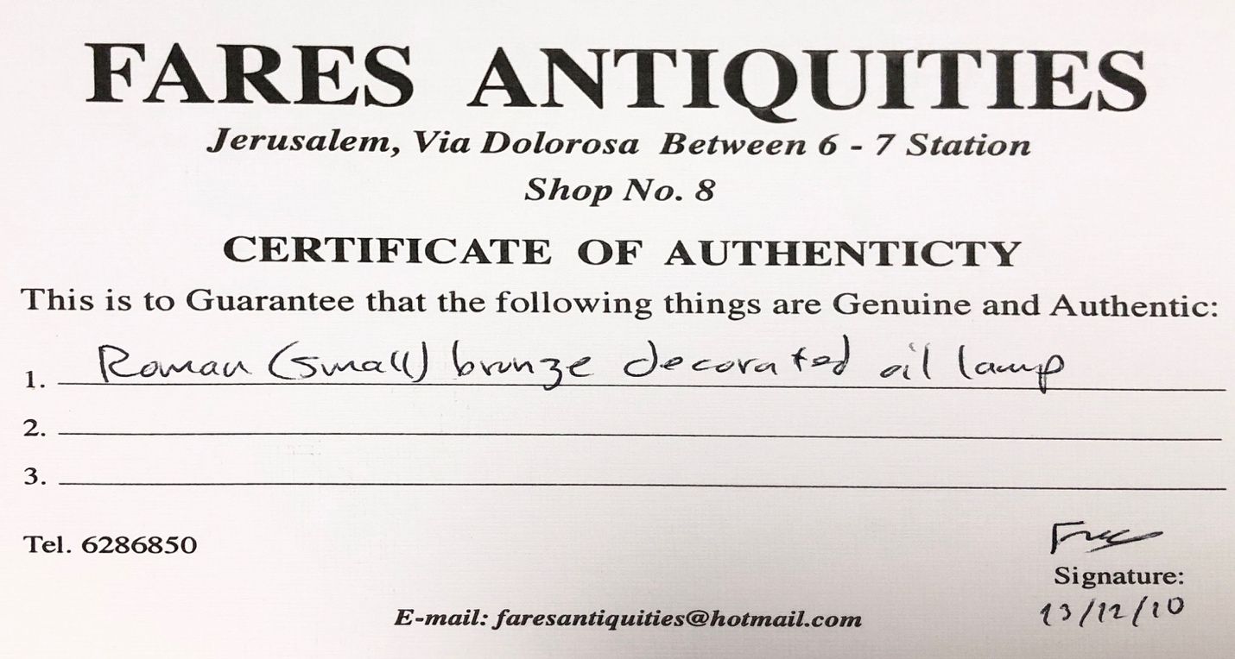

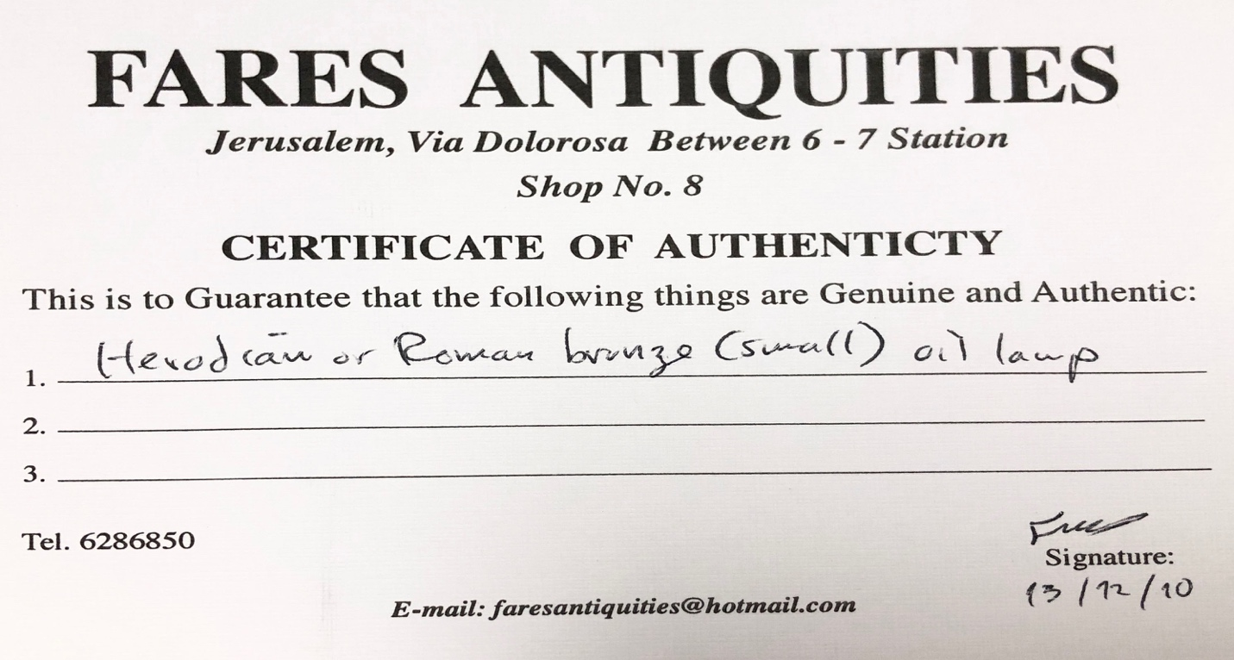
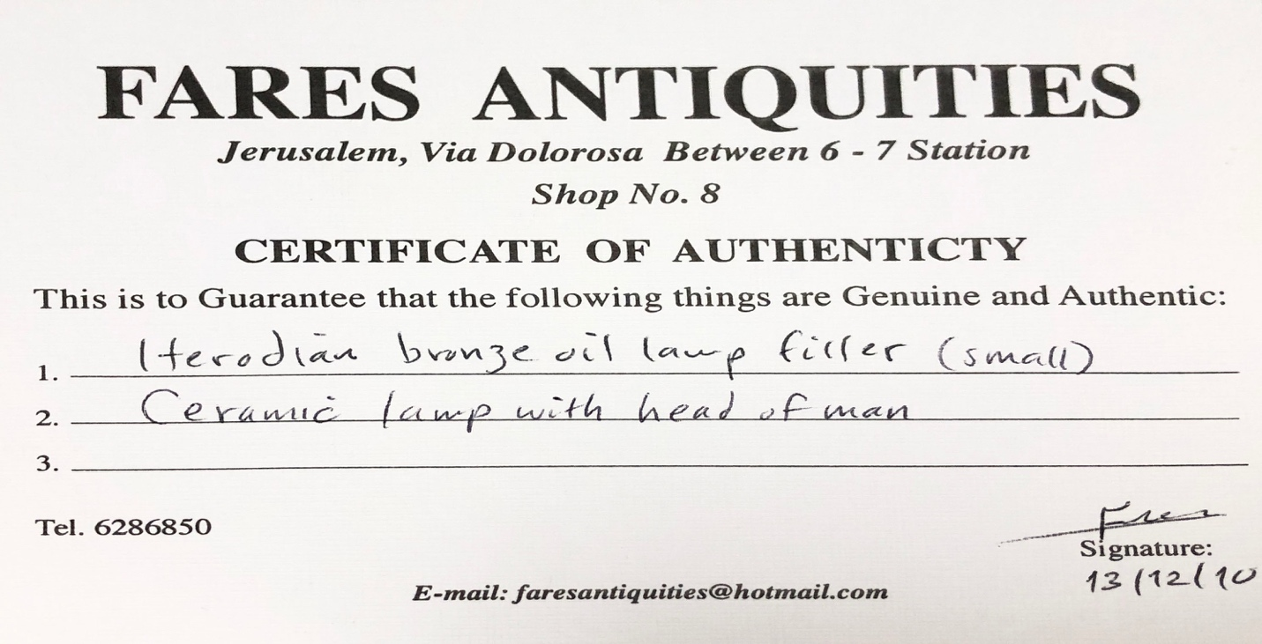

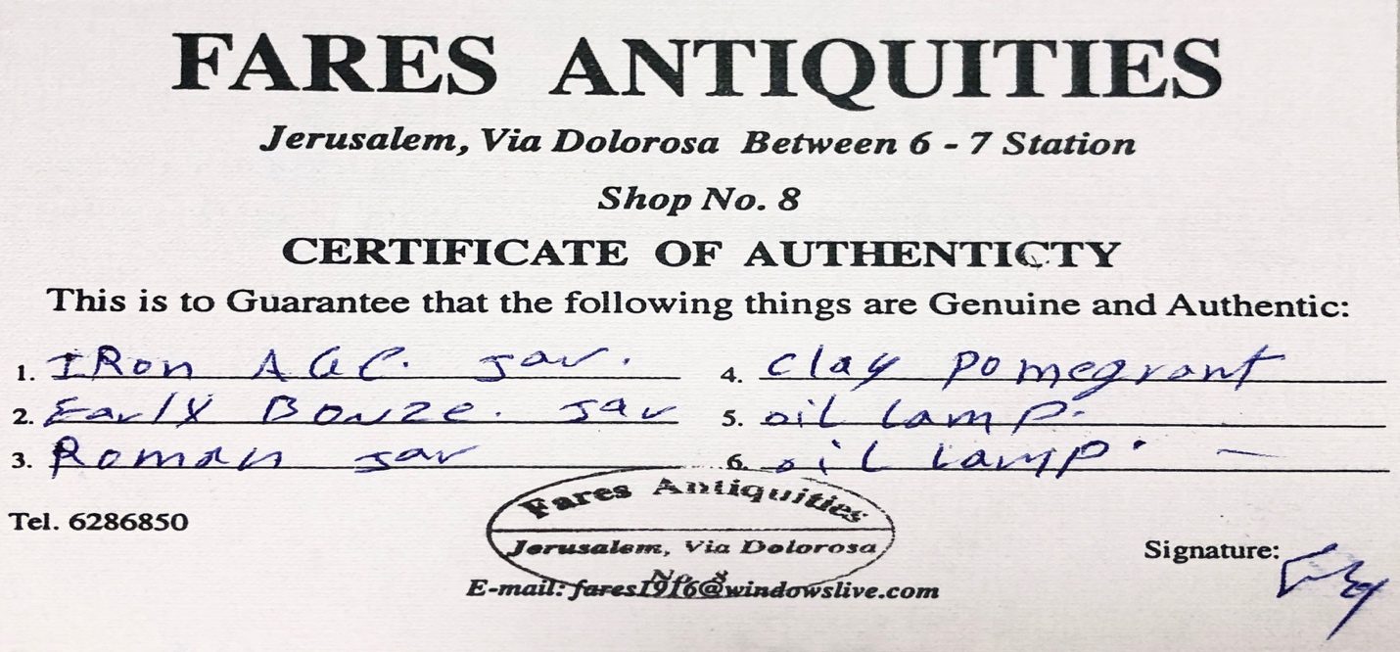

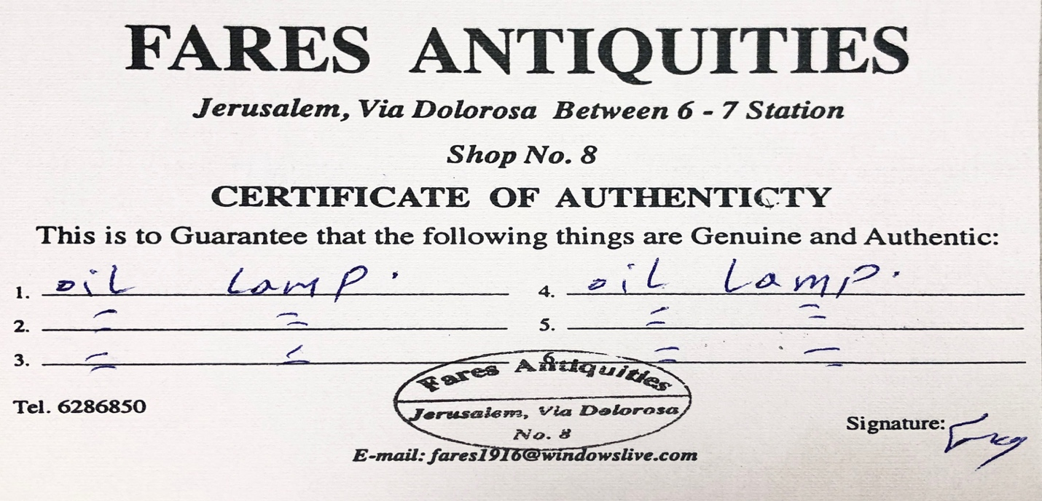

Transportation of Roman helmet (later returned for refund)
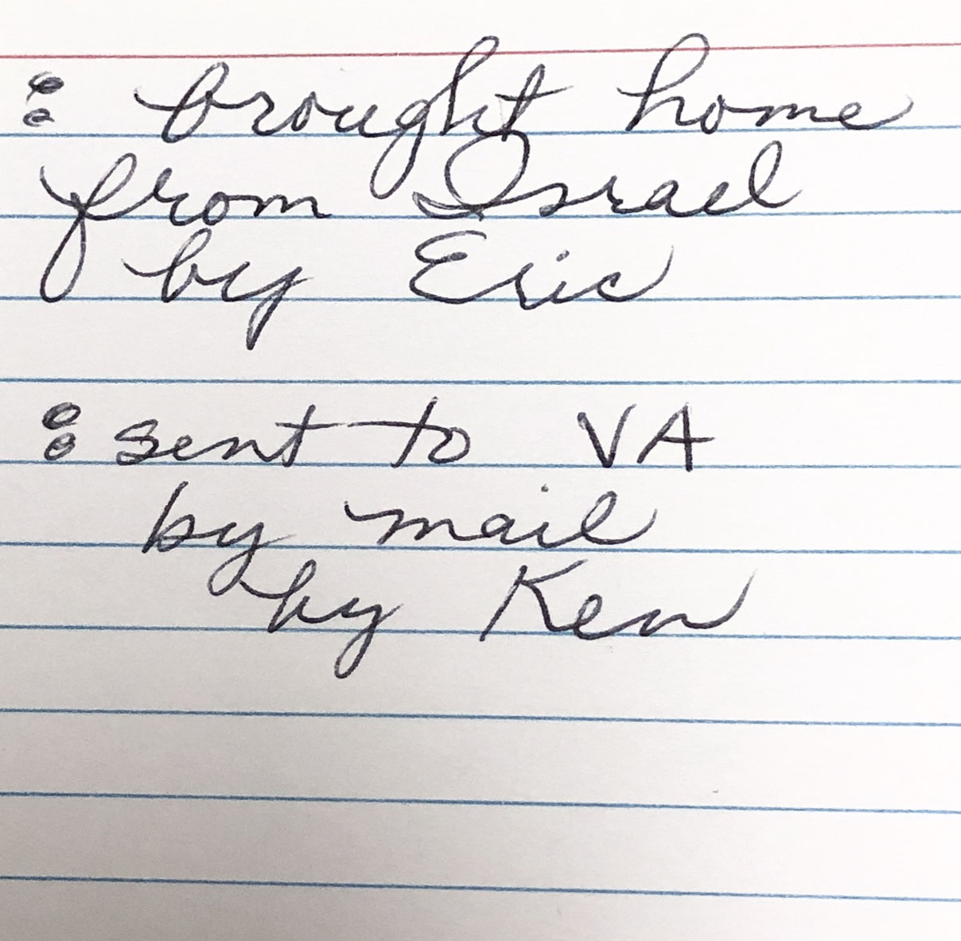

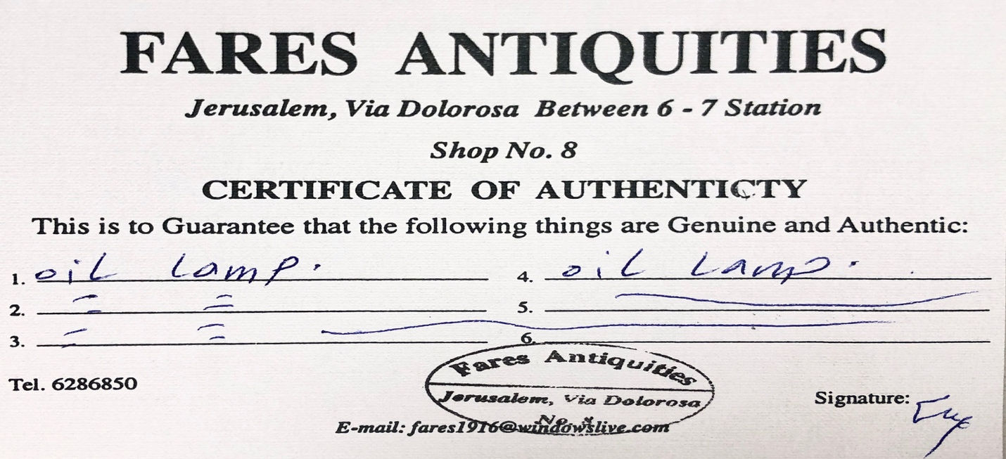
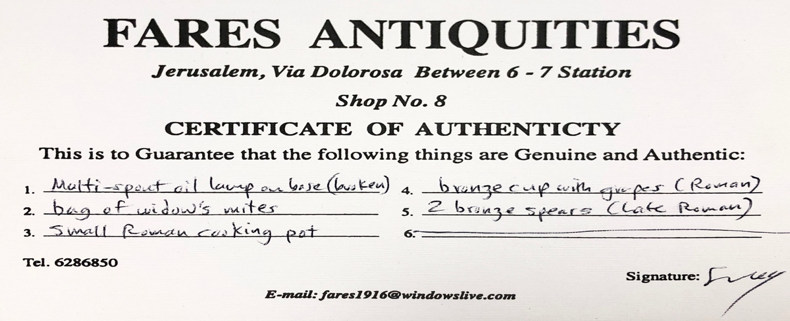

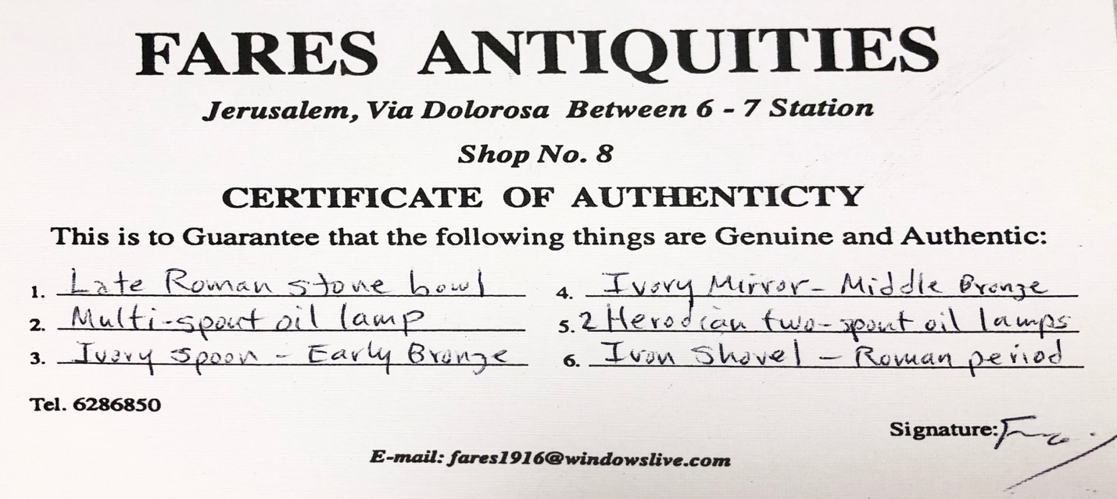

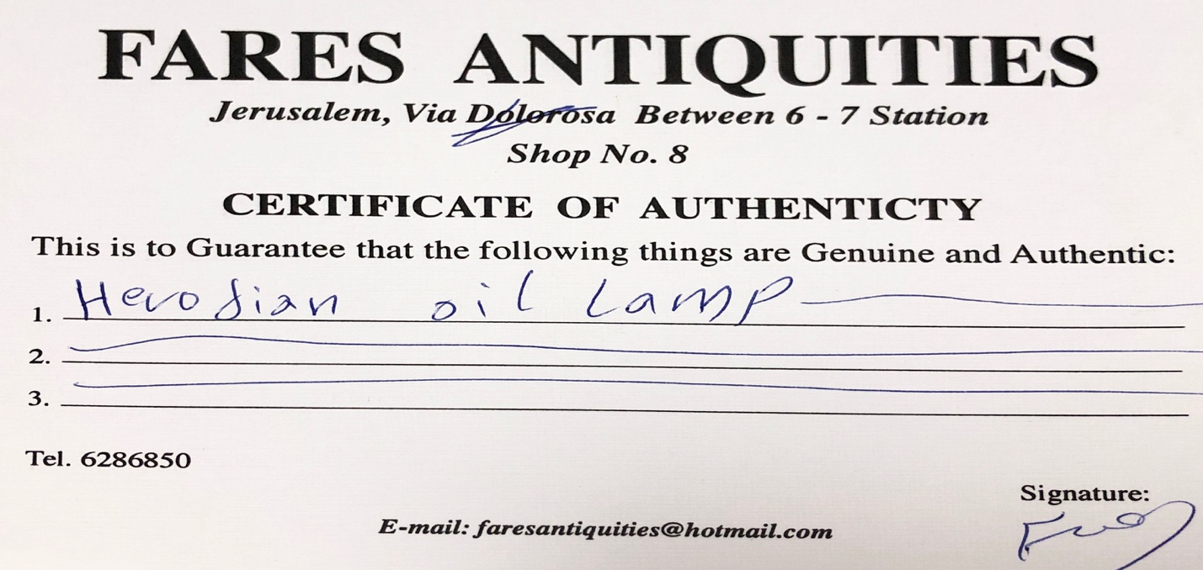
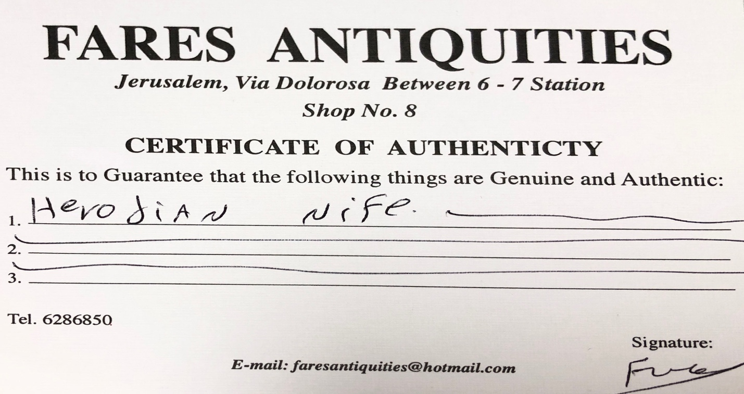

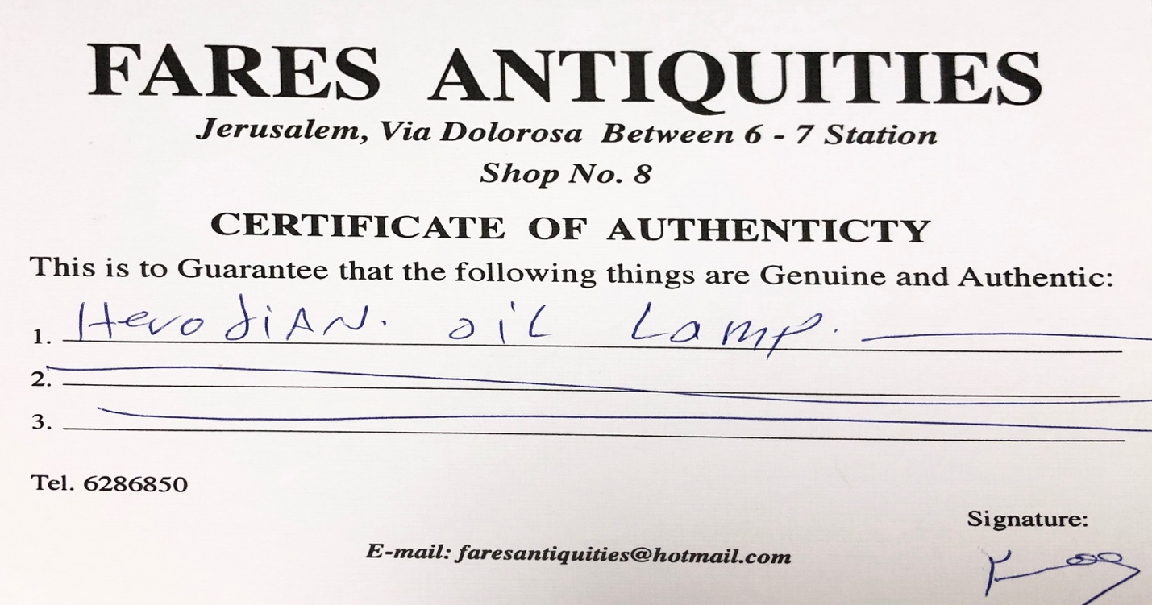
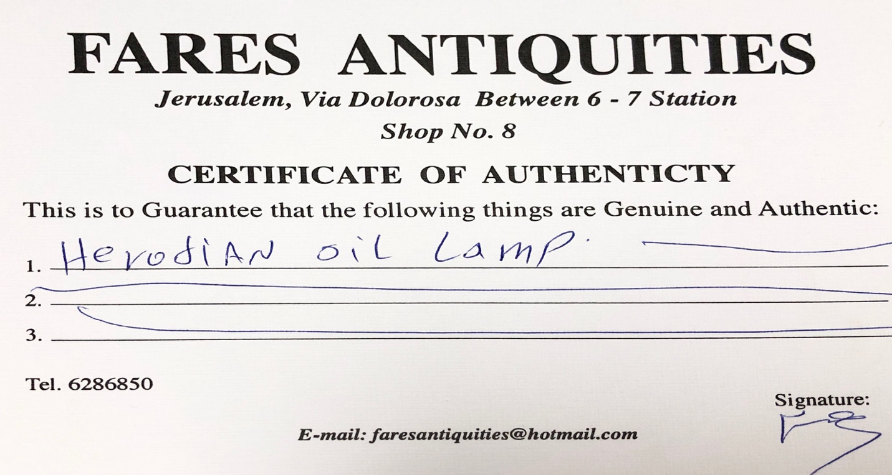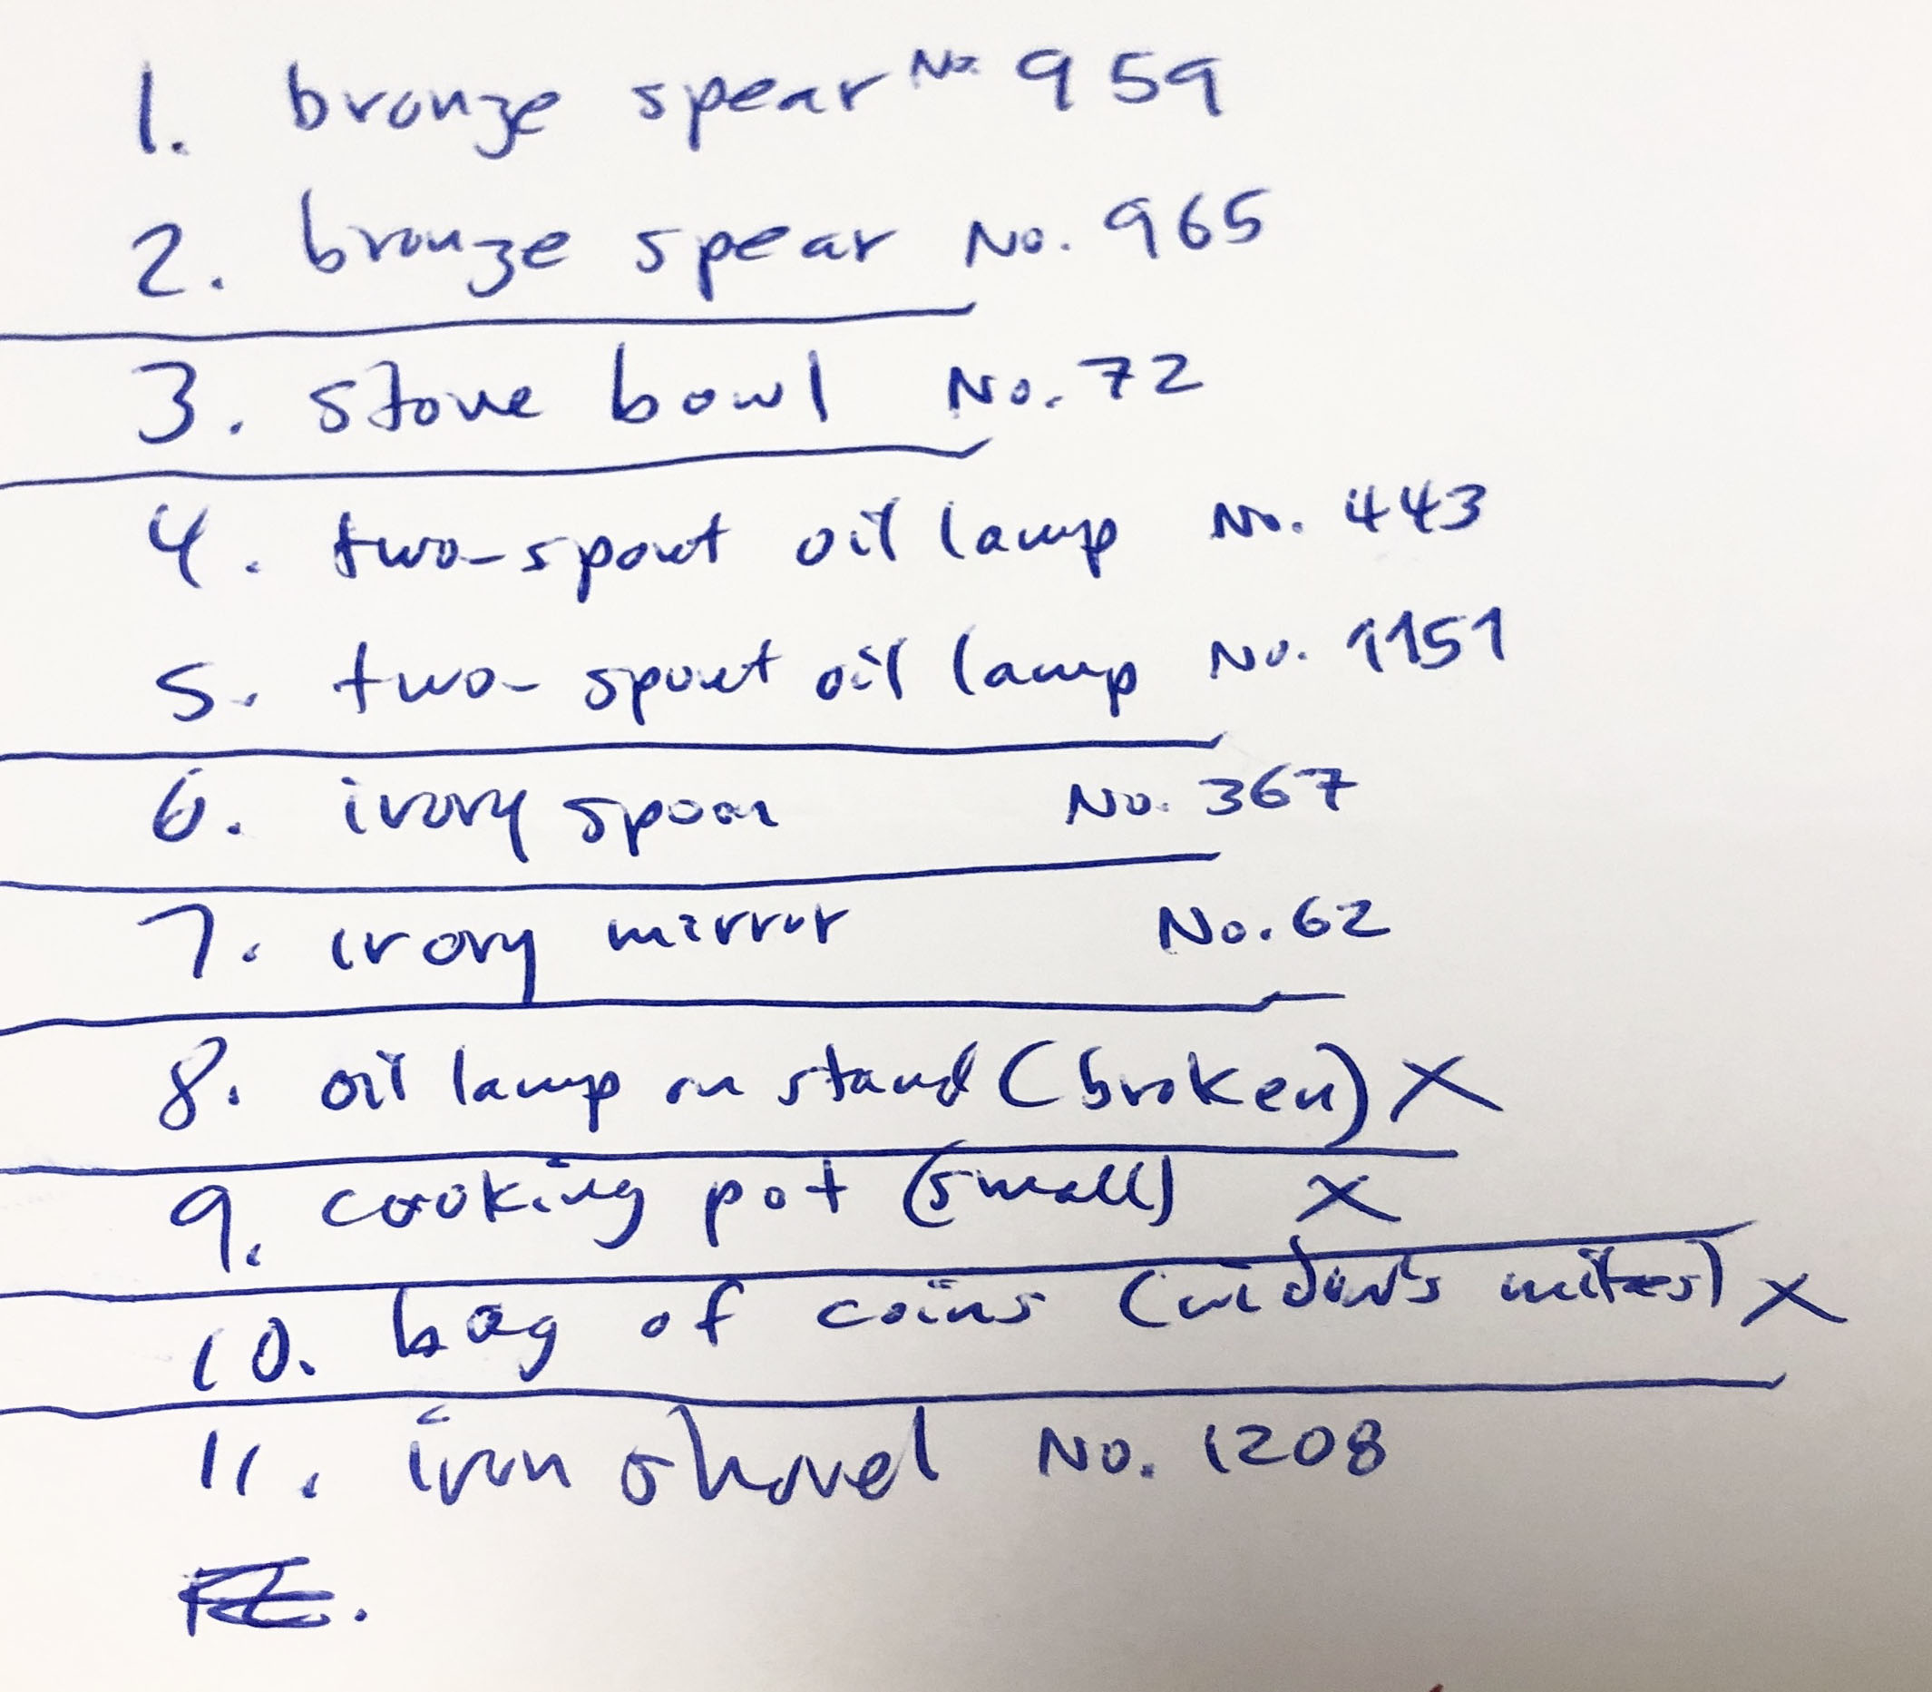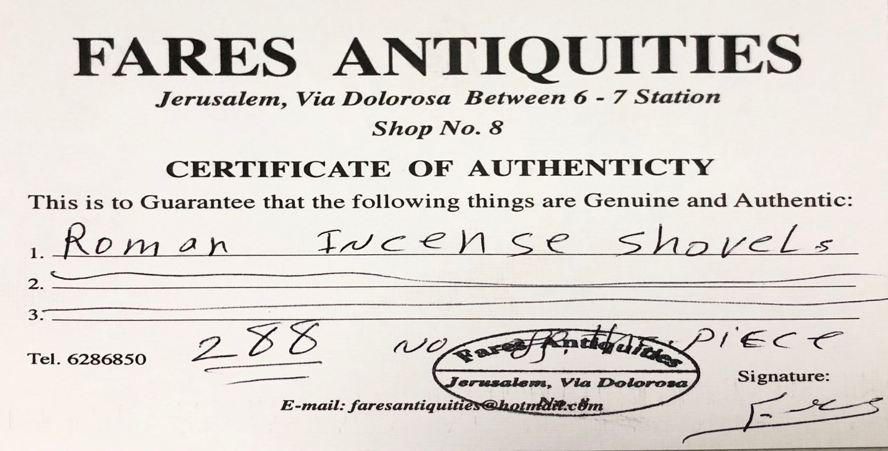

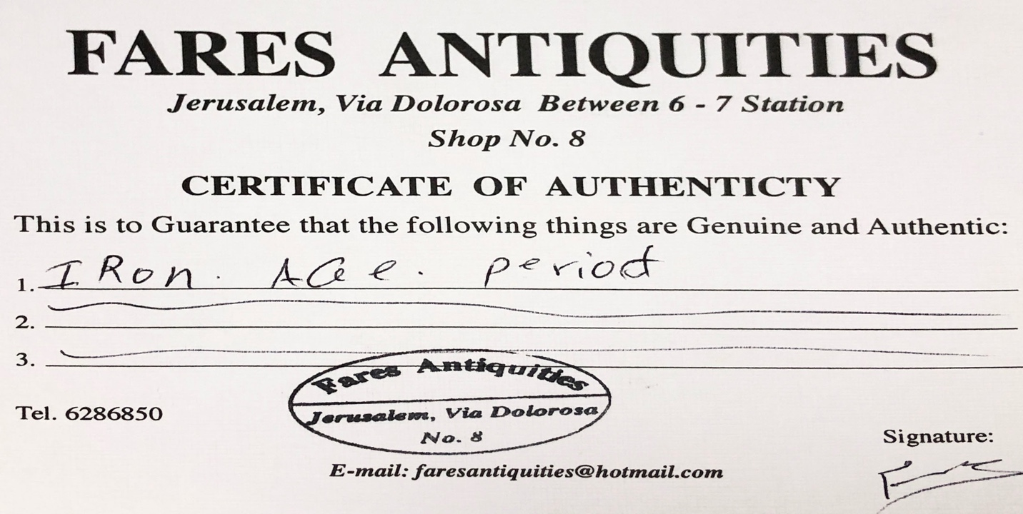
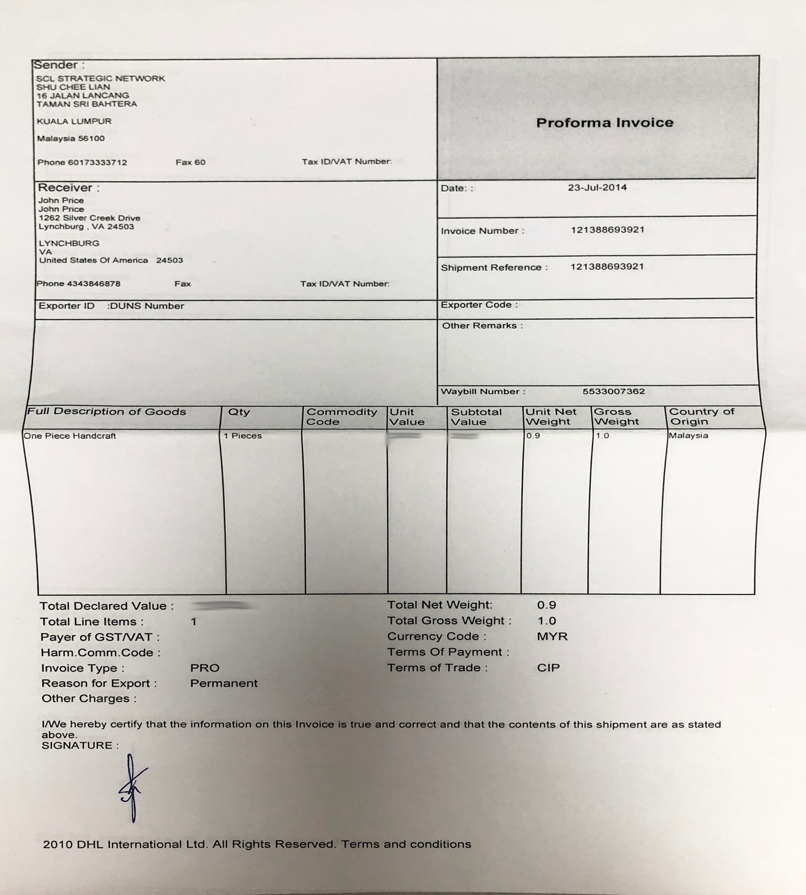

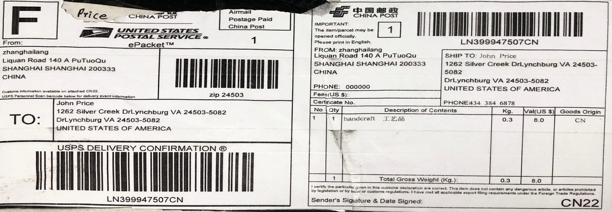
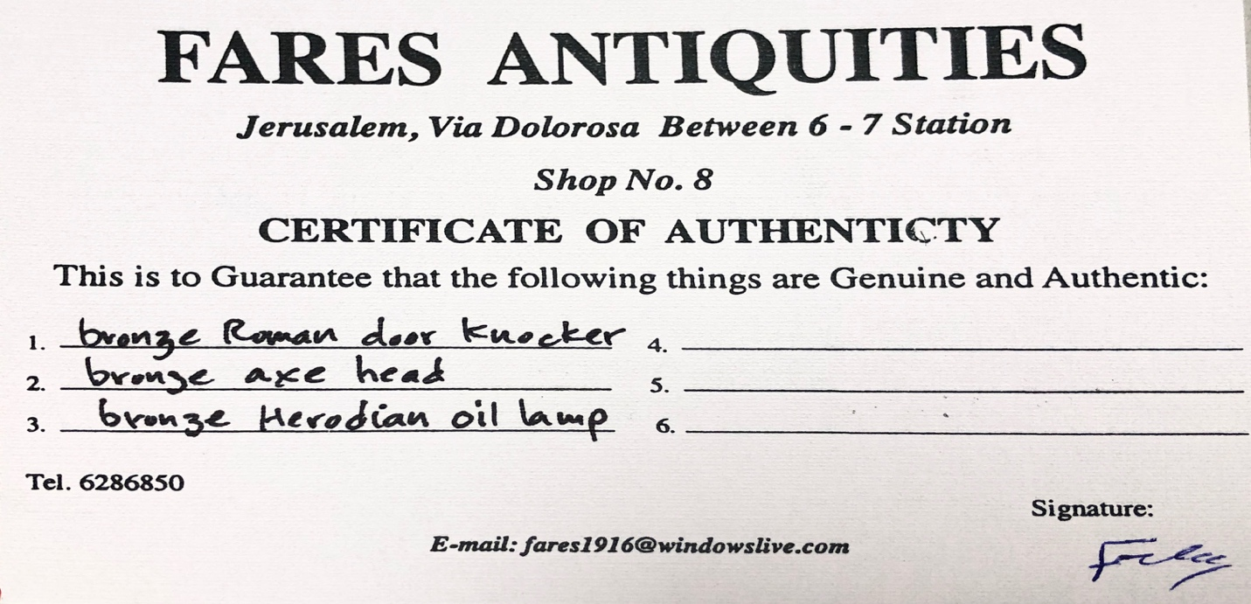

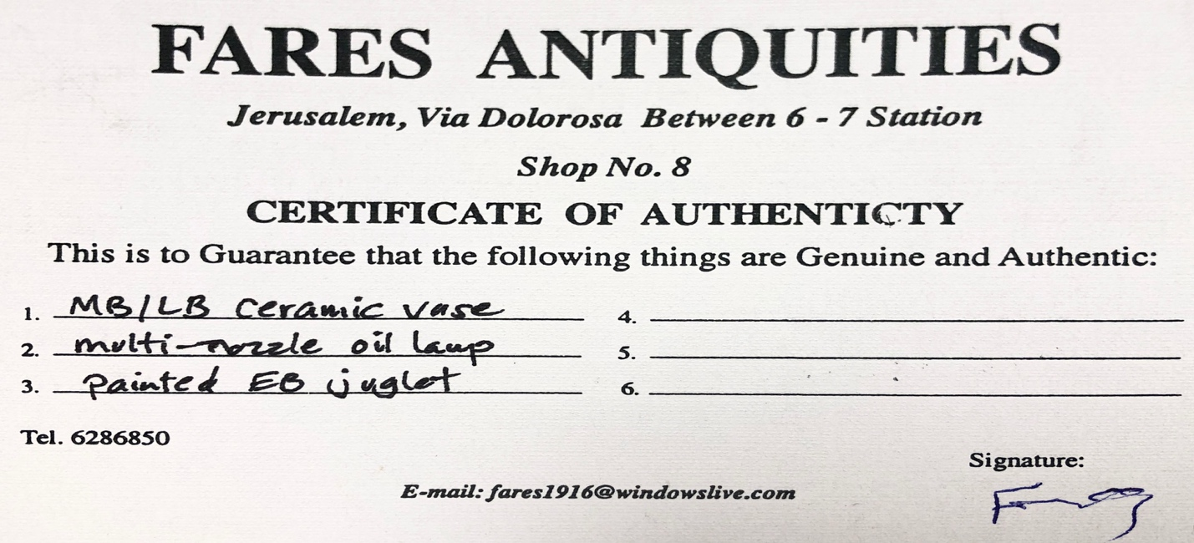

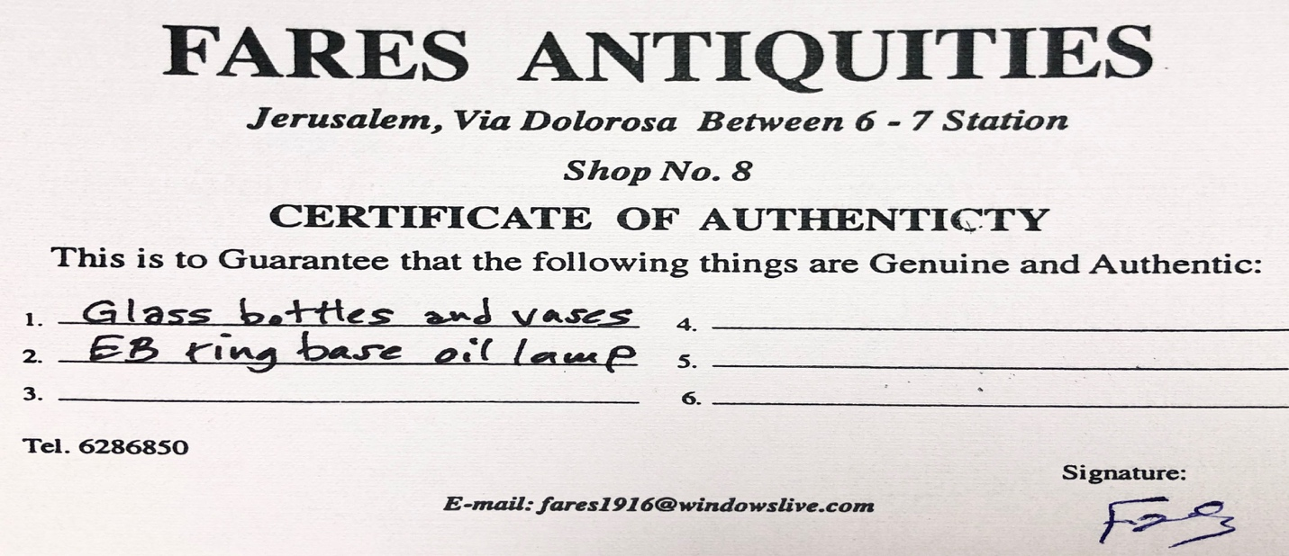
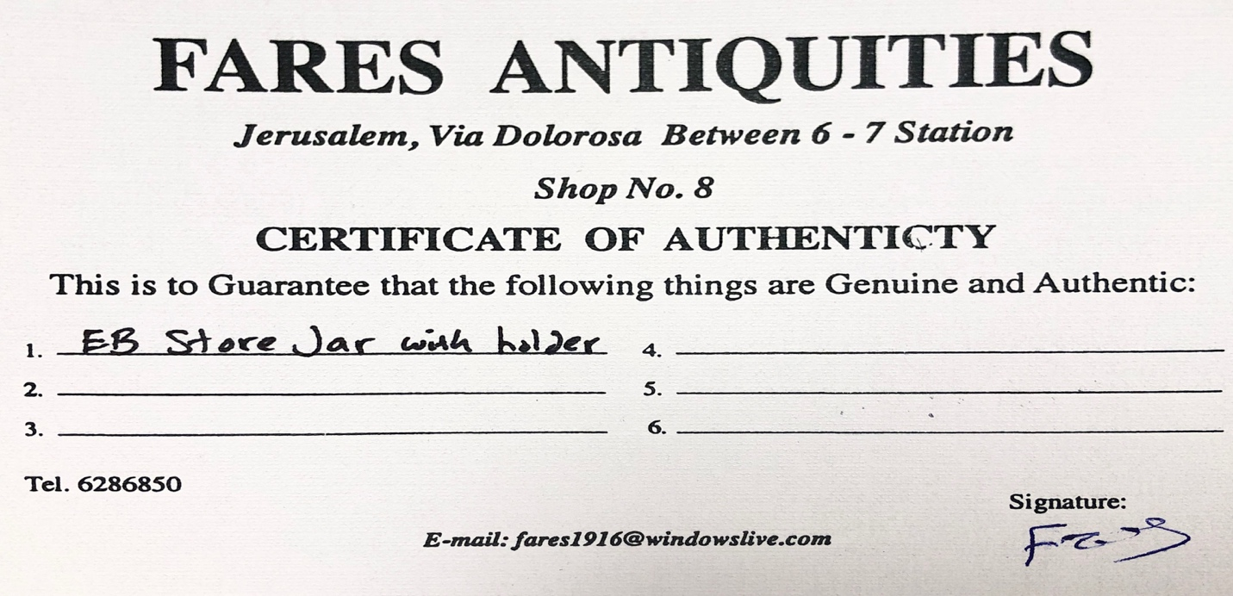

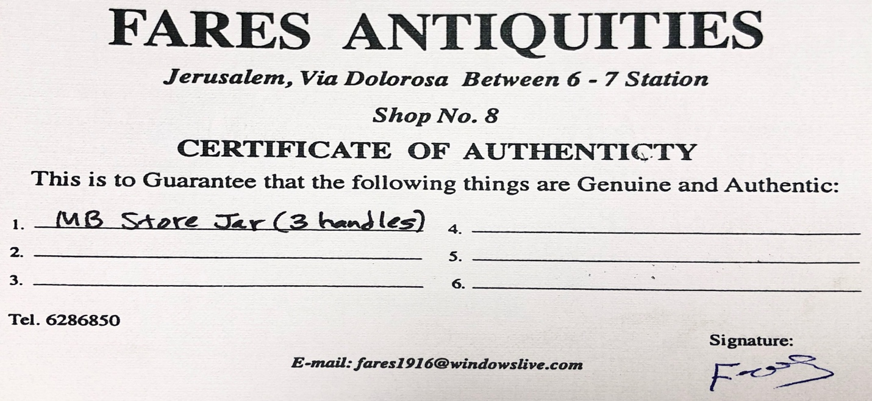

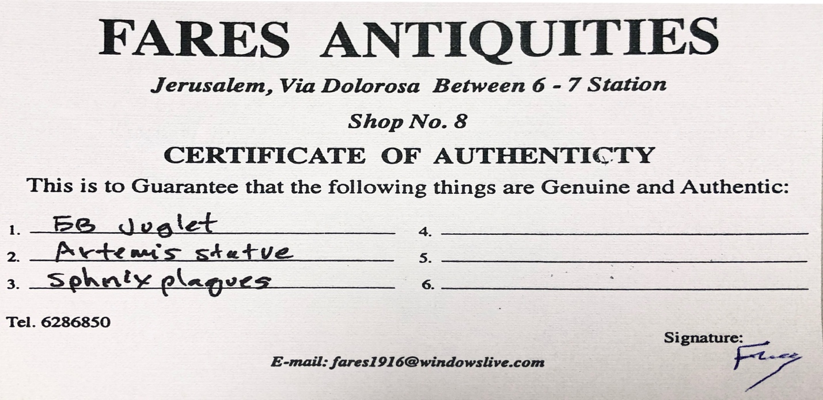
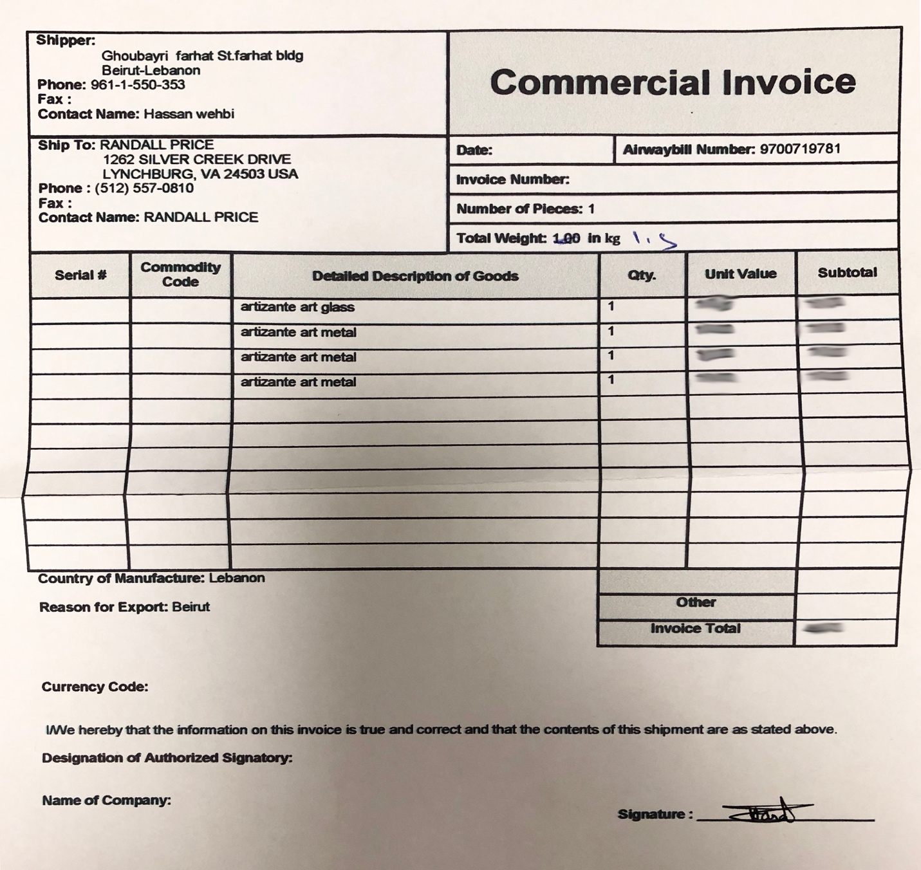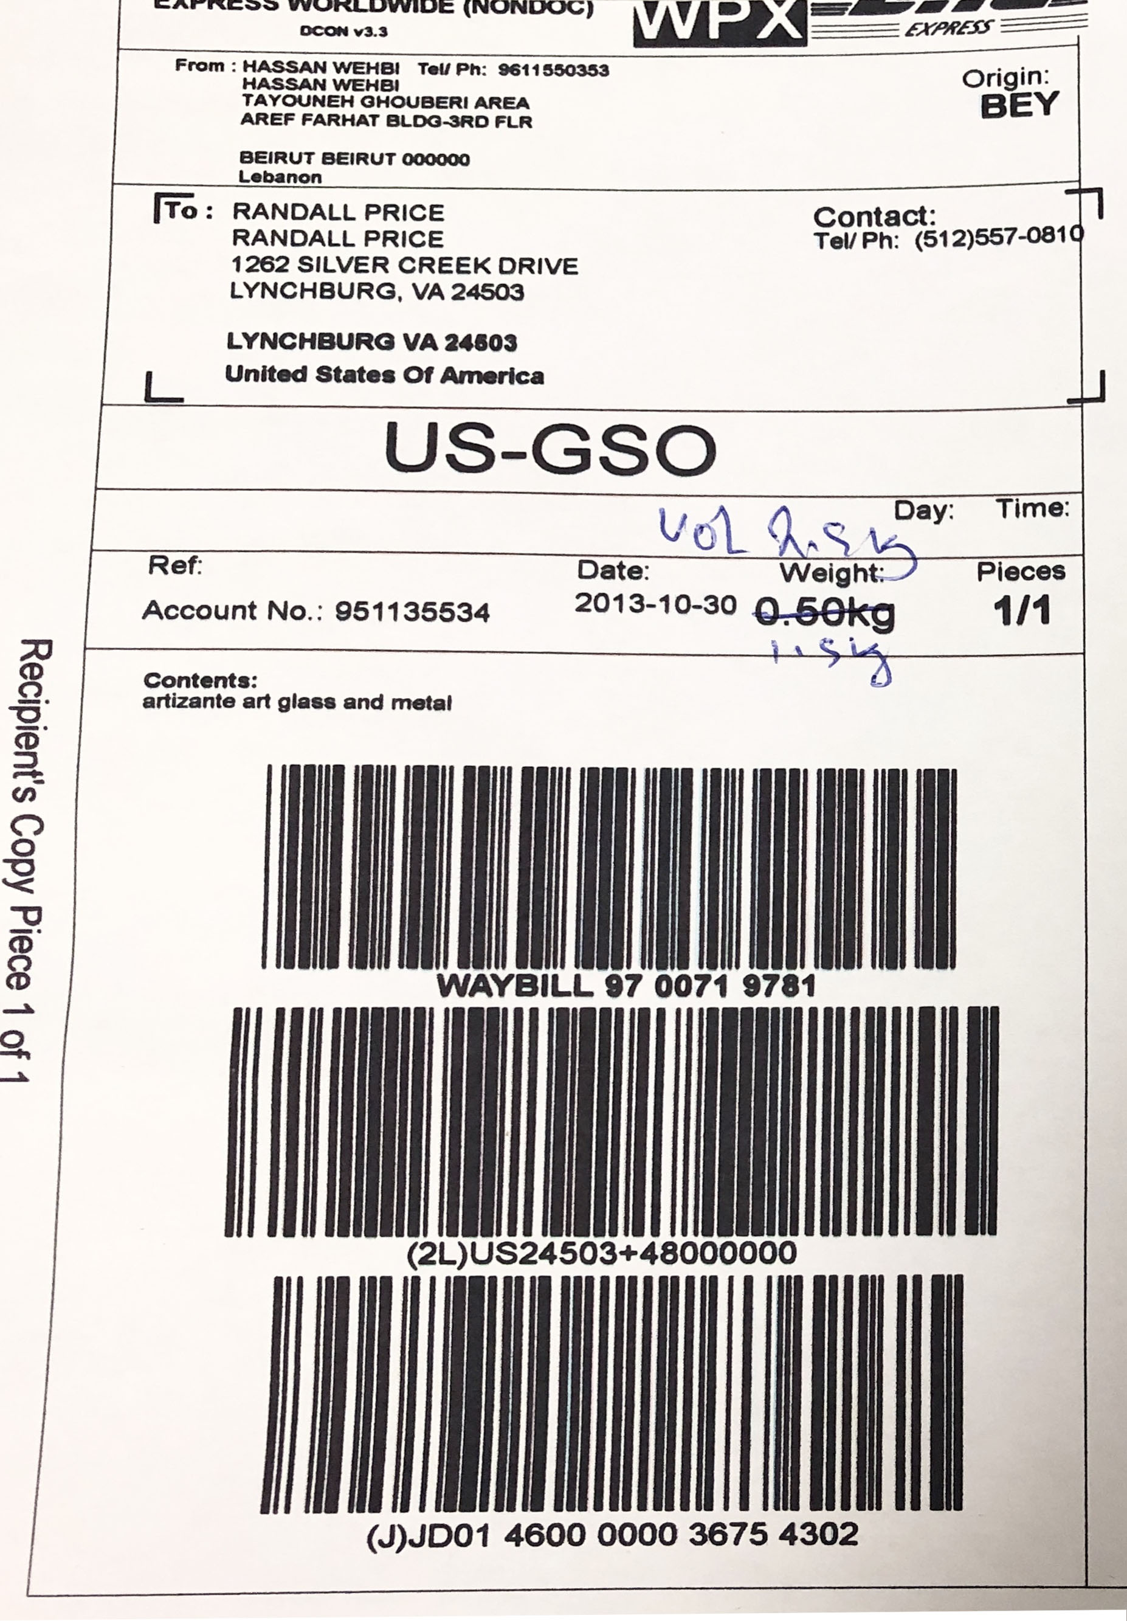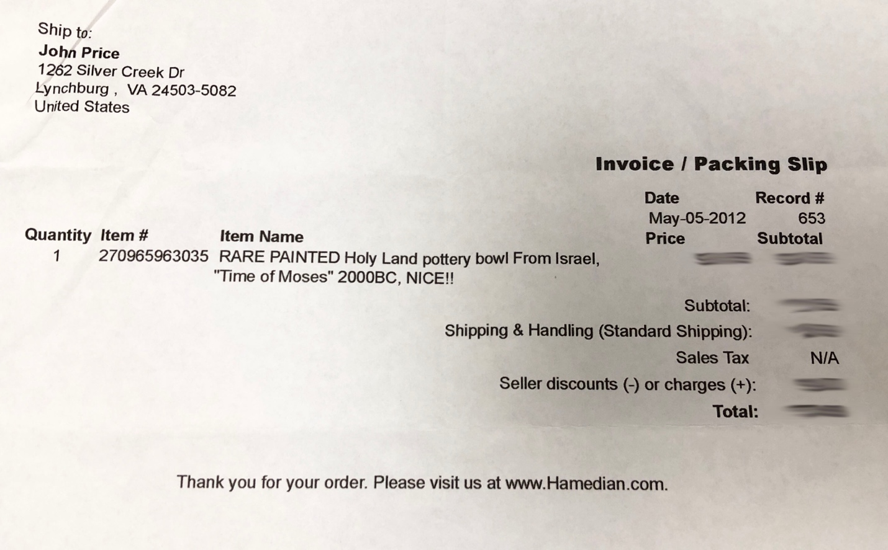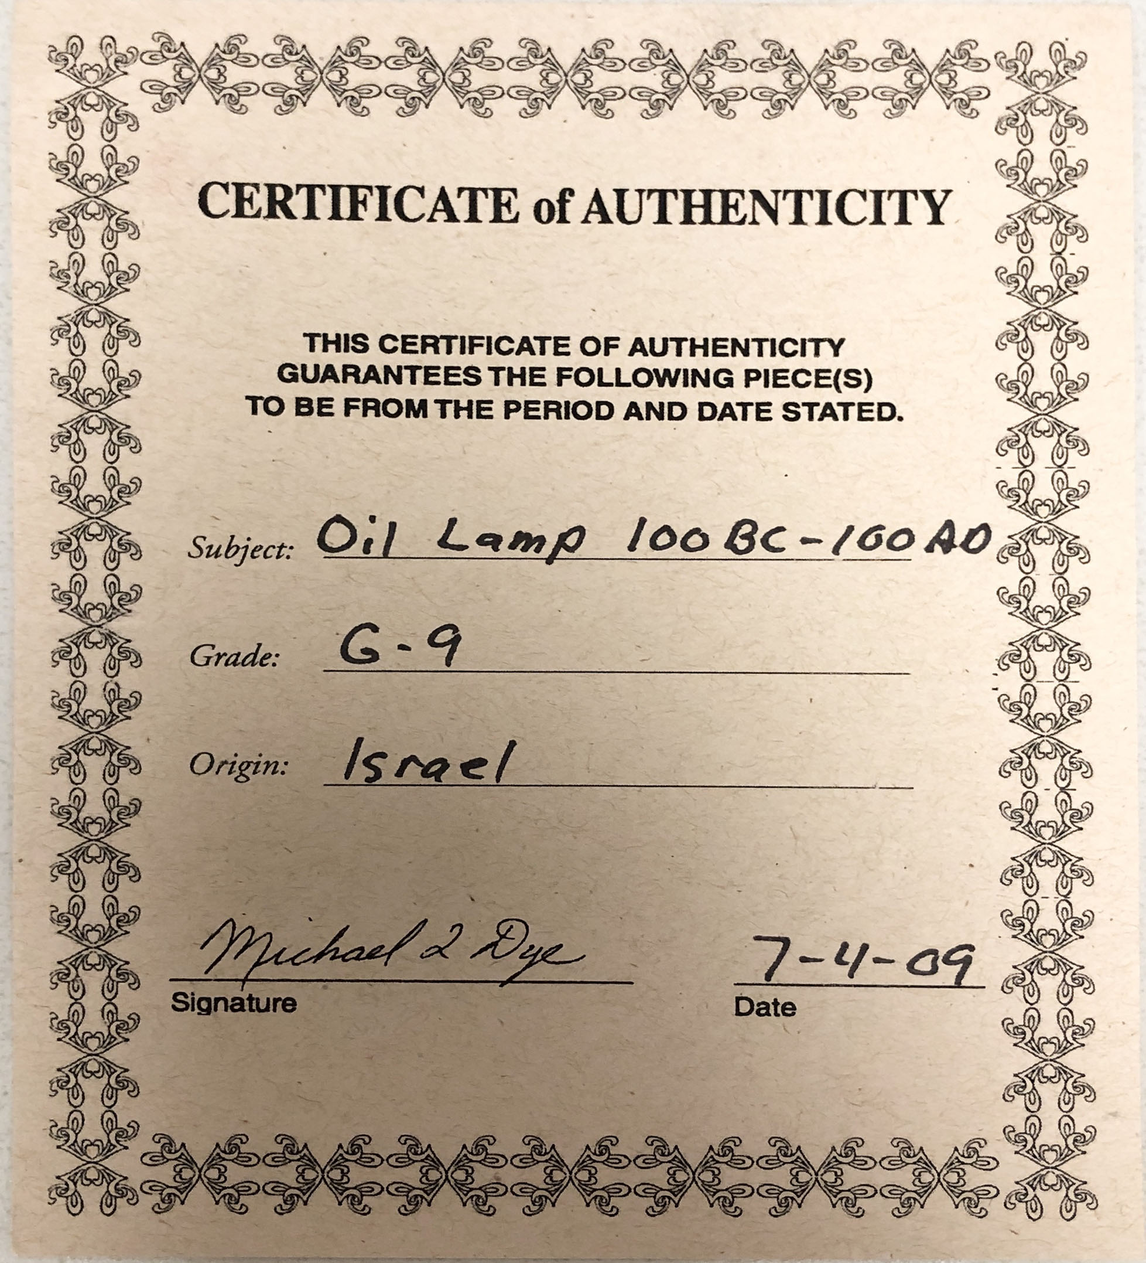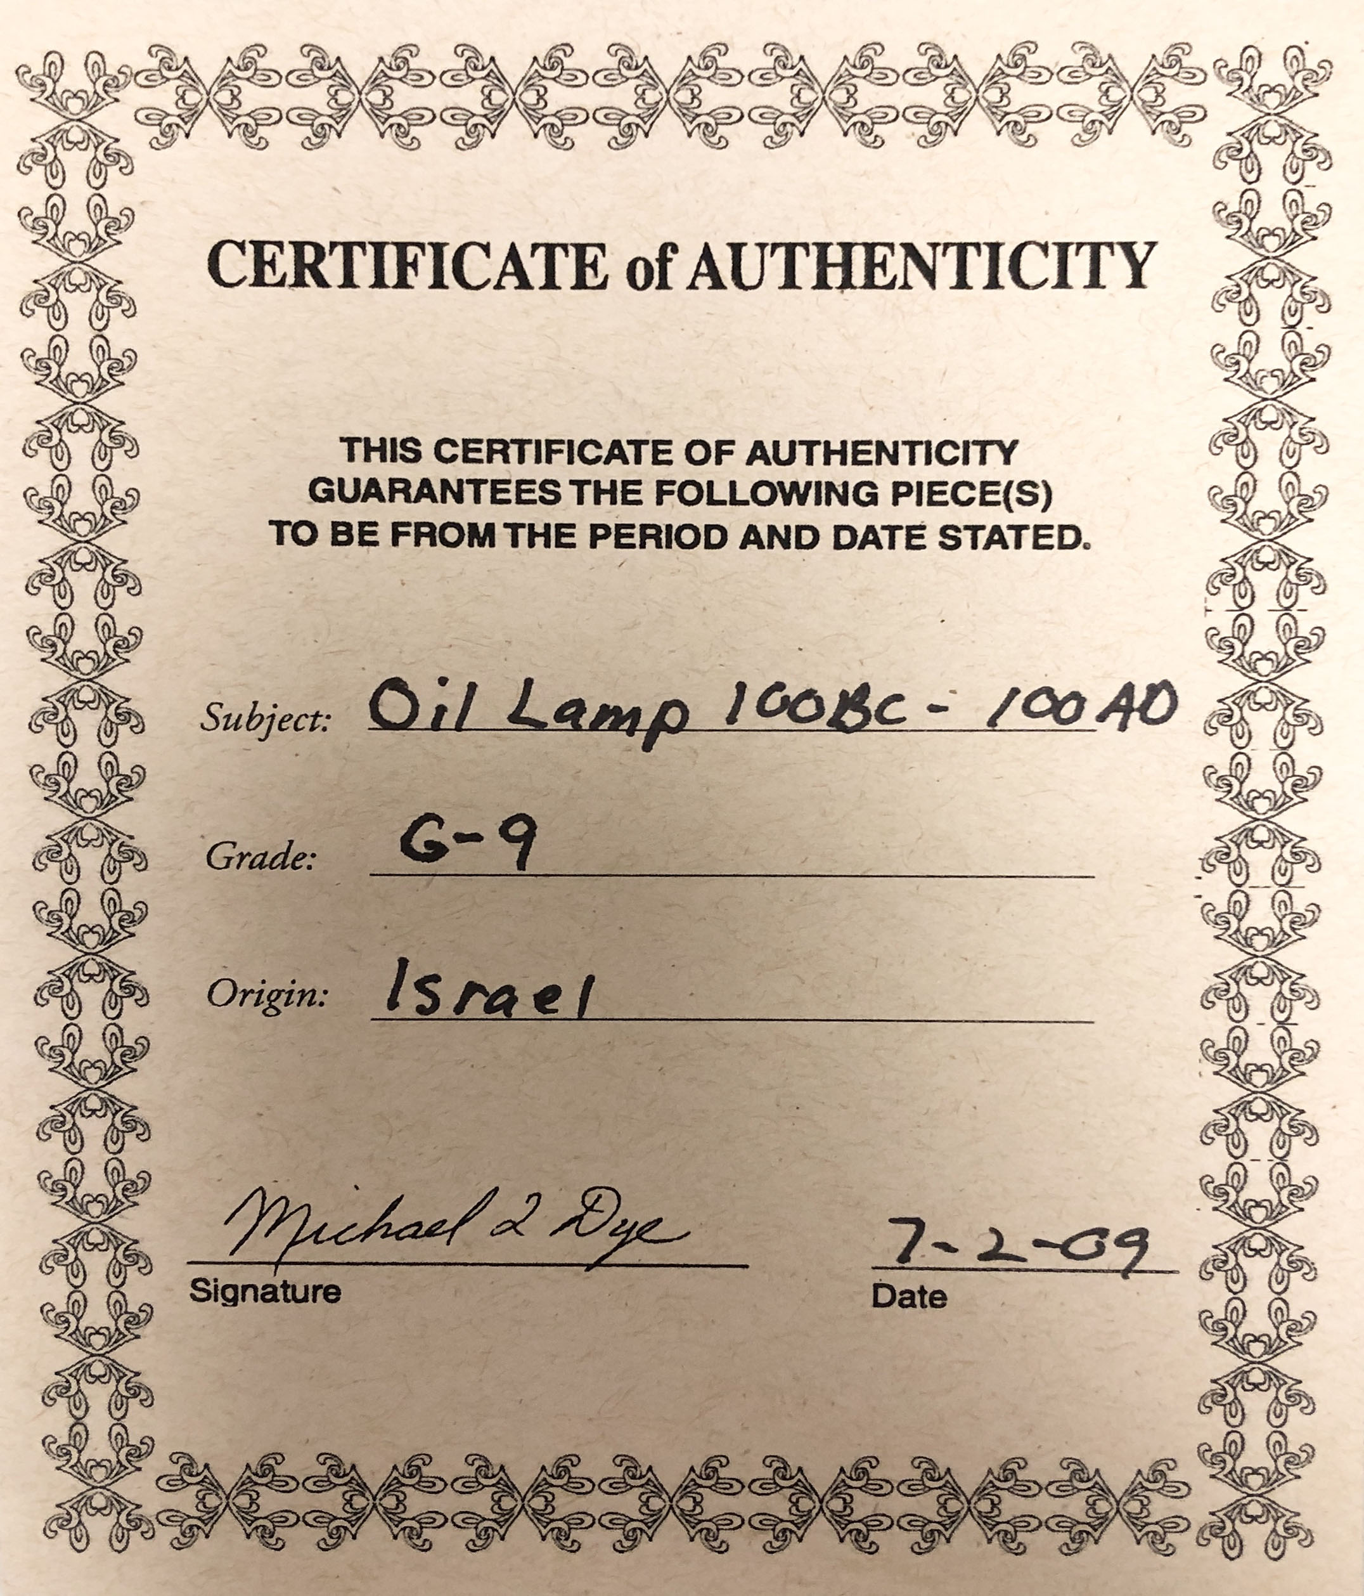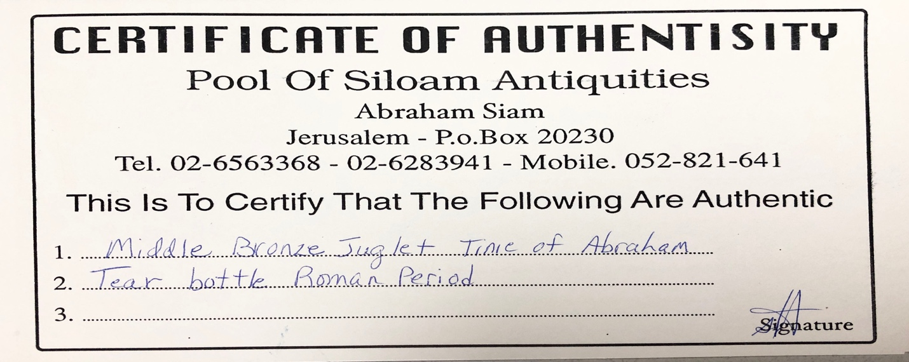

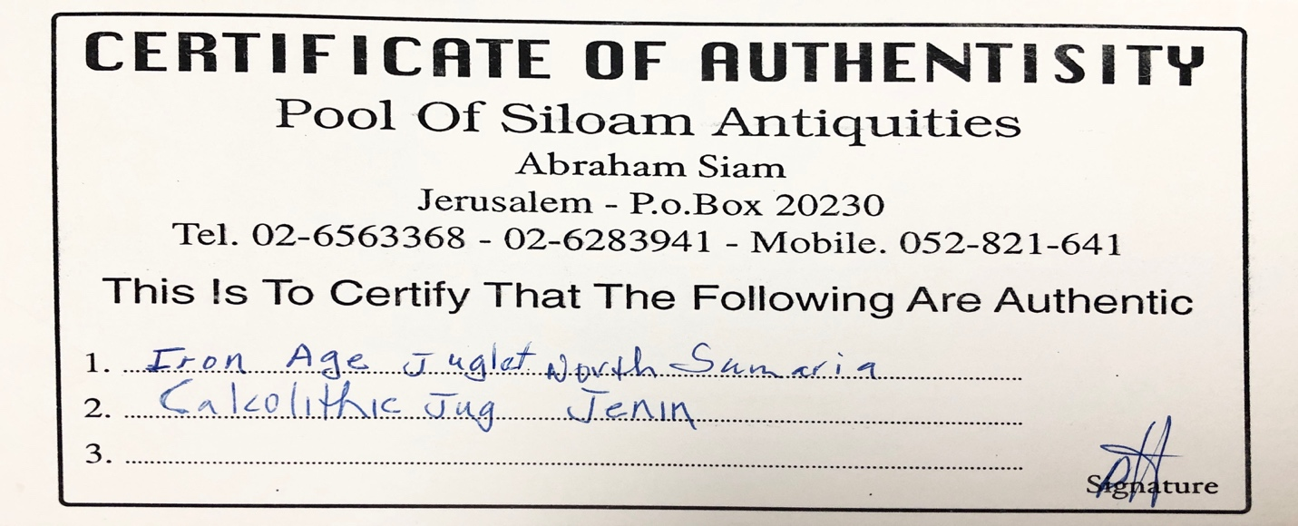

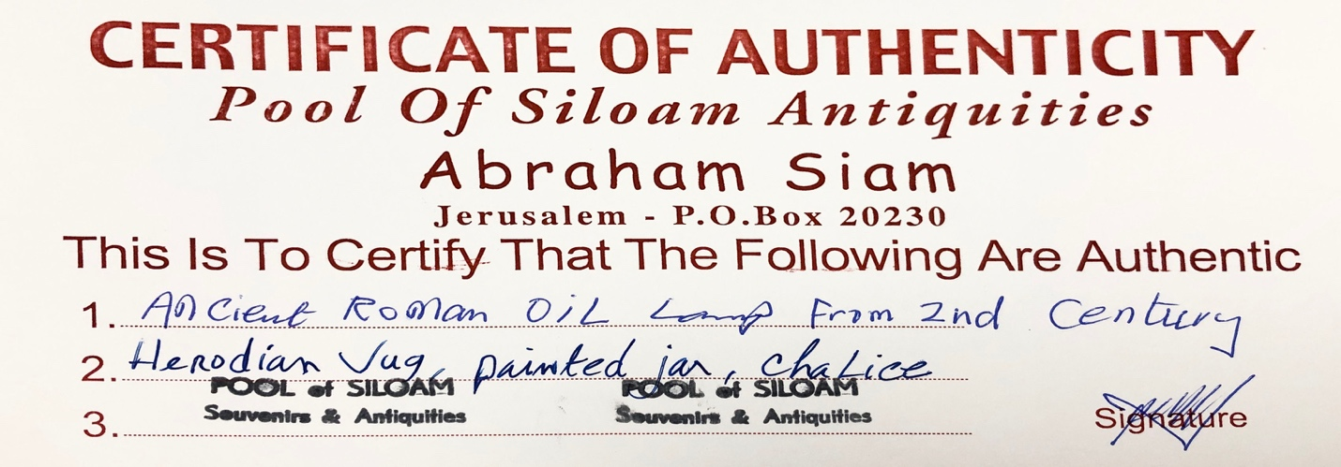

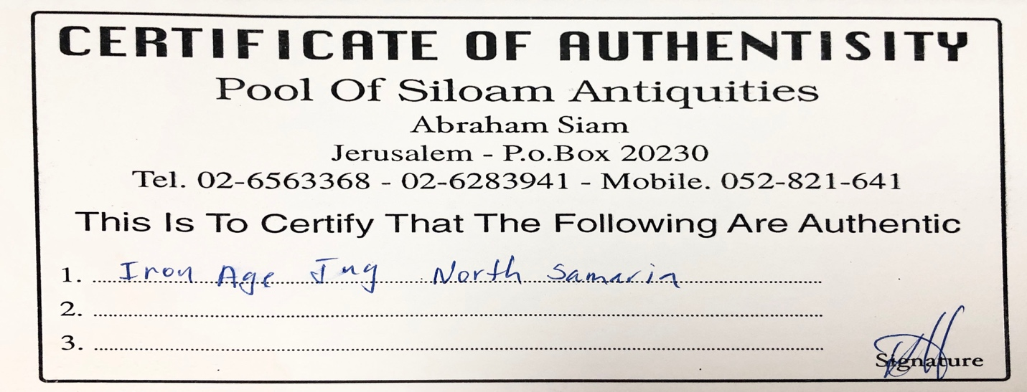

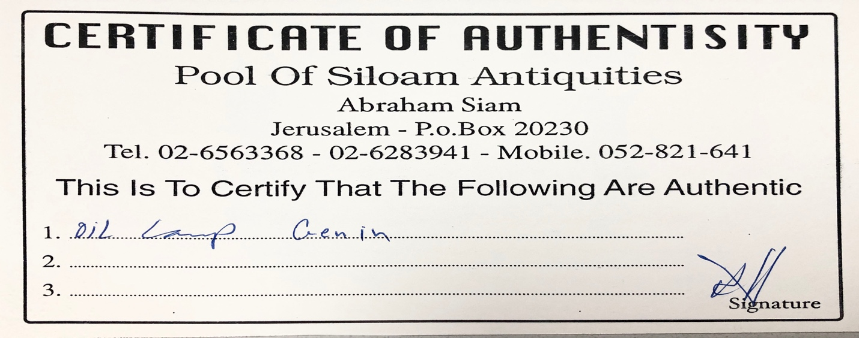

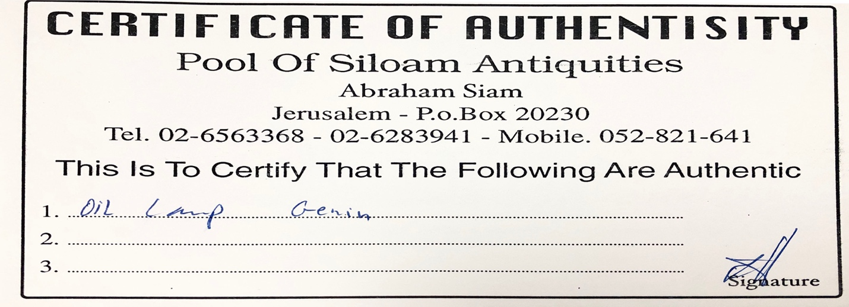

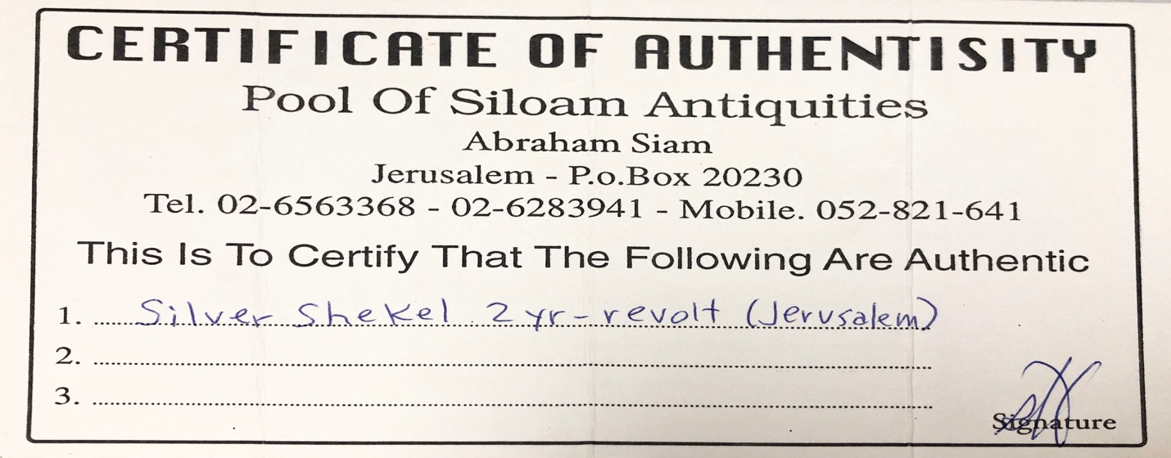

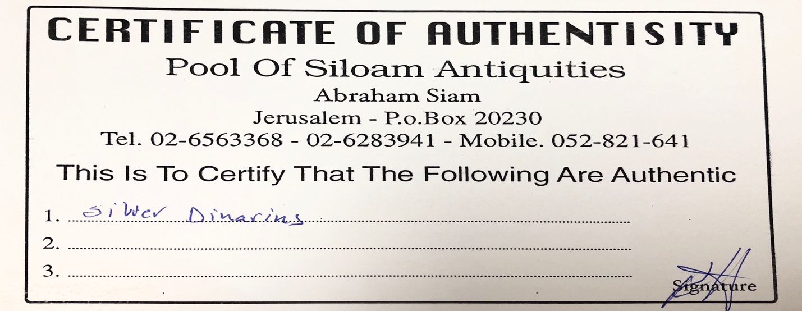
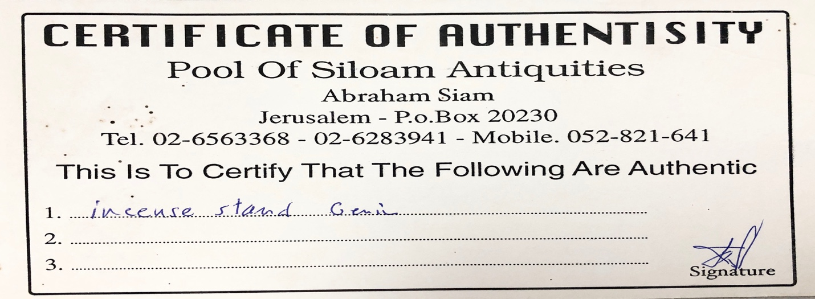

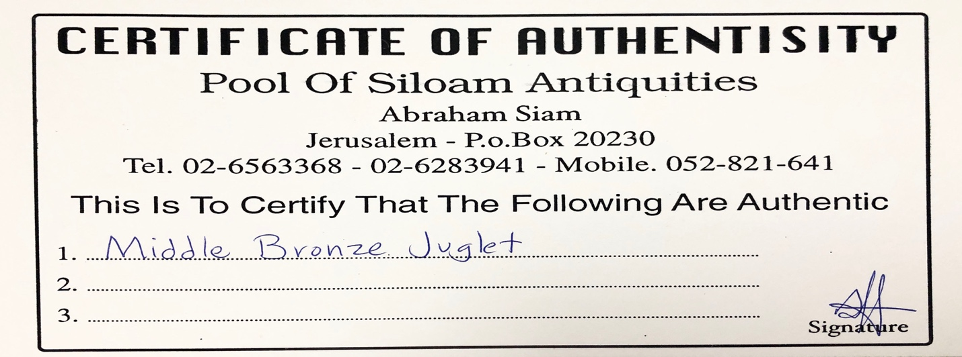

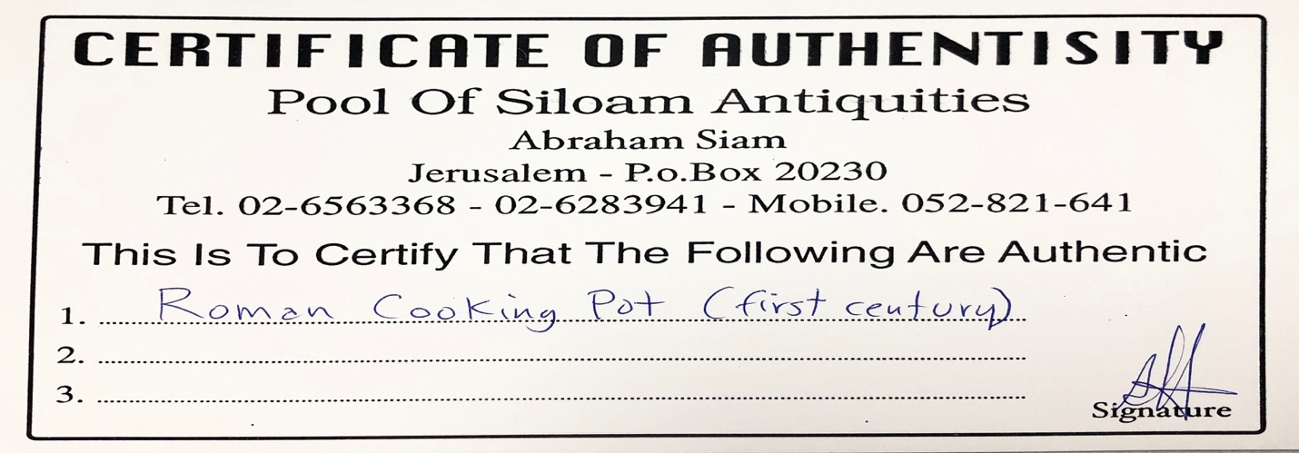

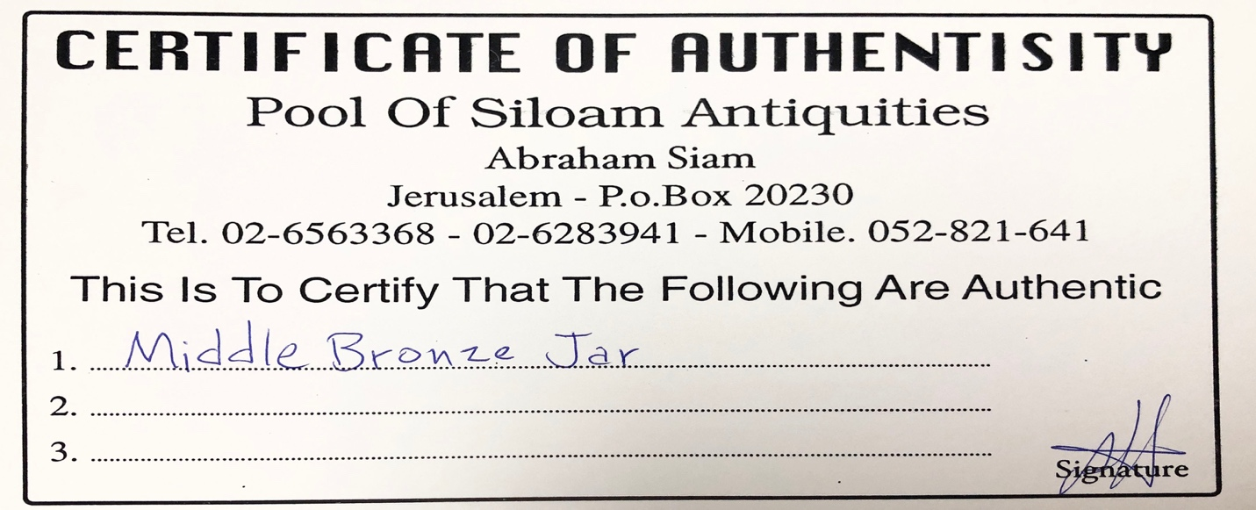

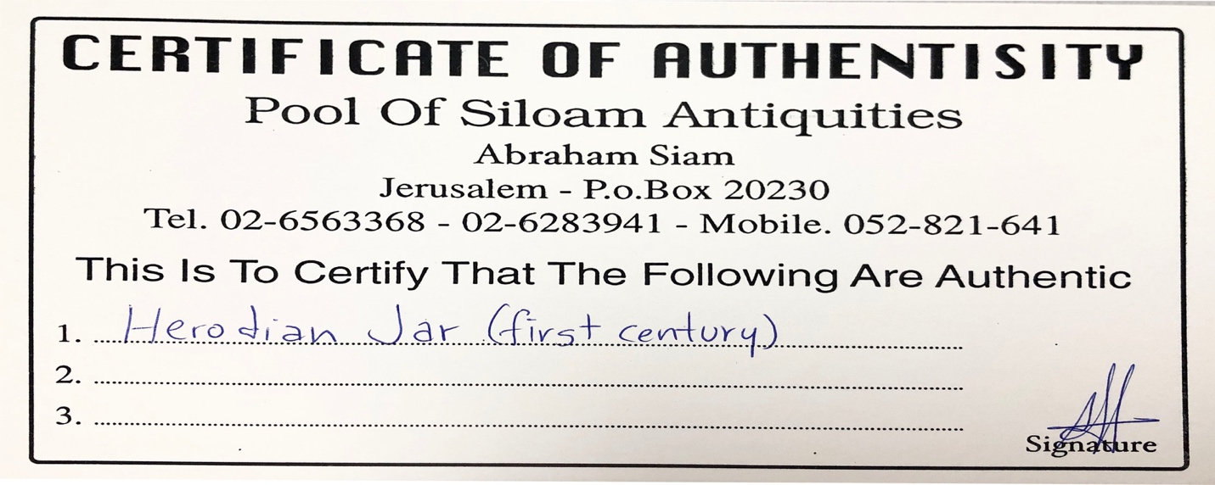

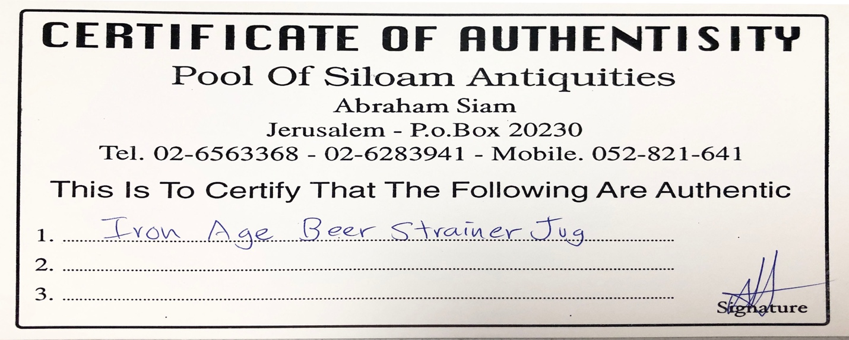
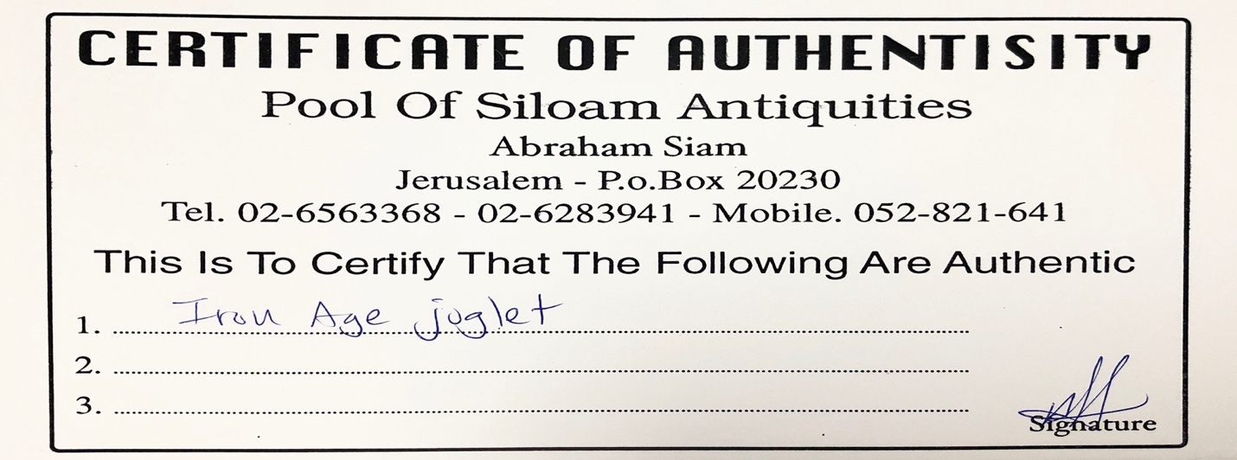

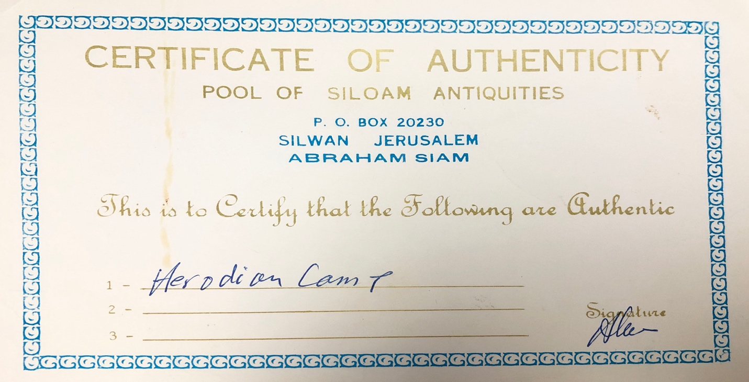

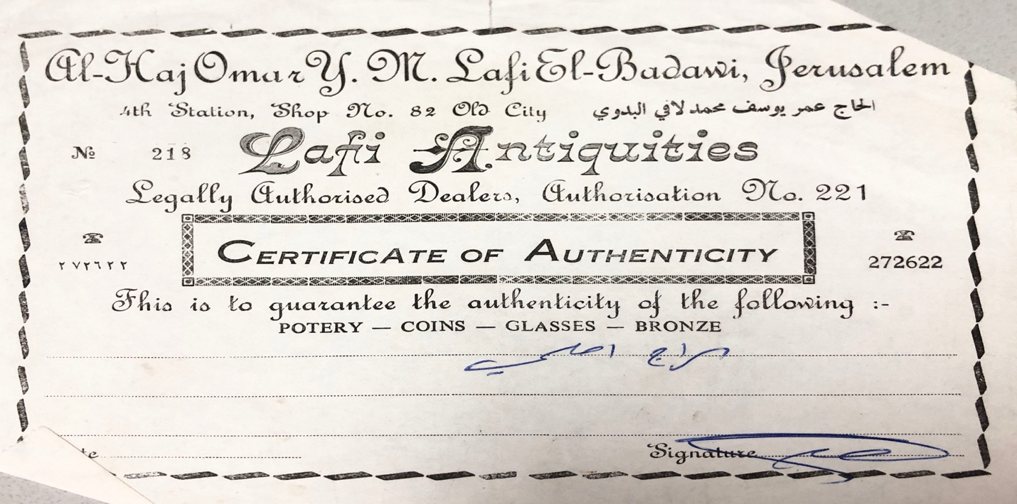
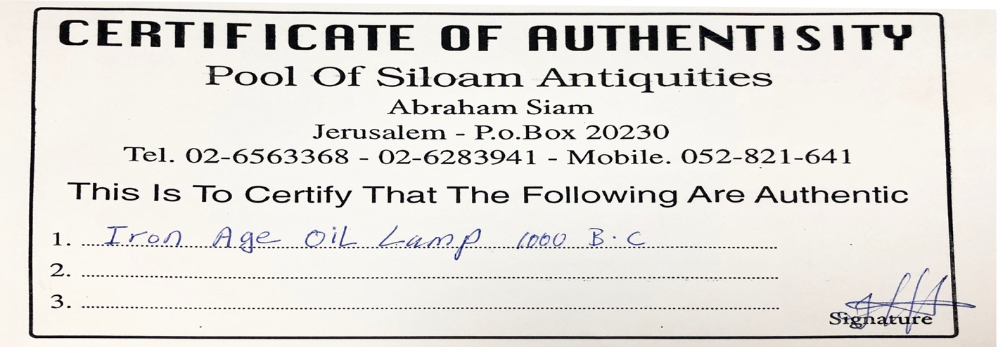

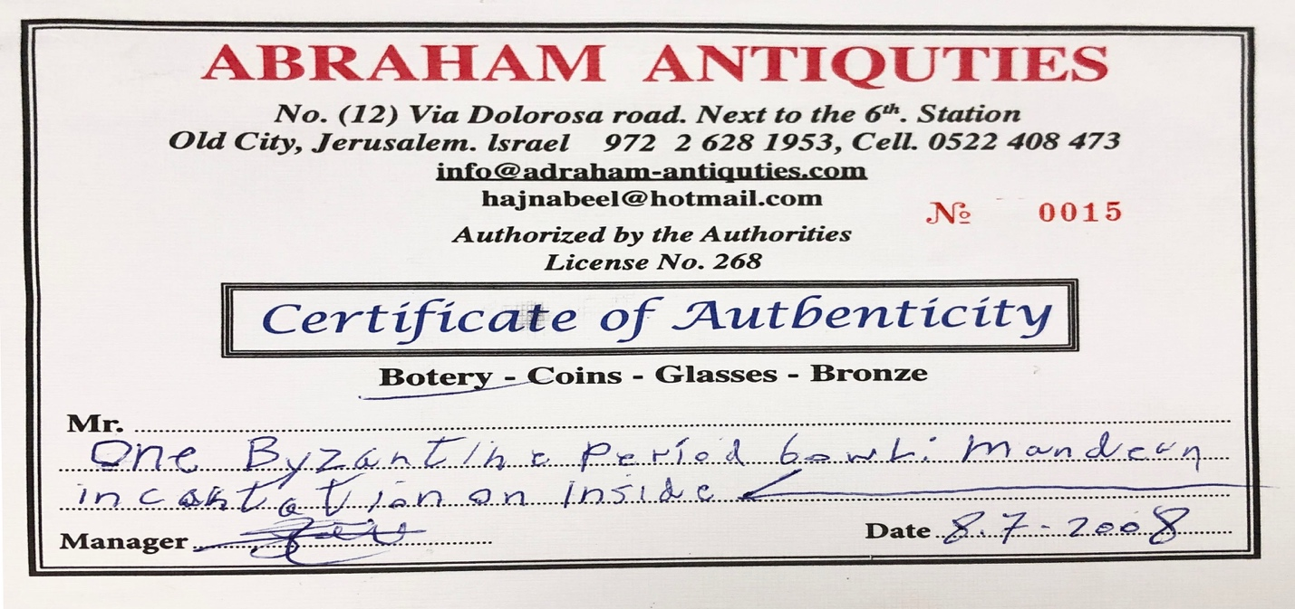
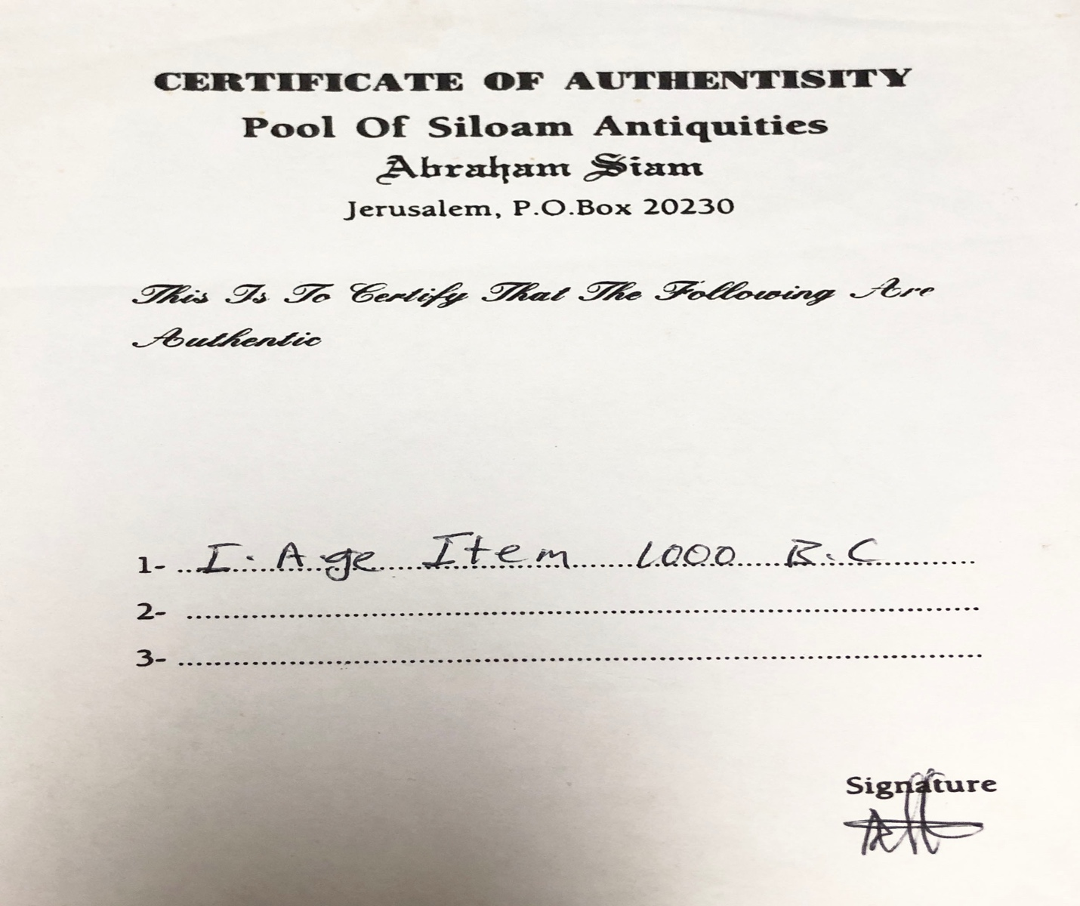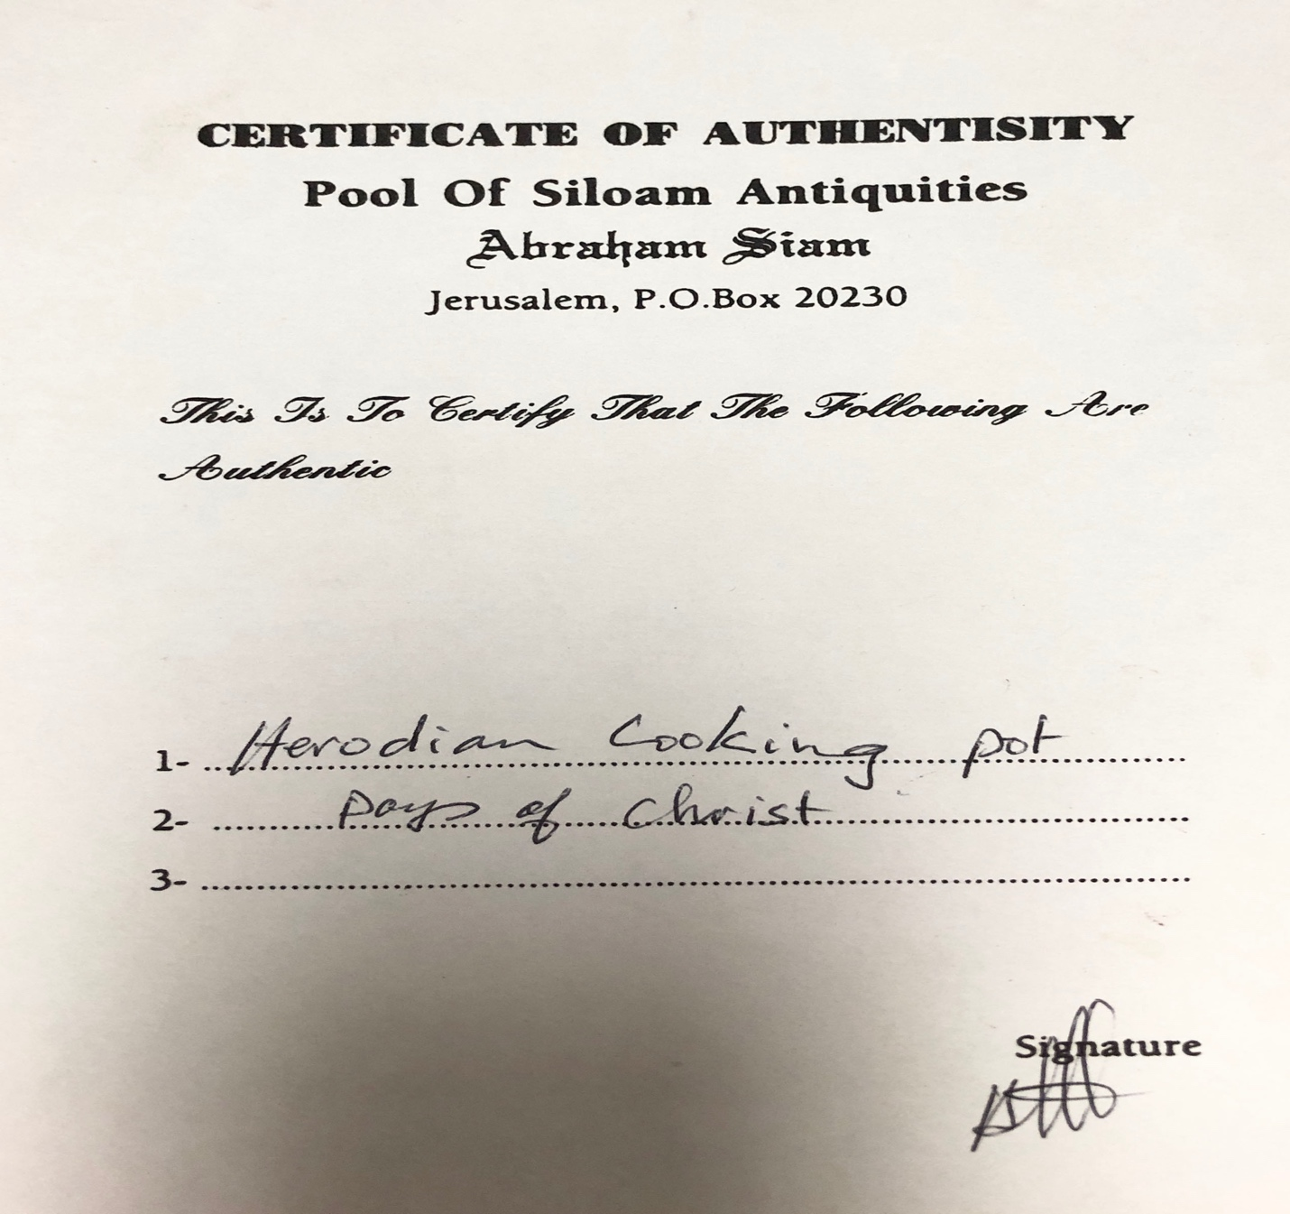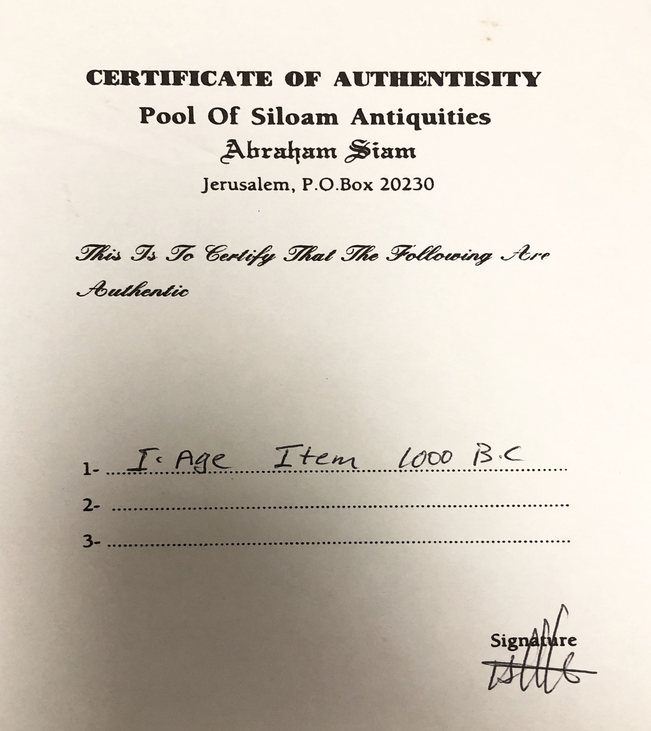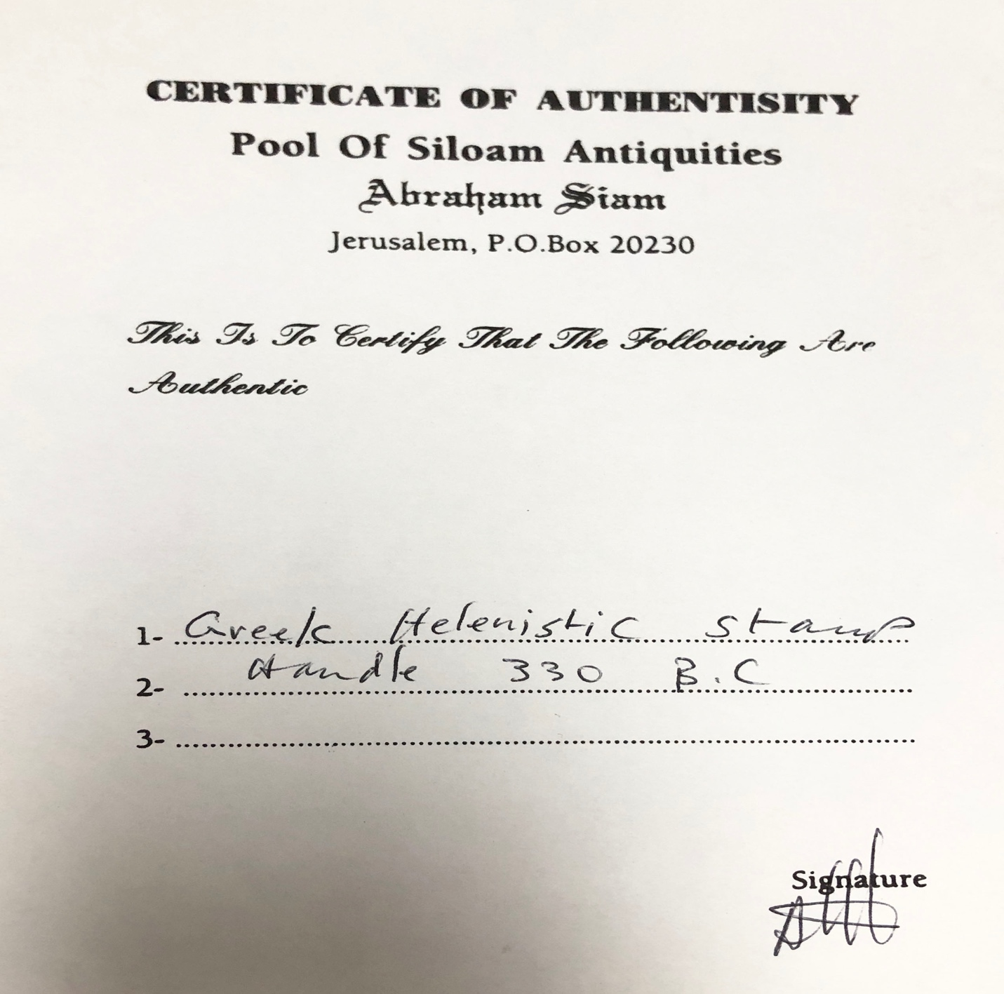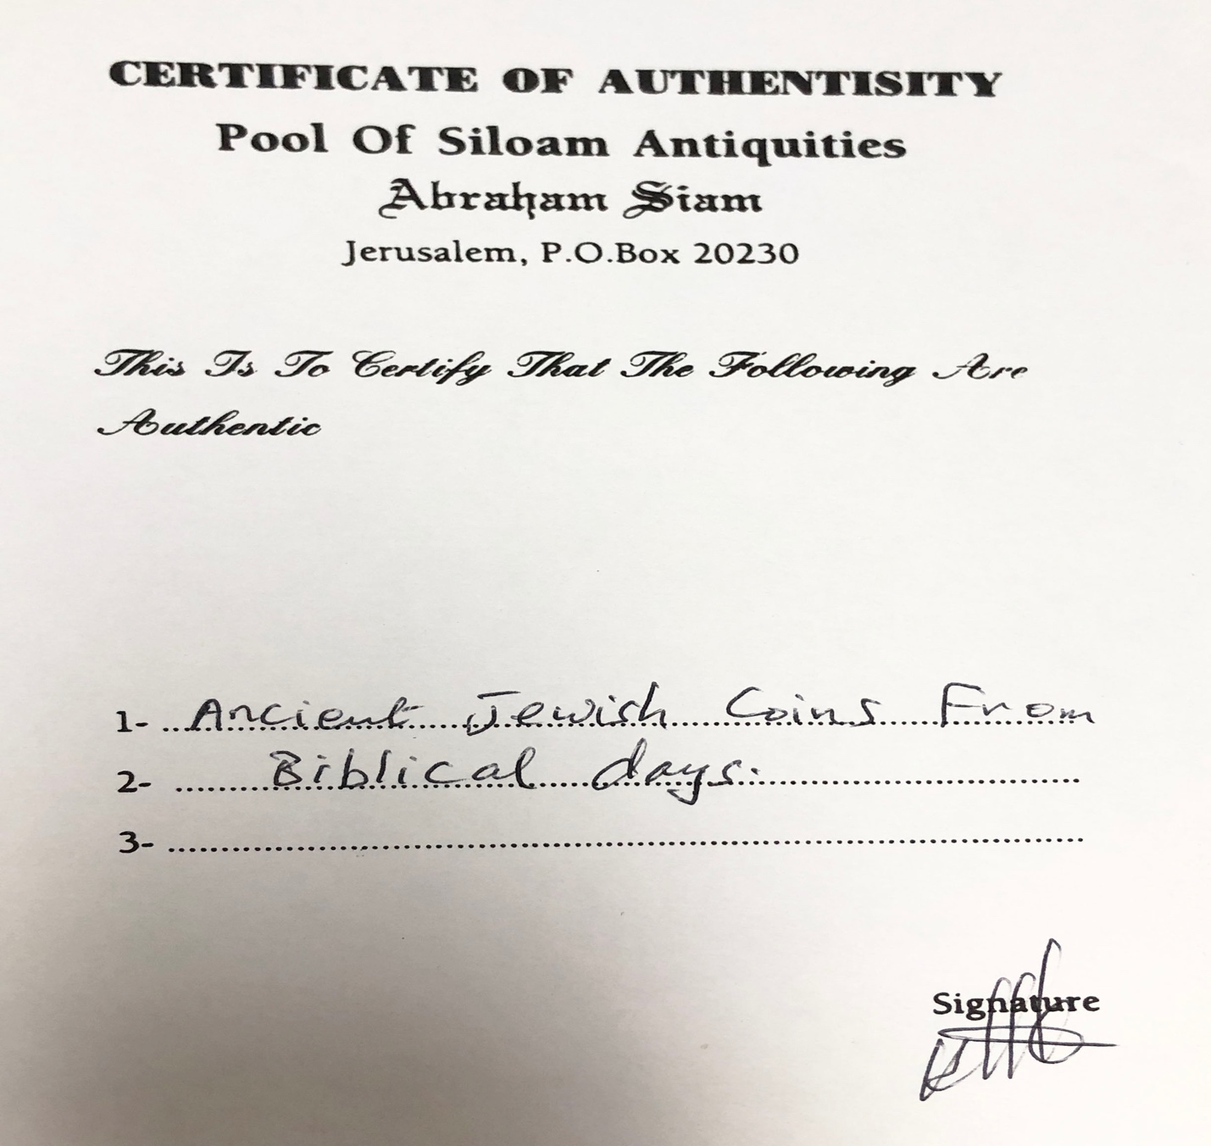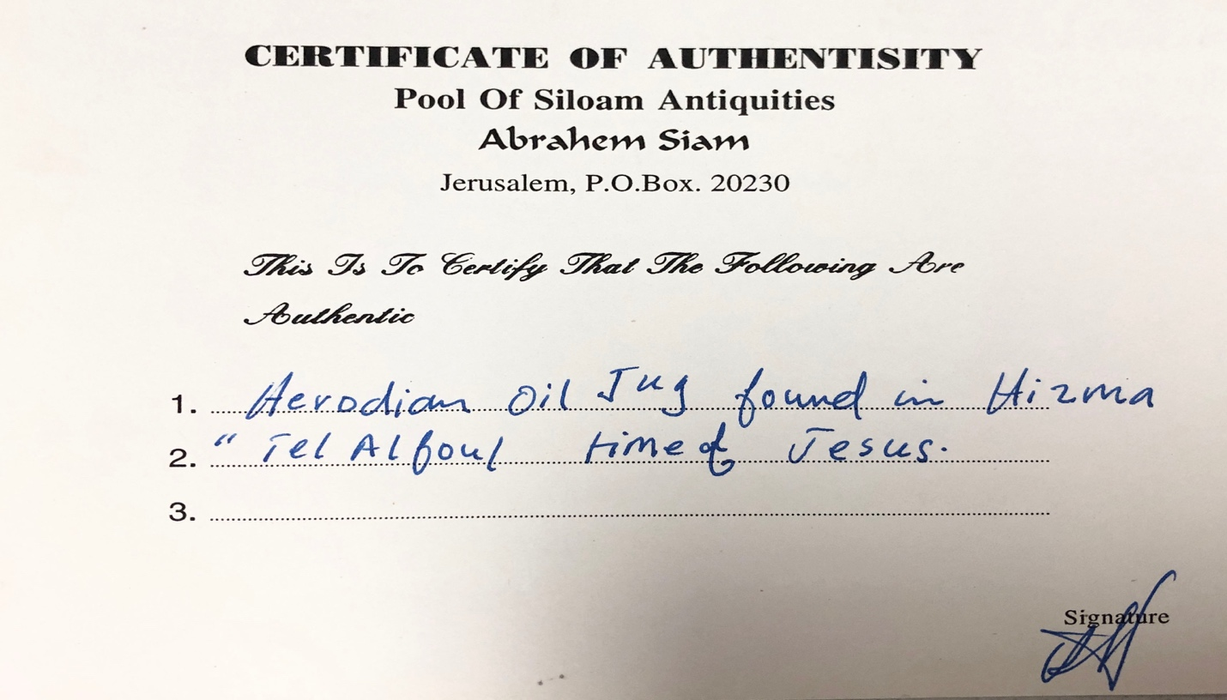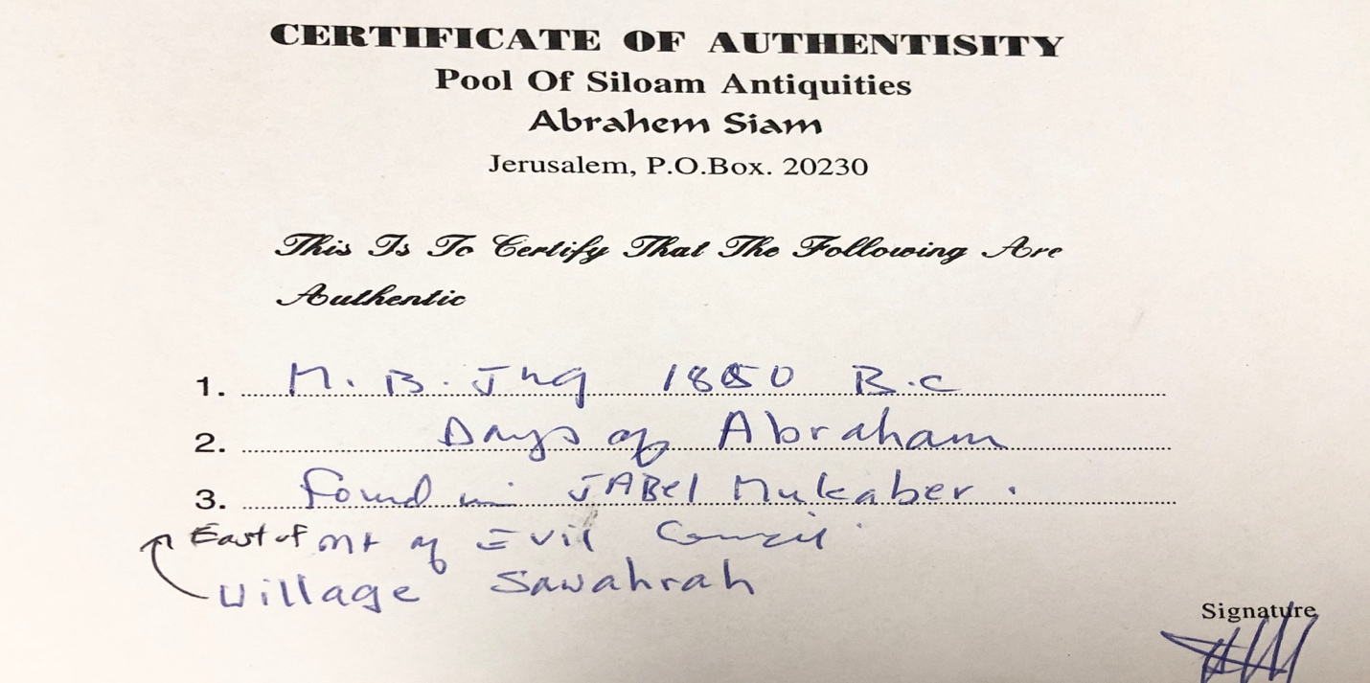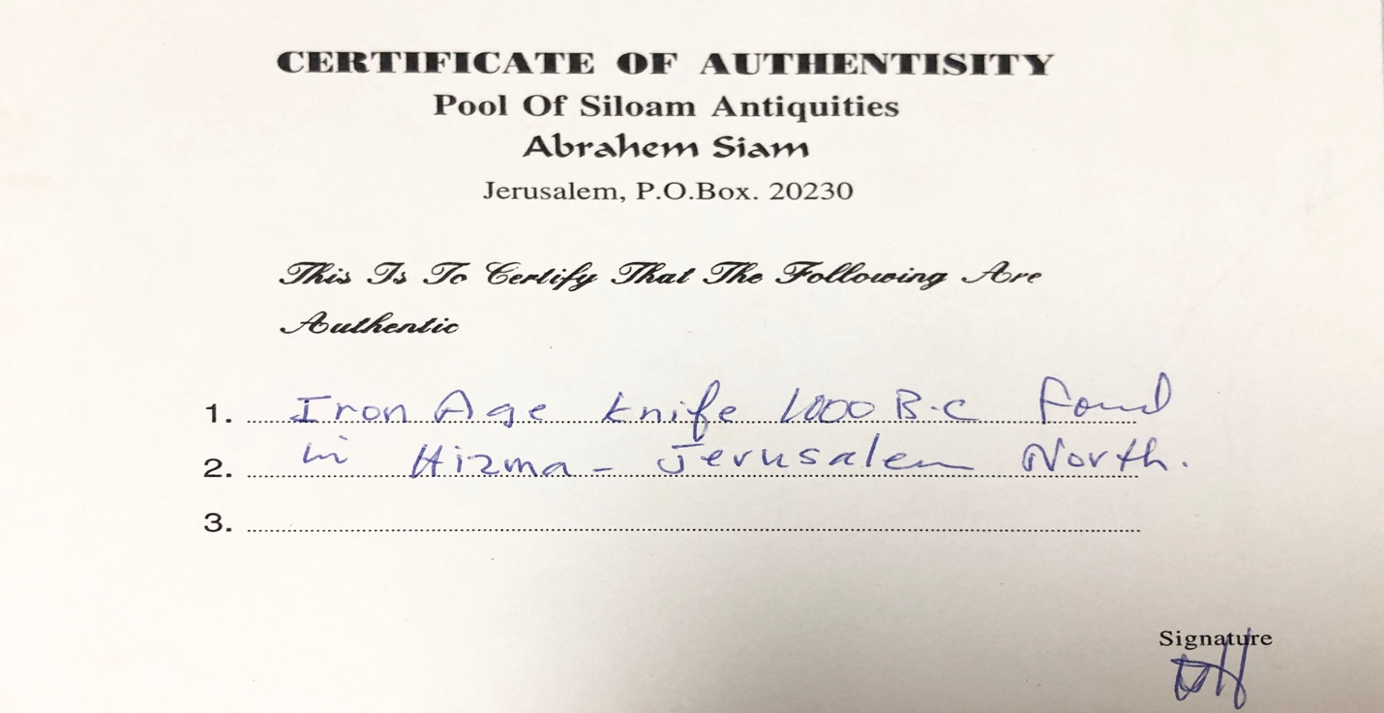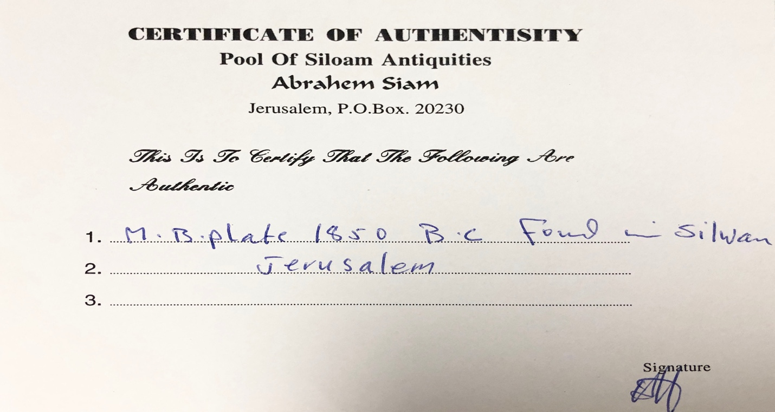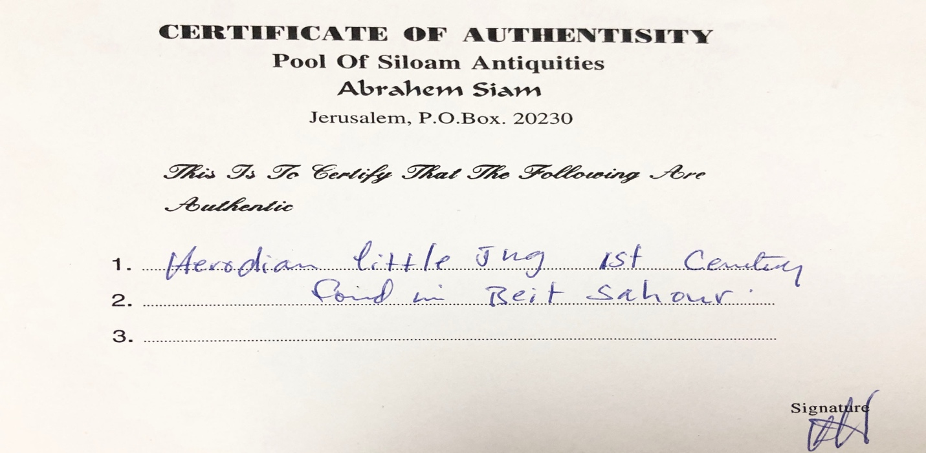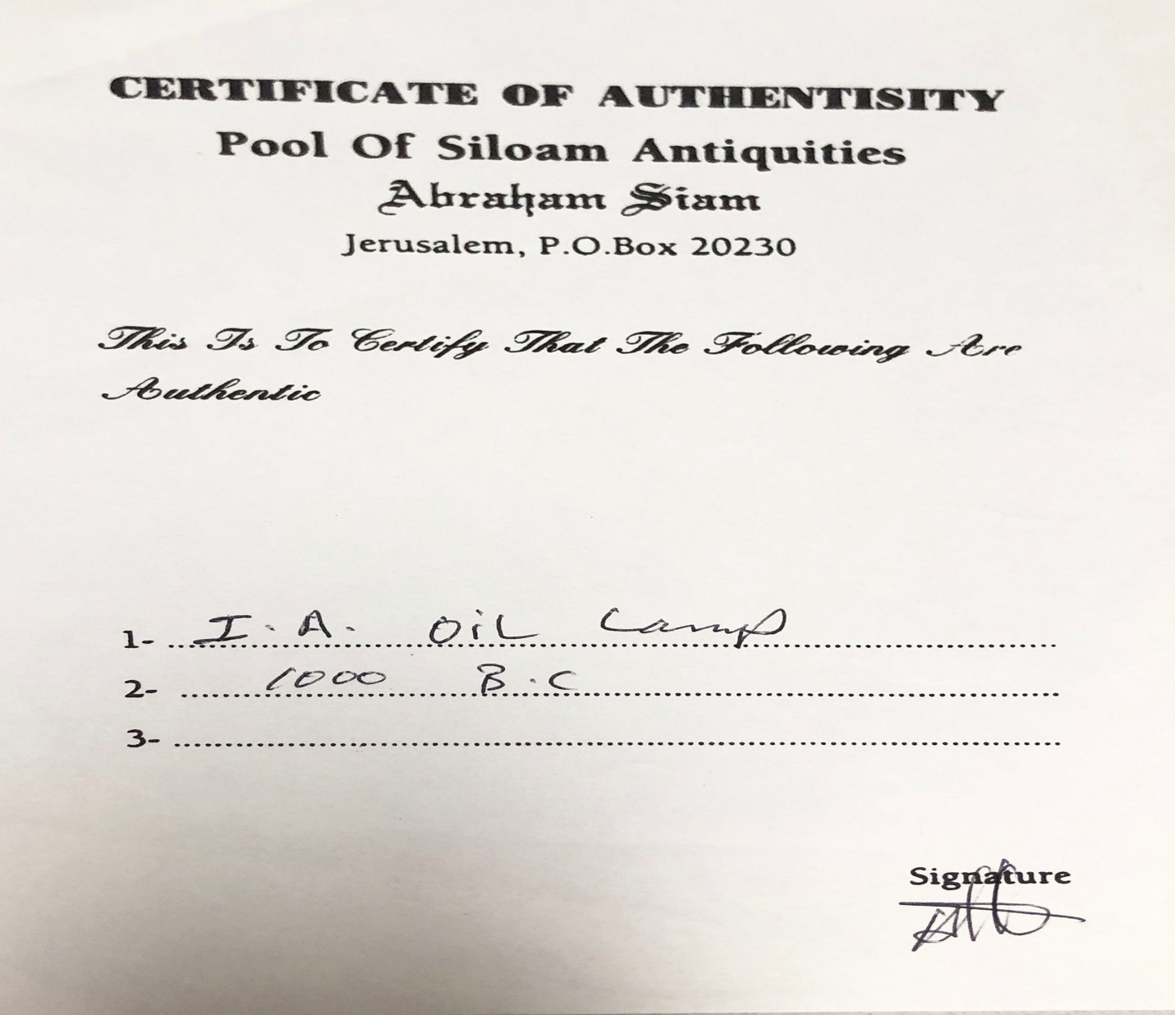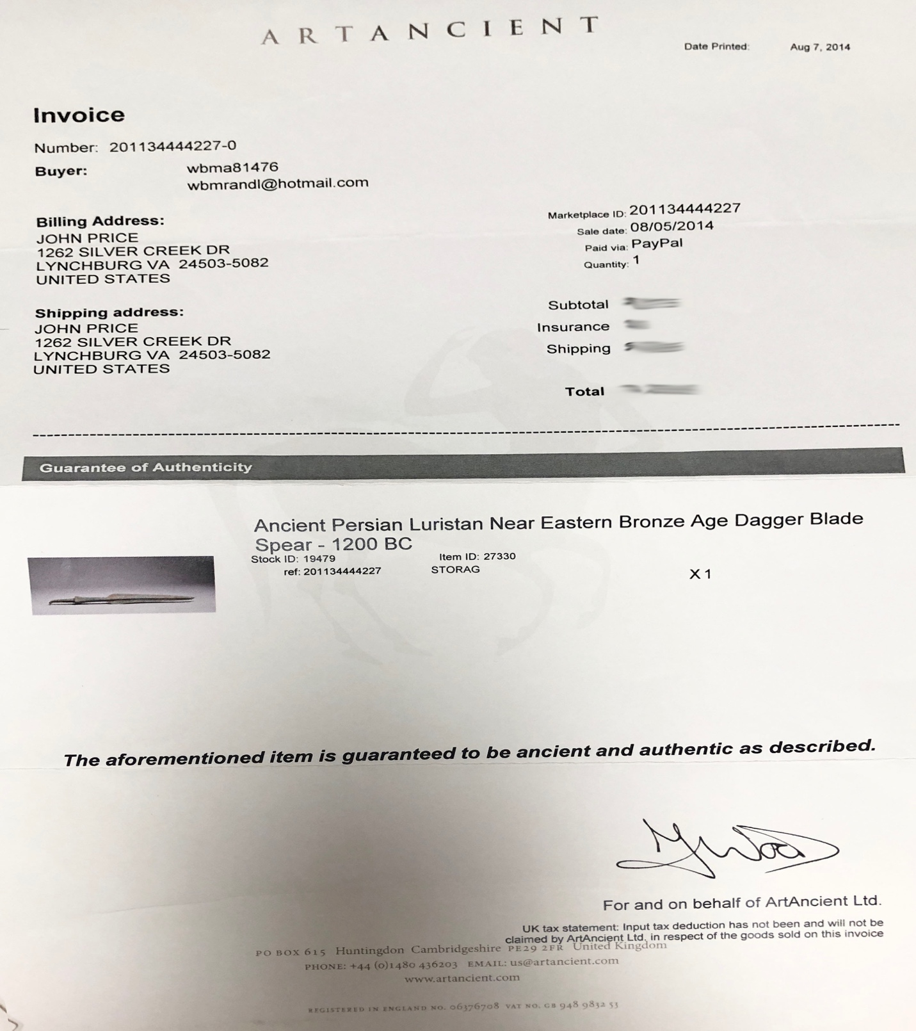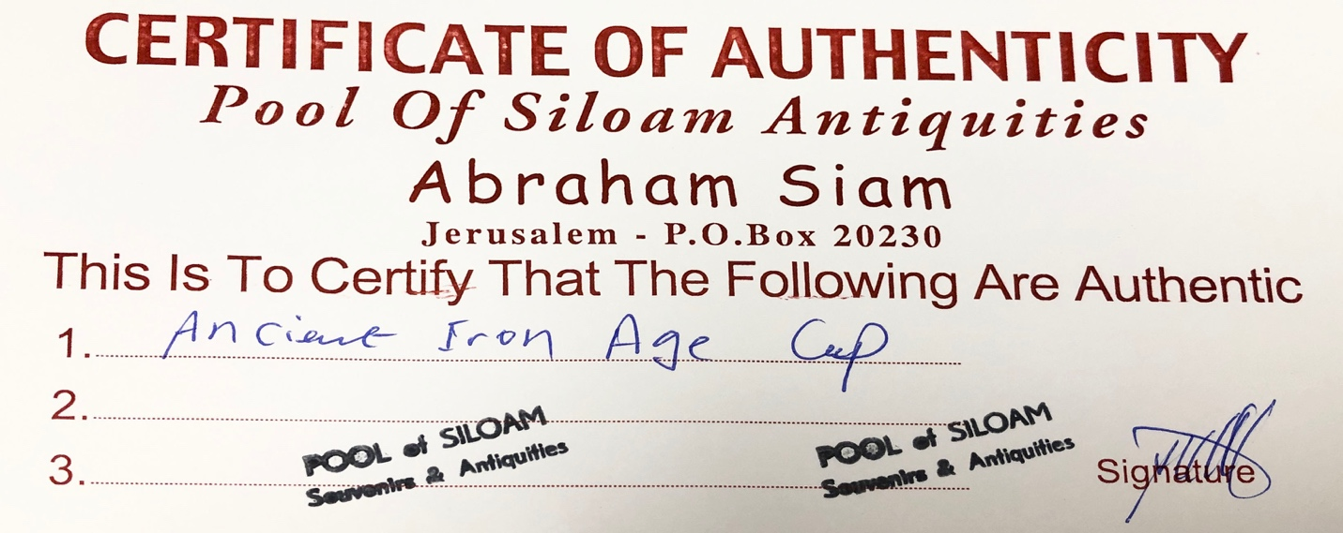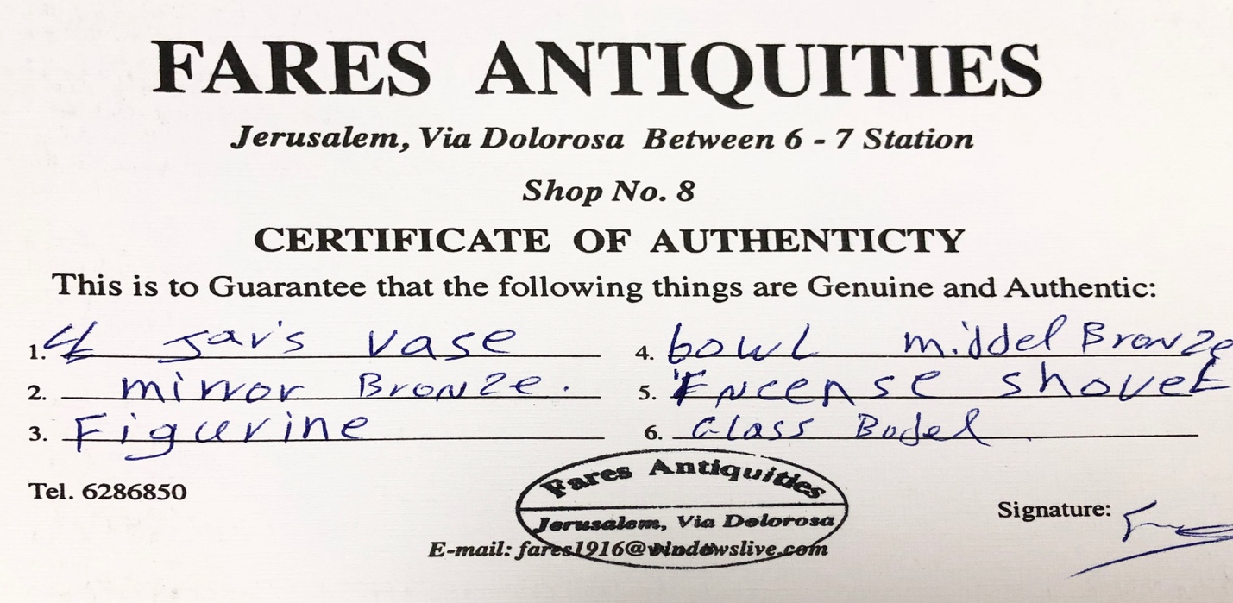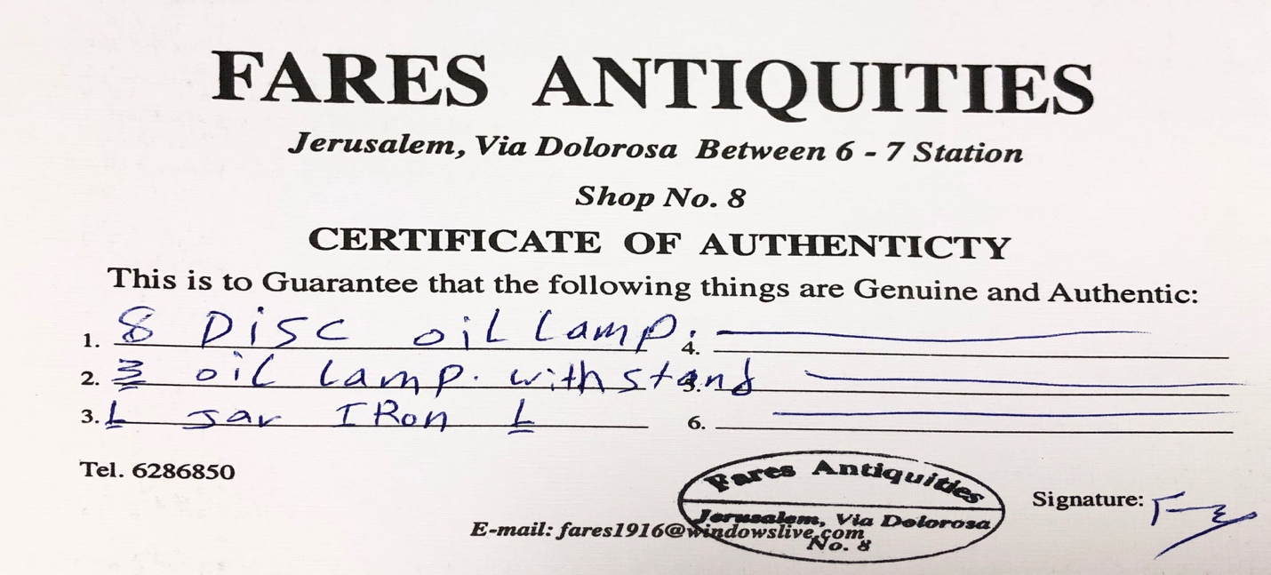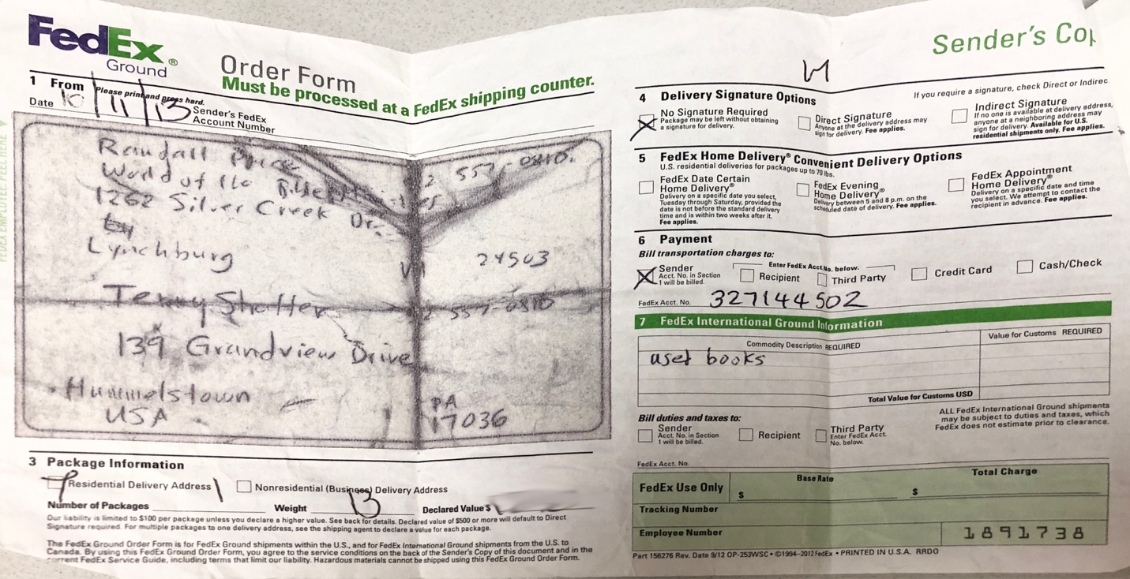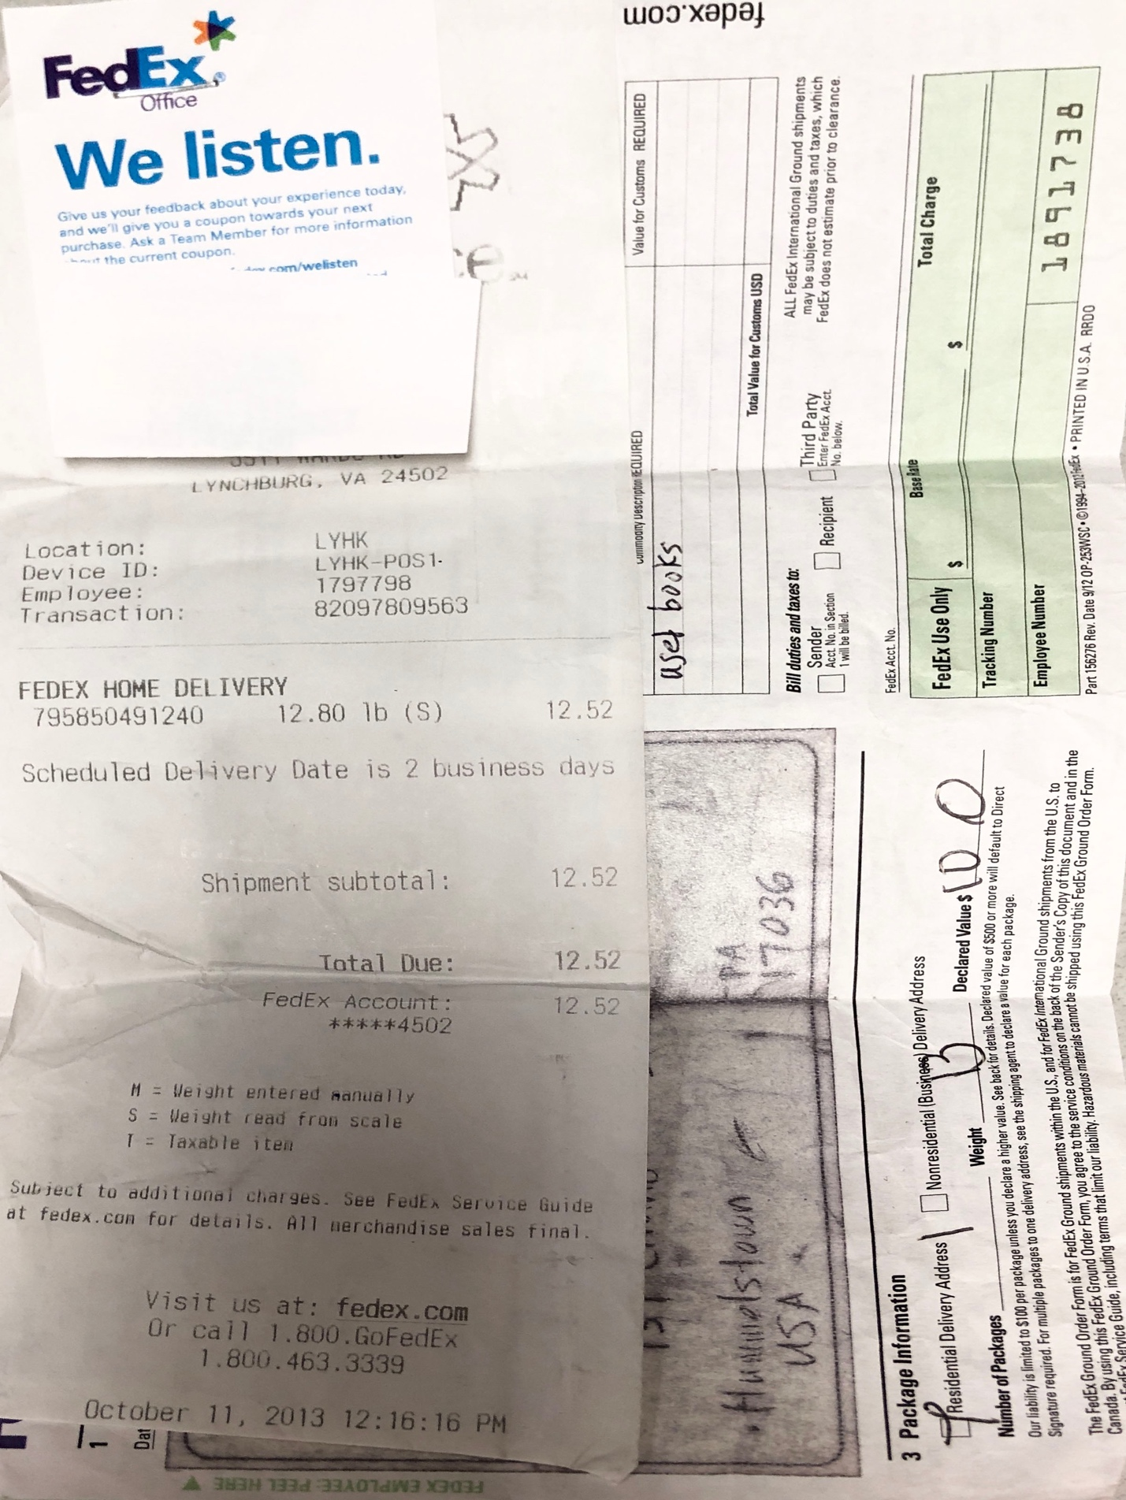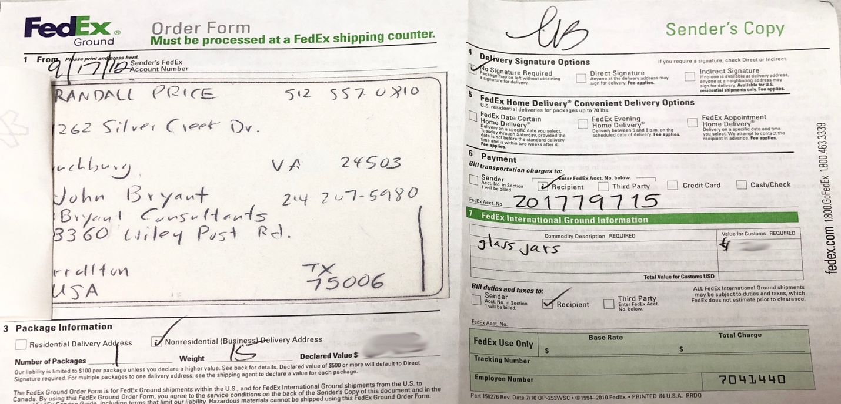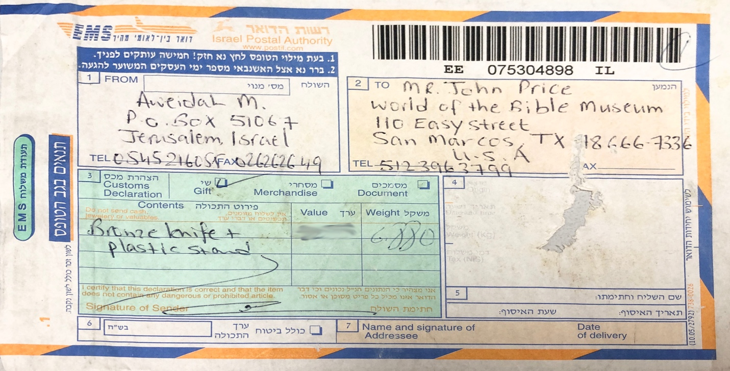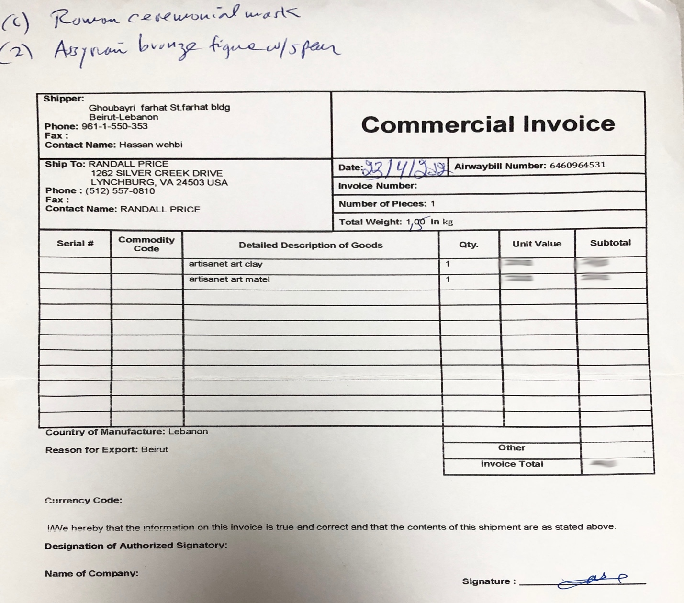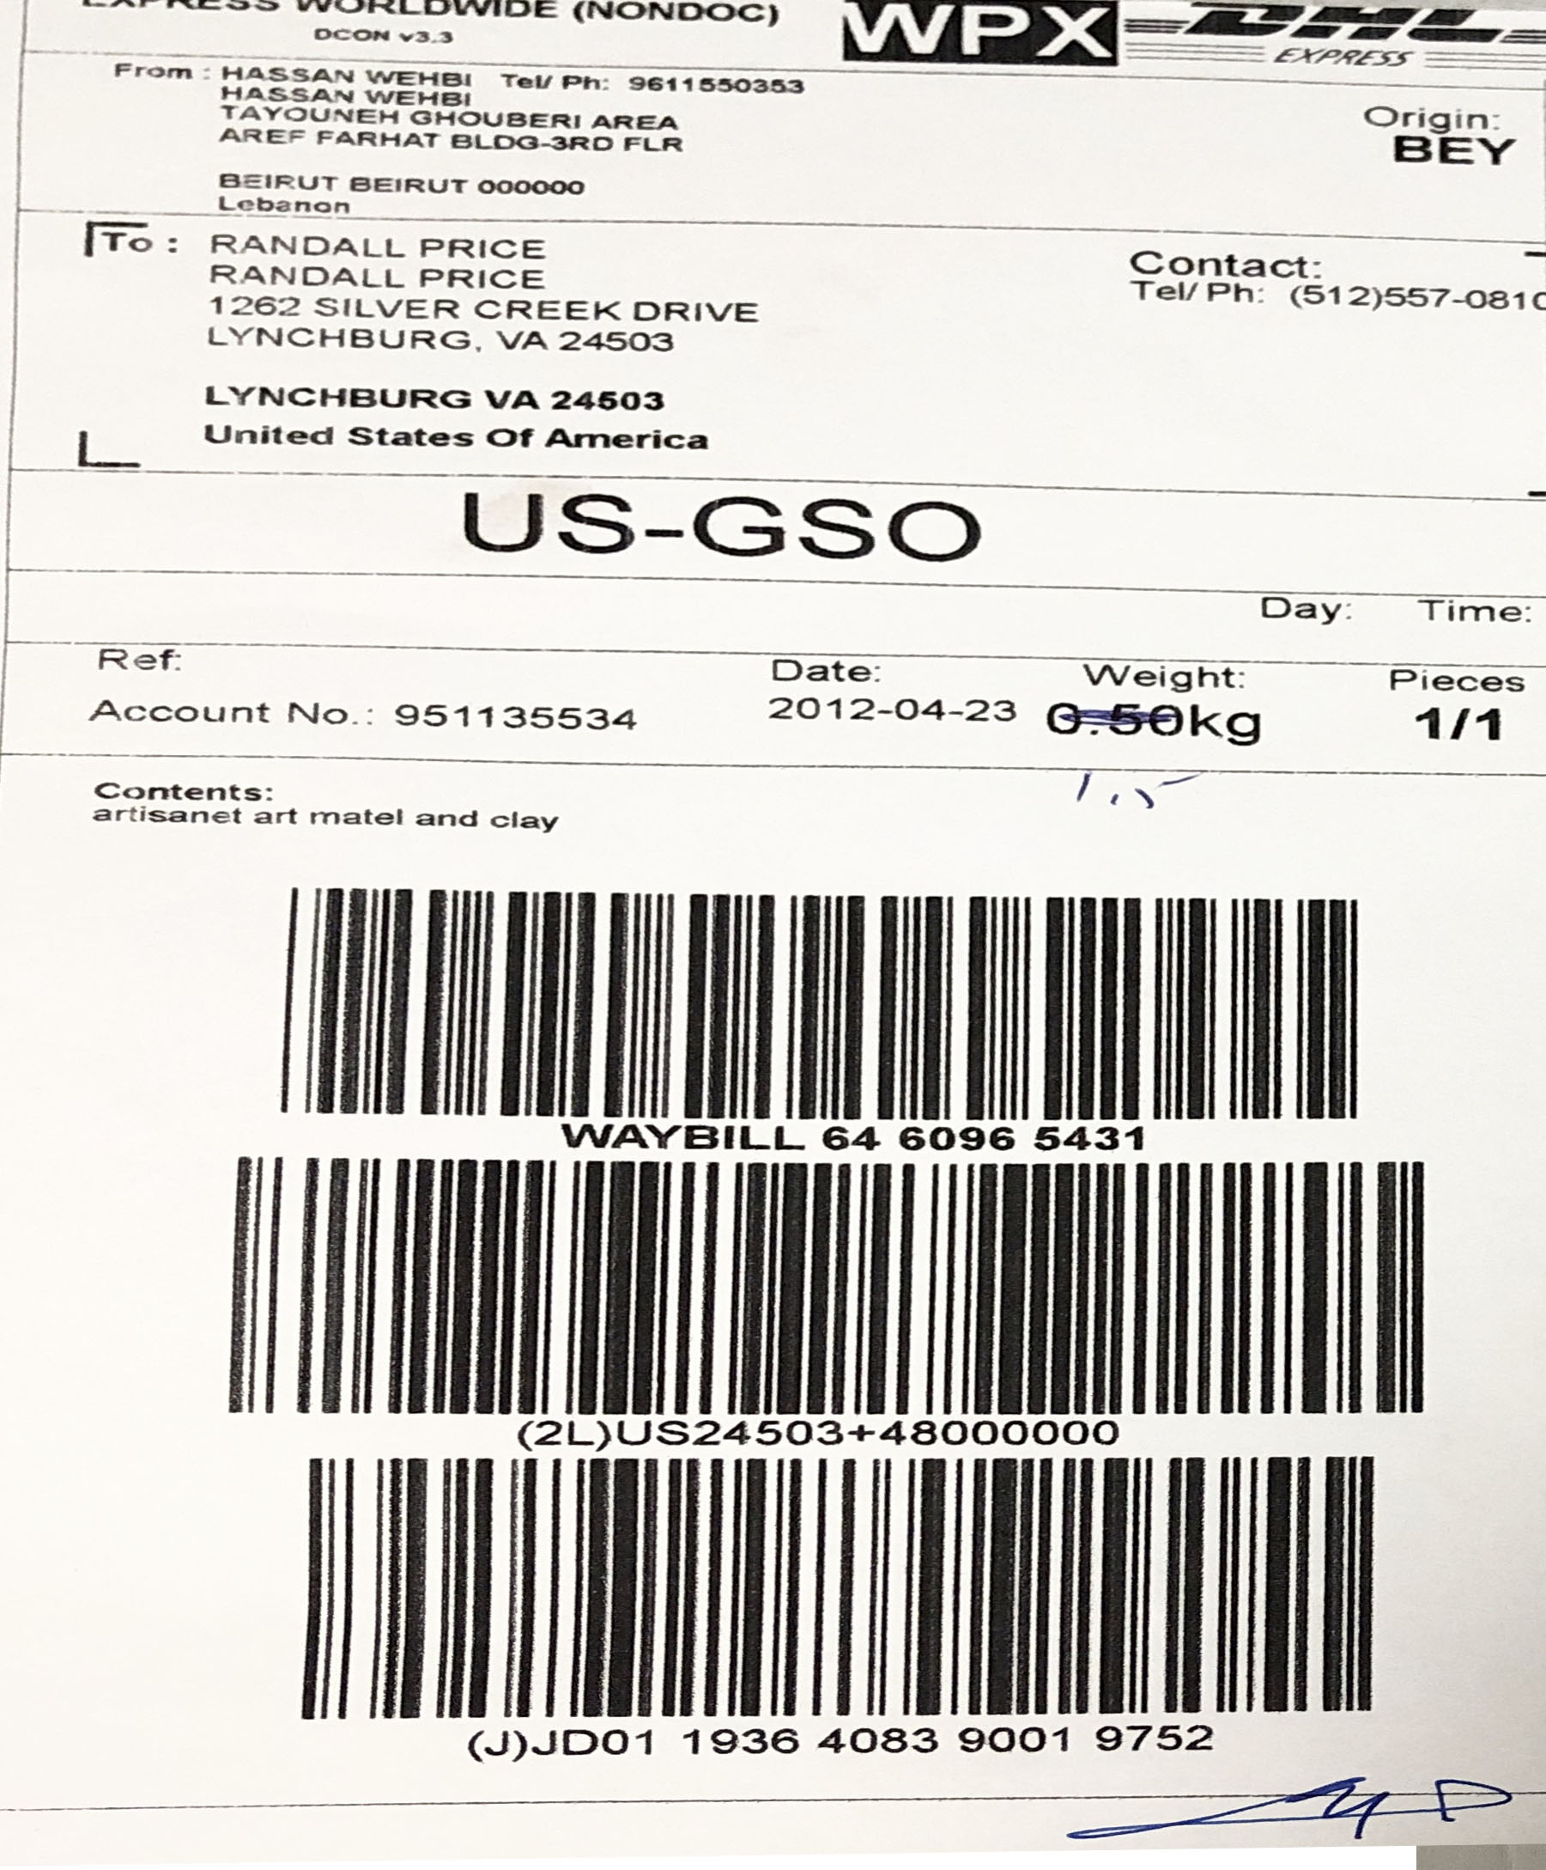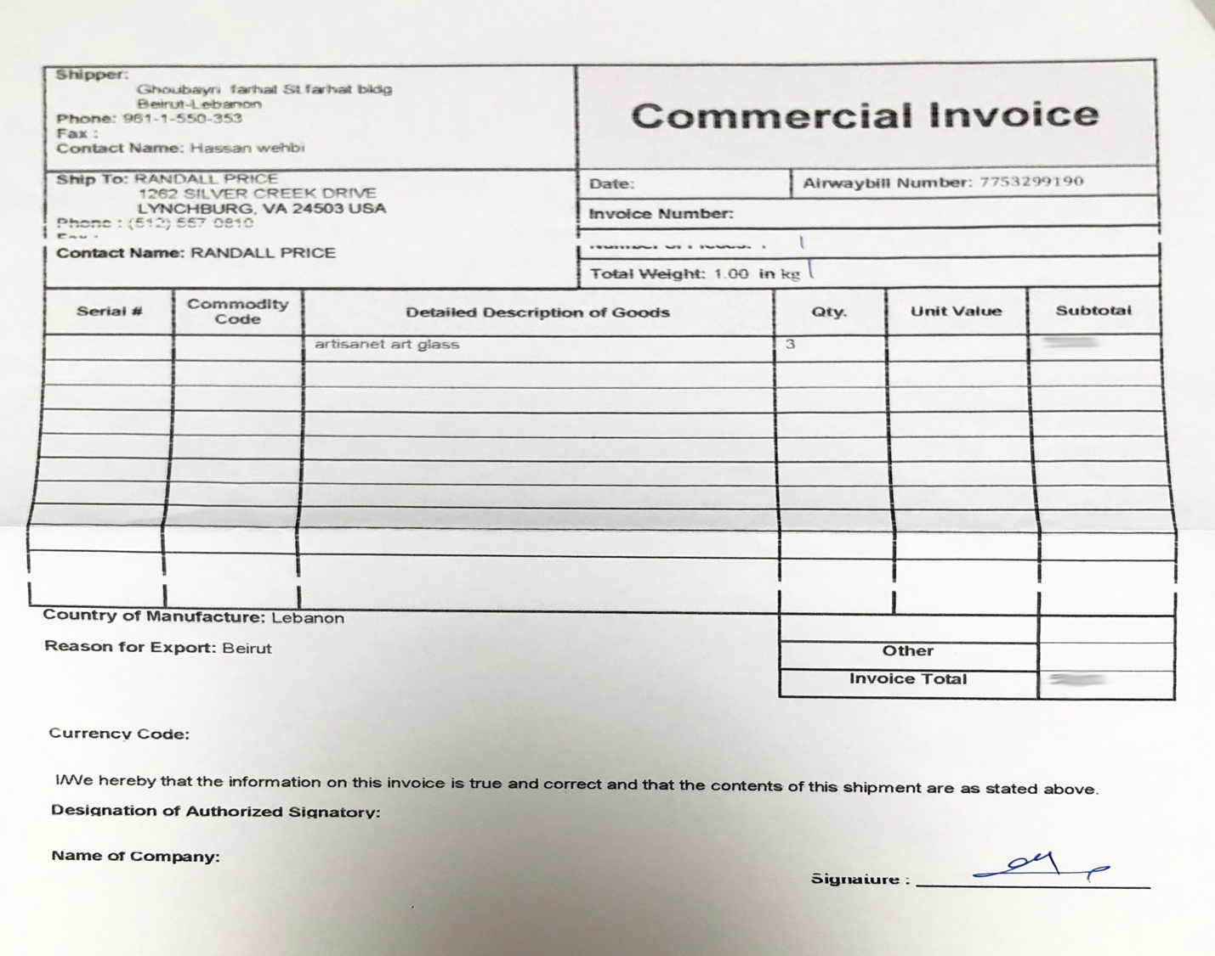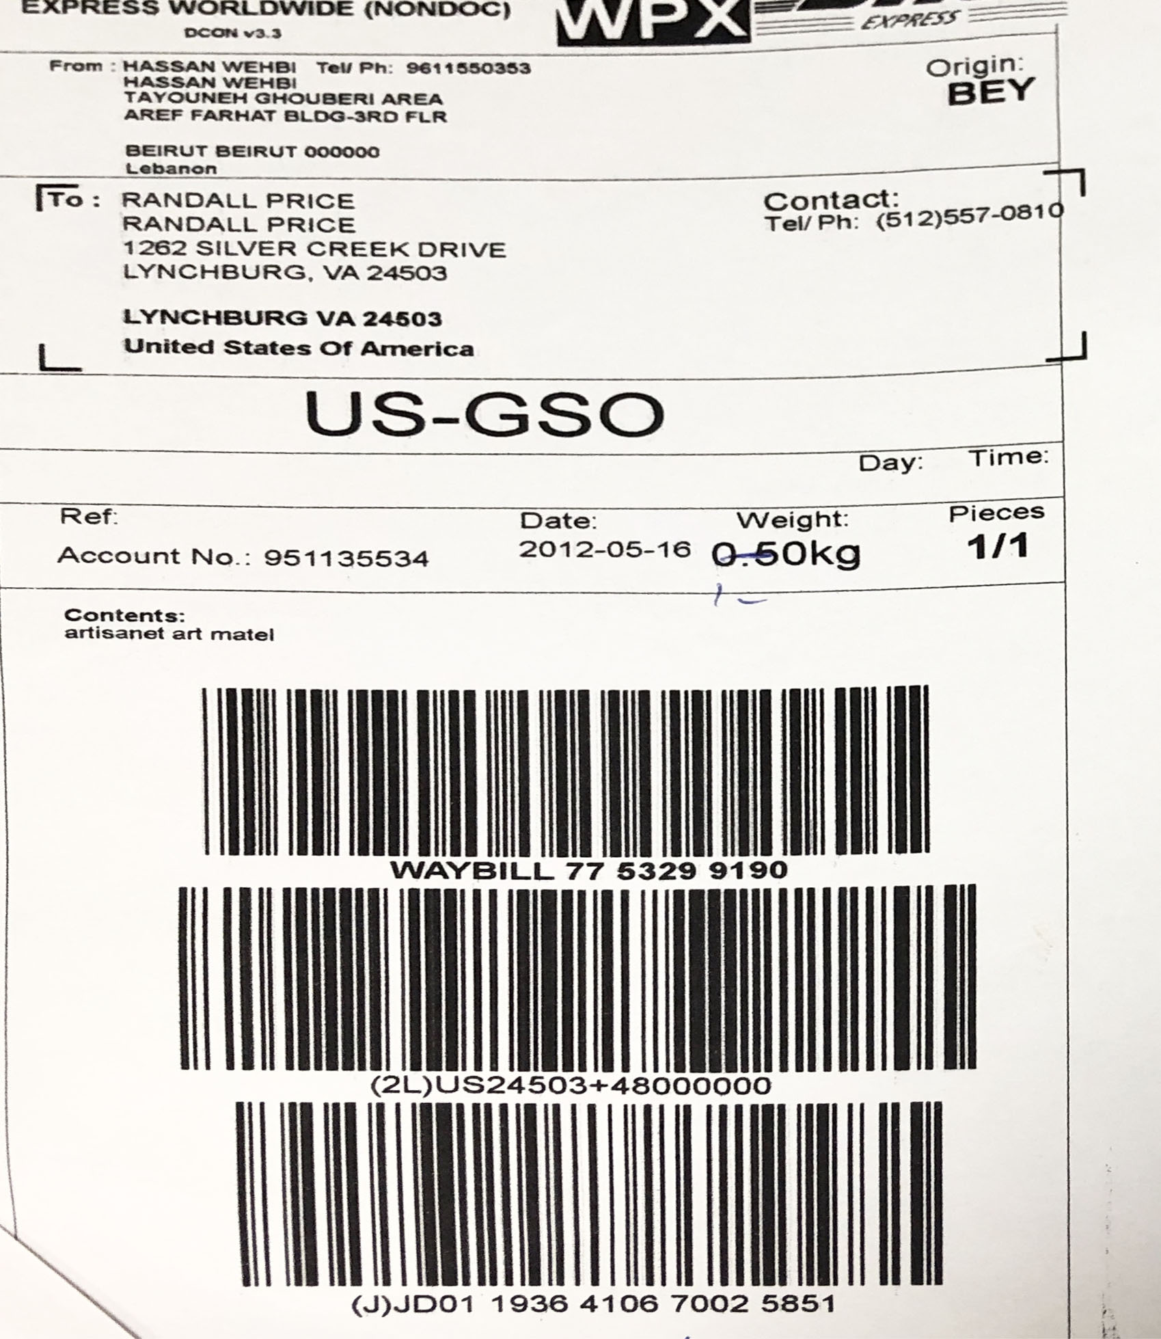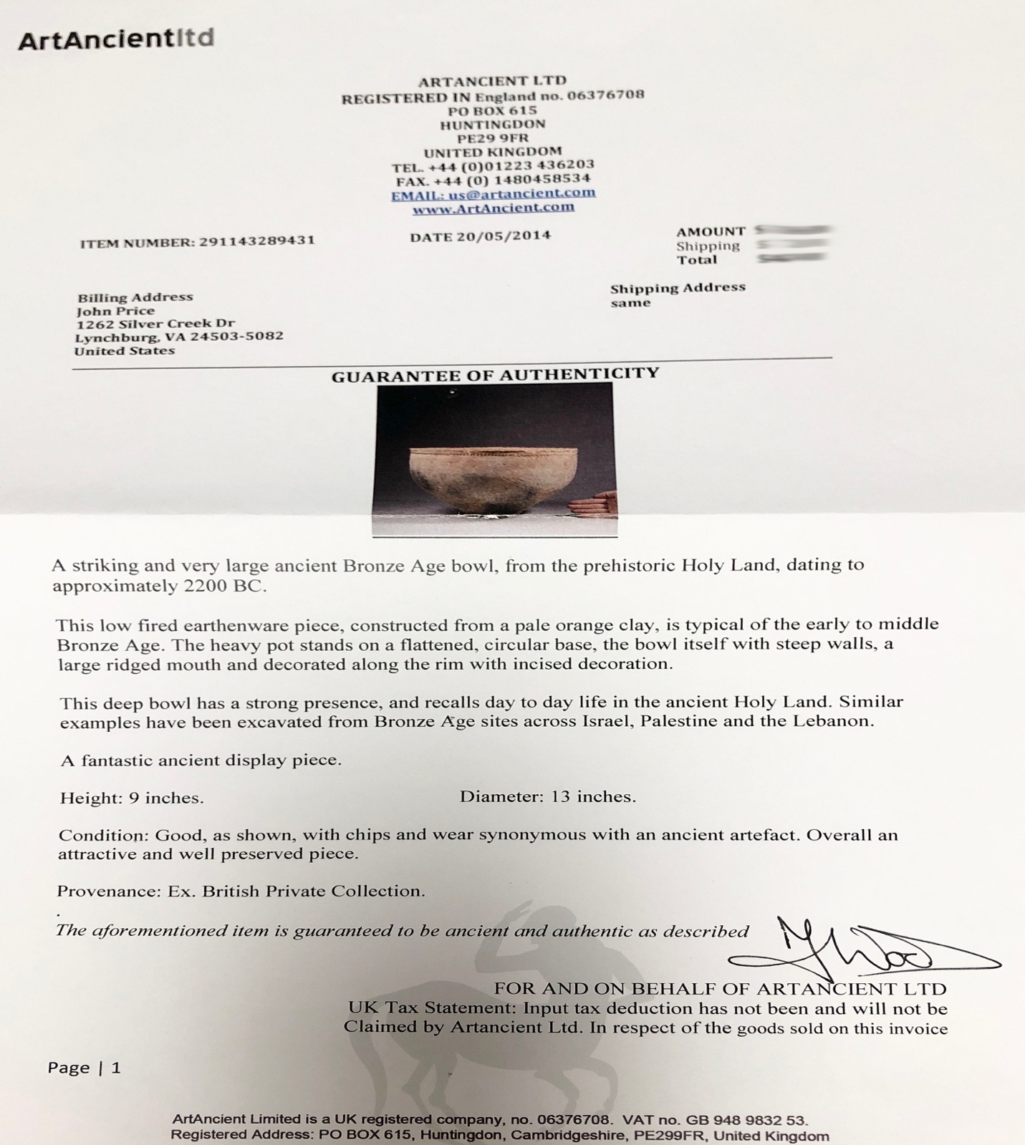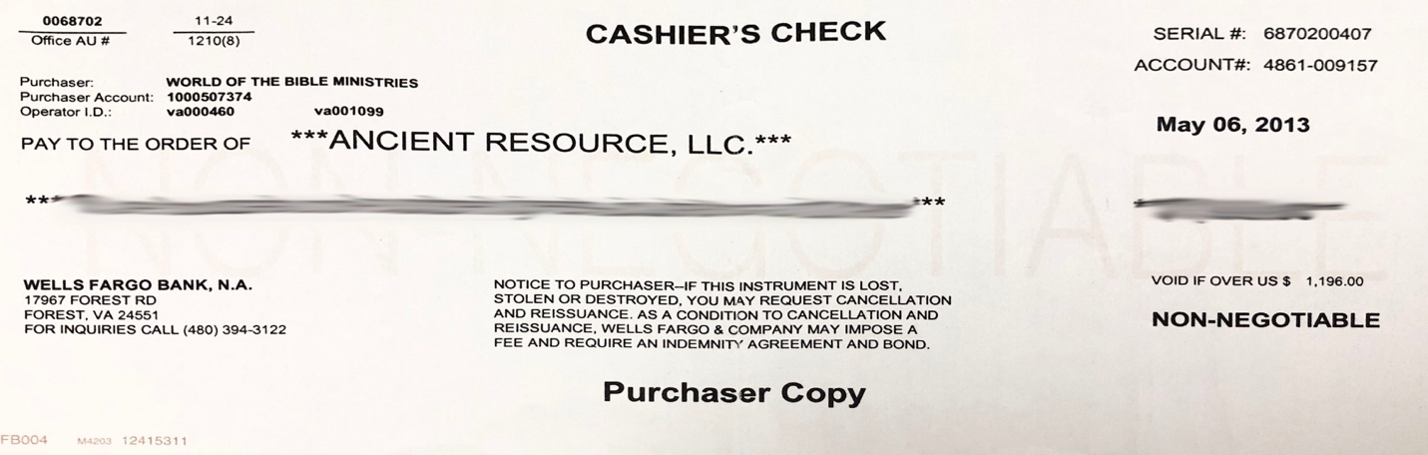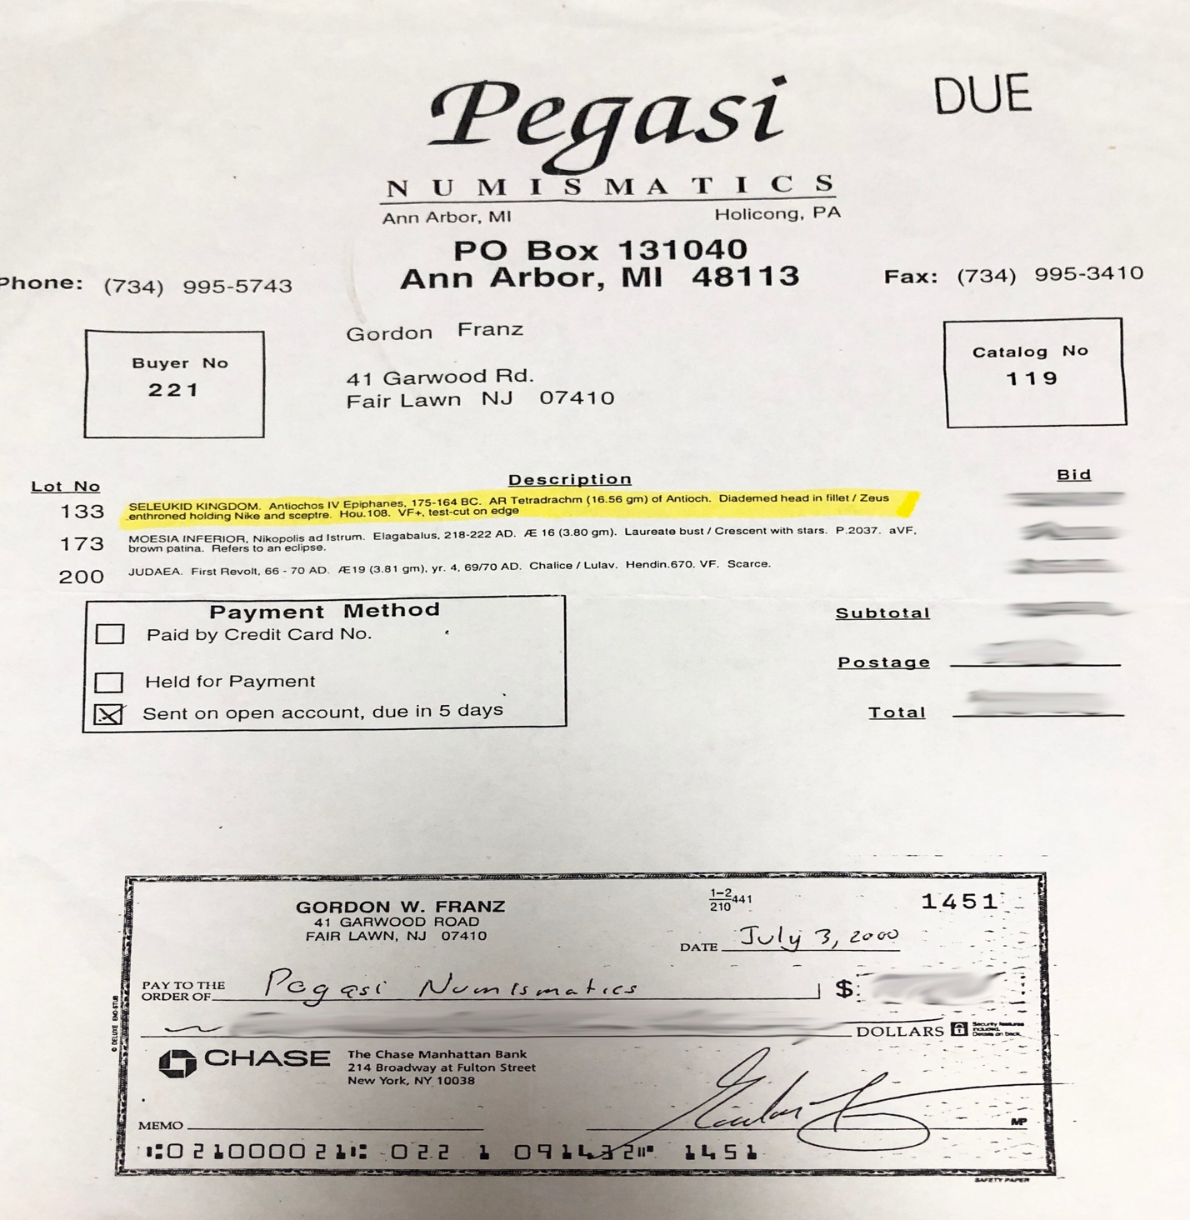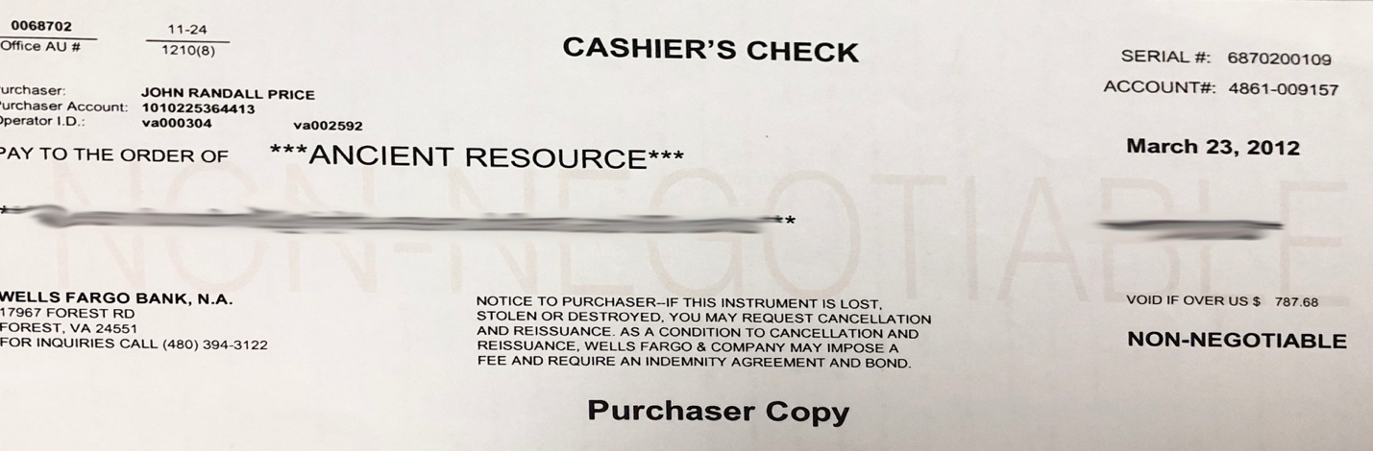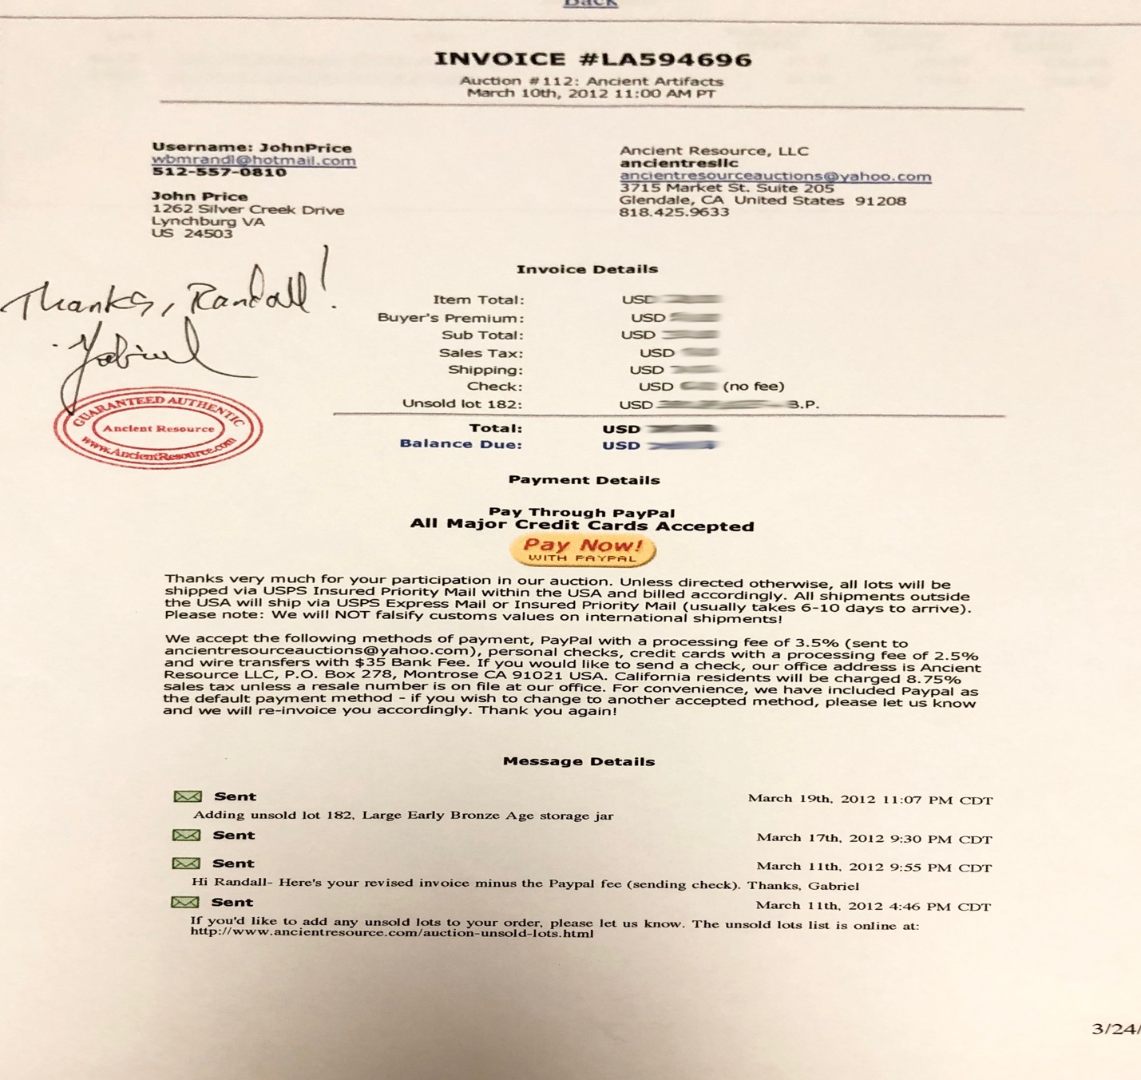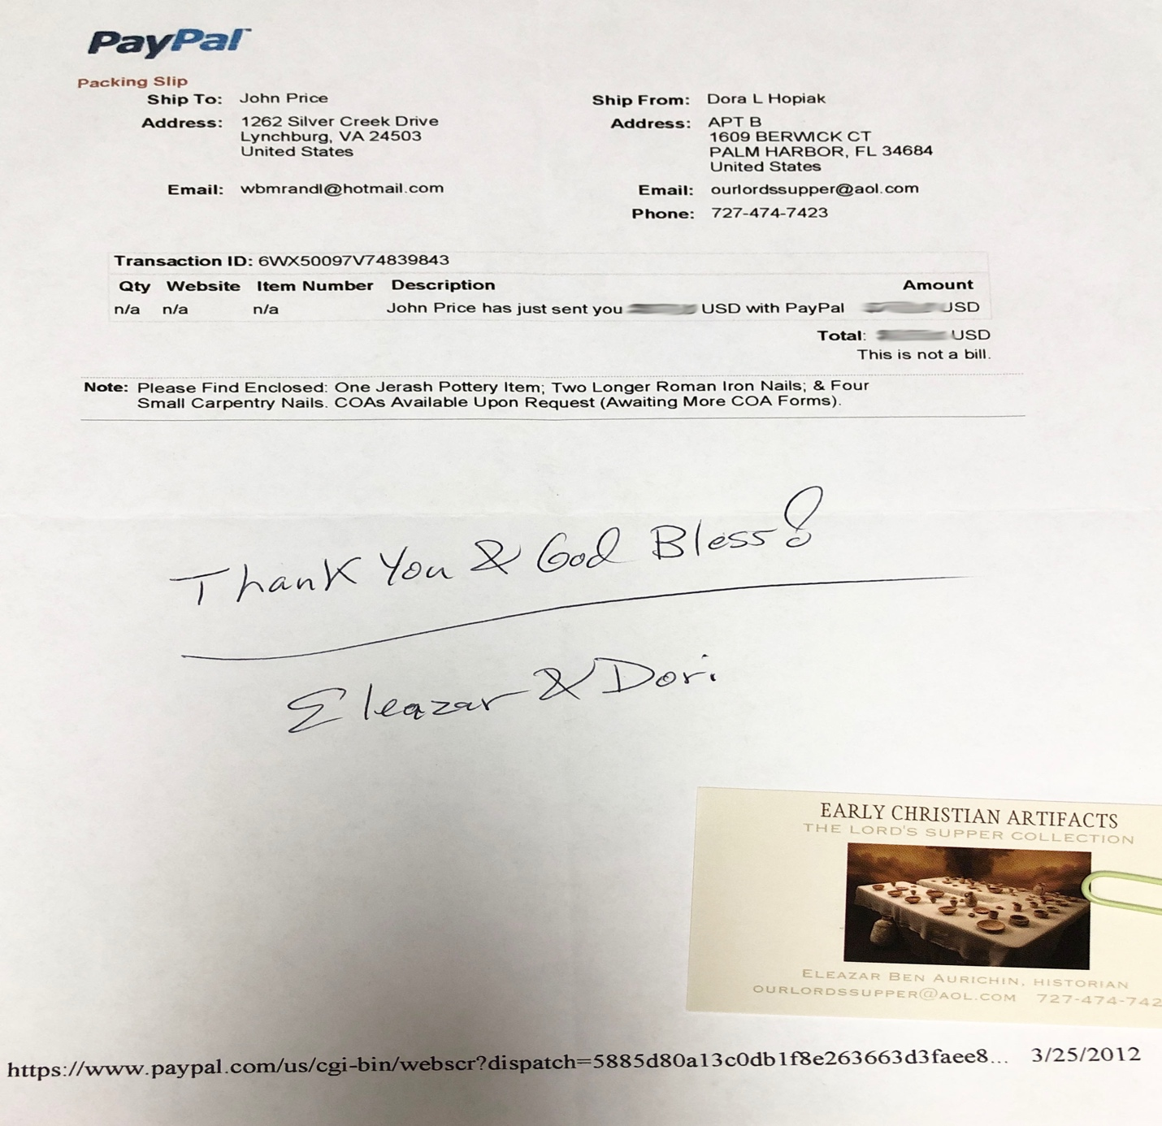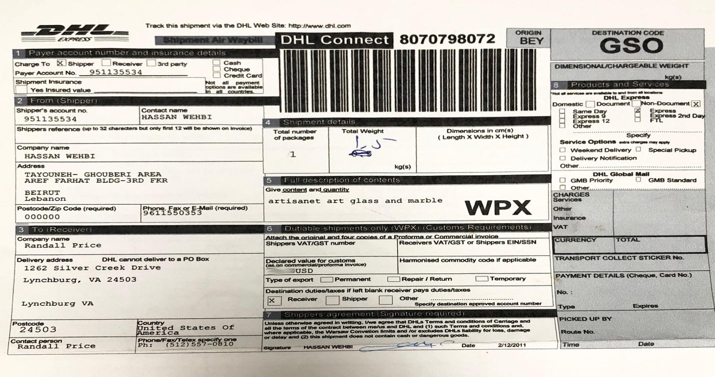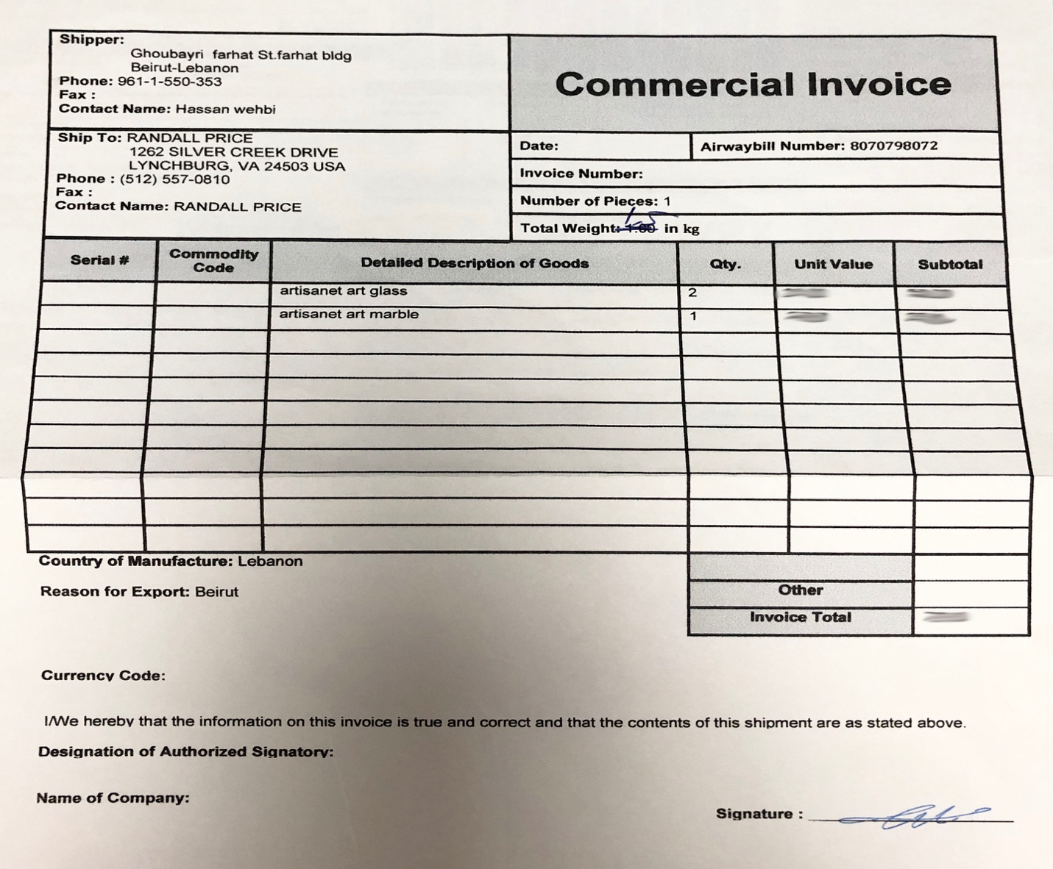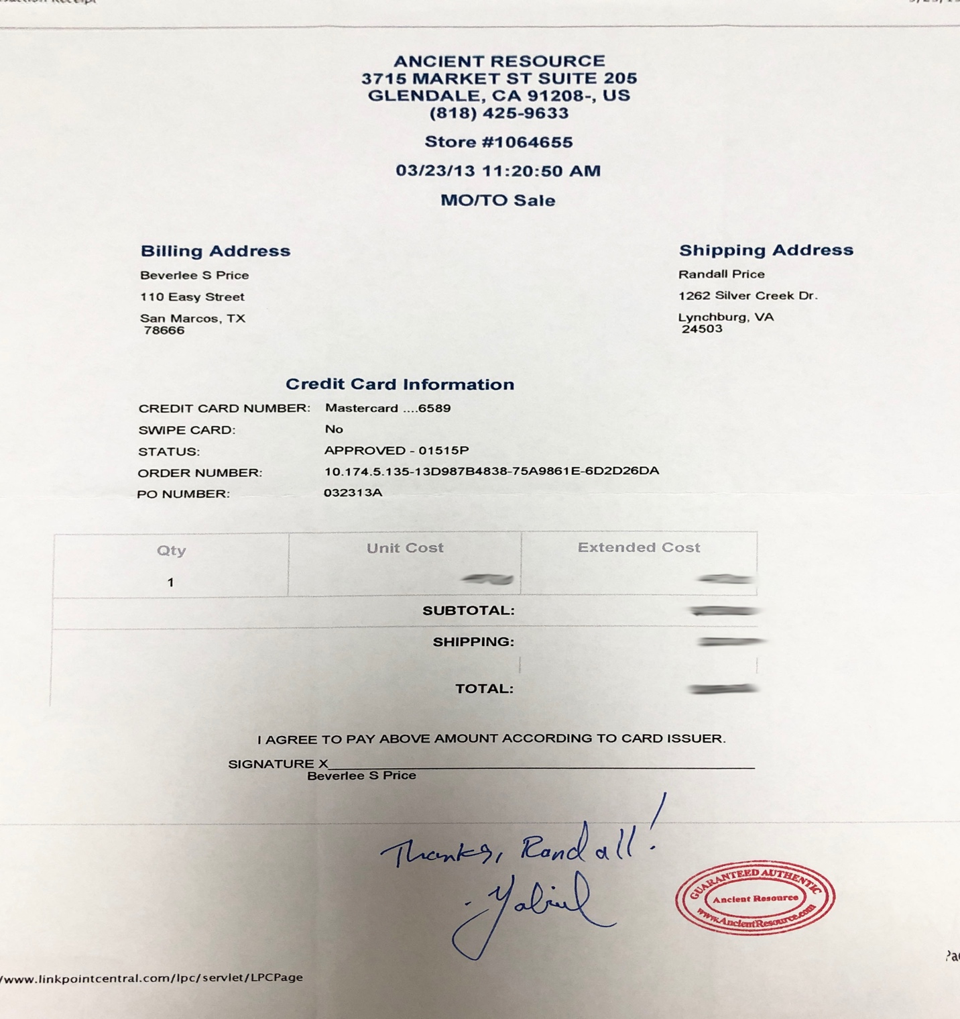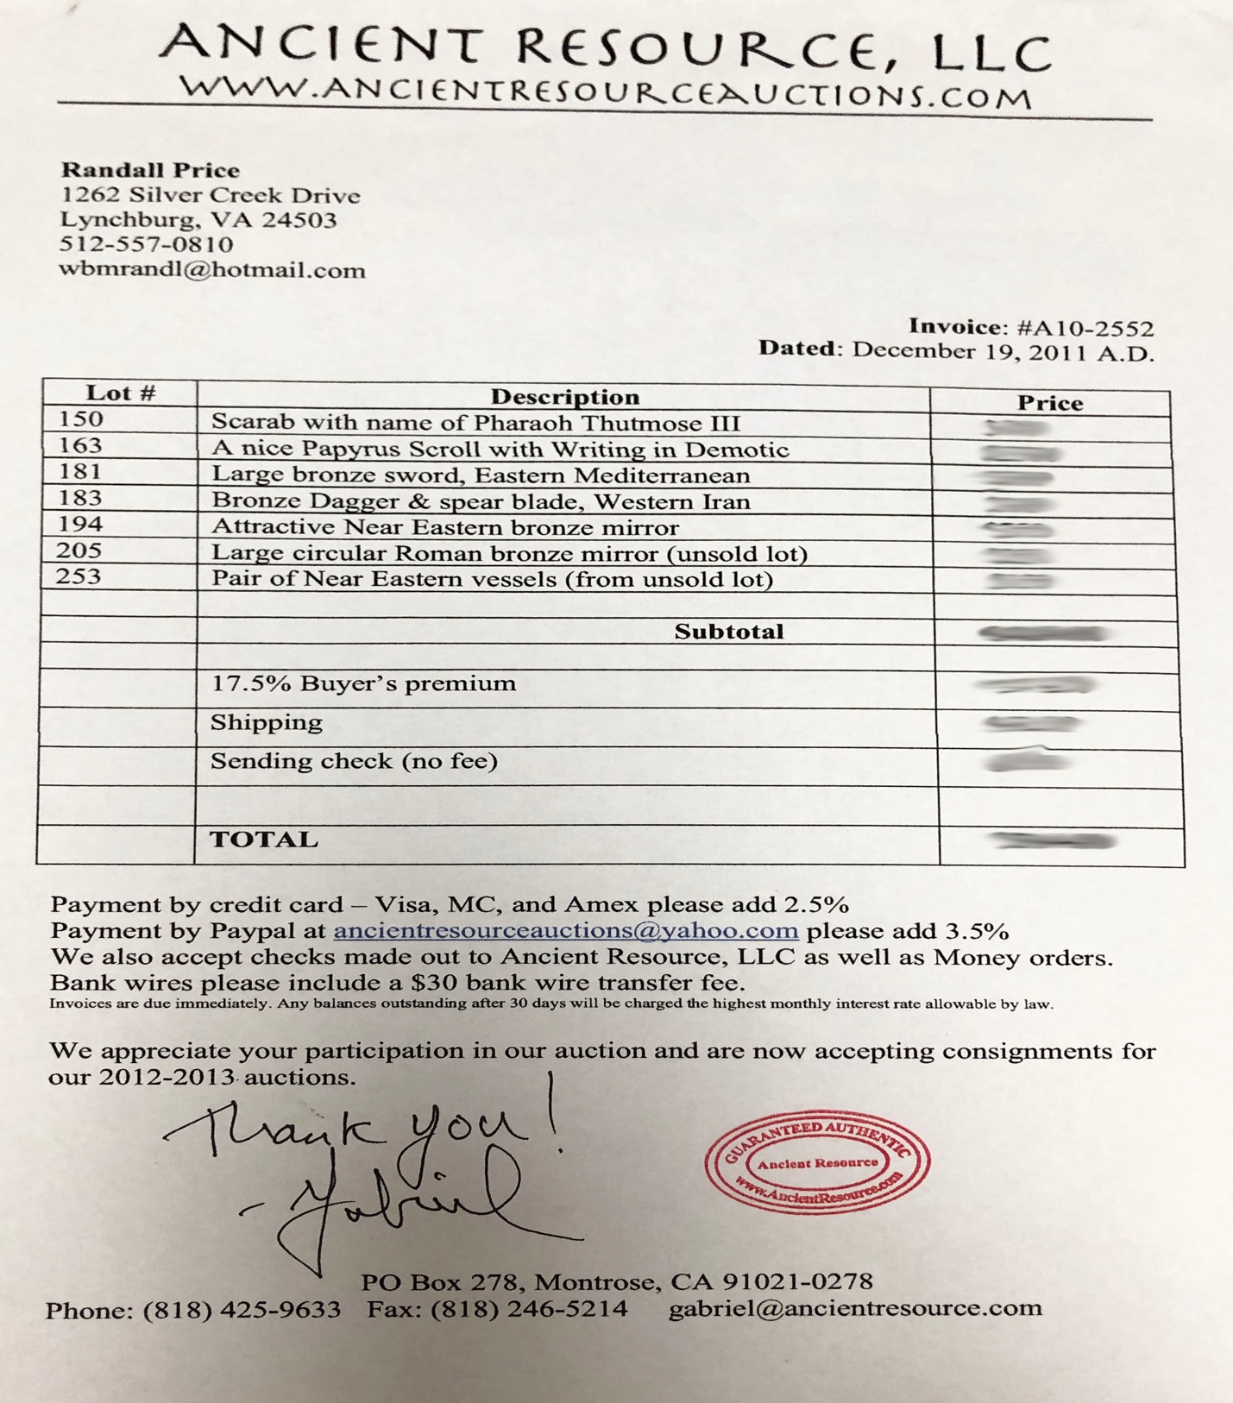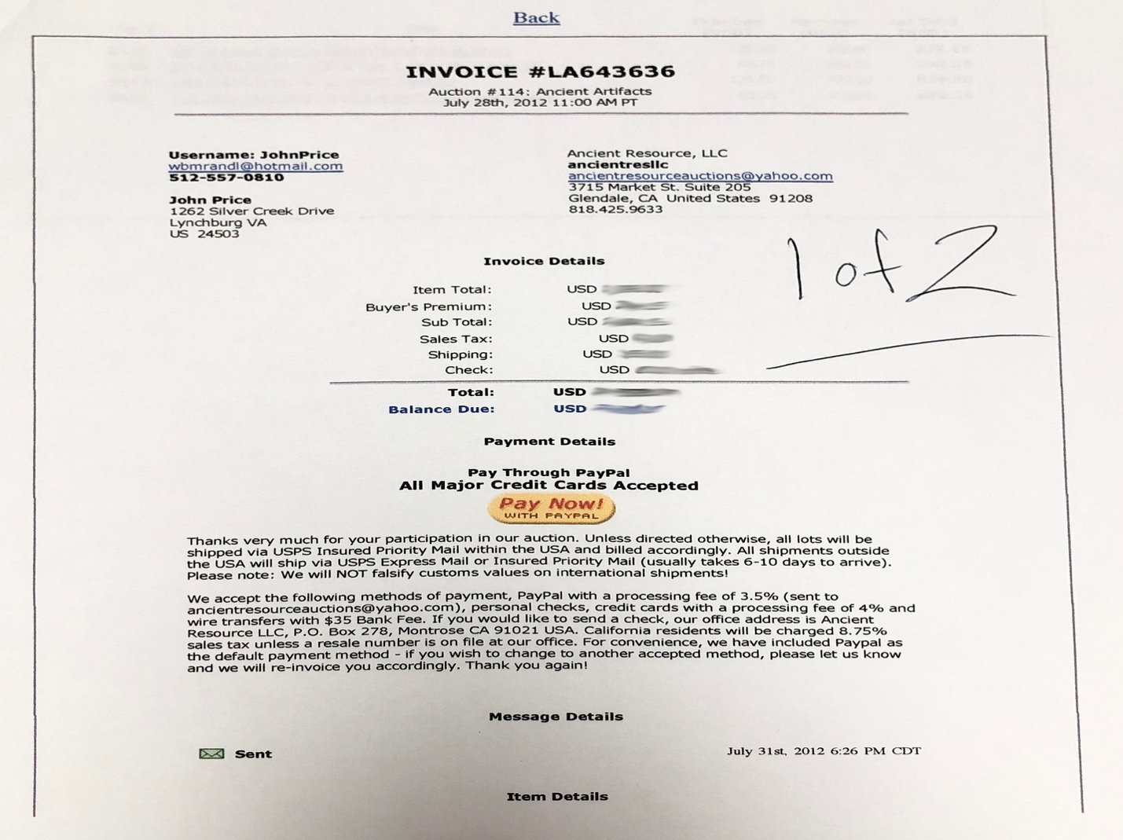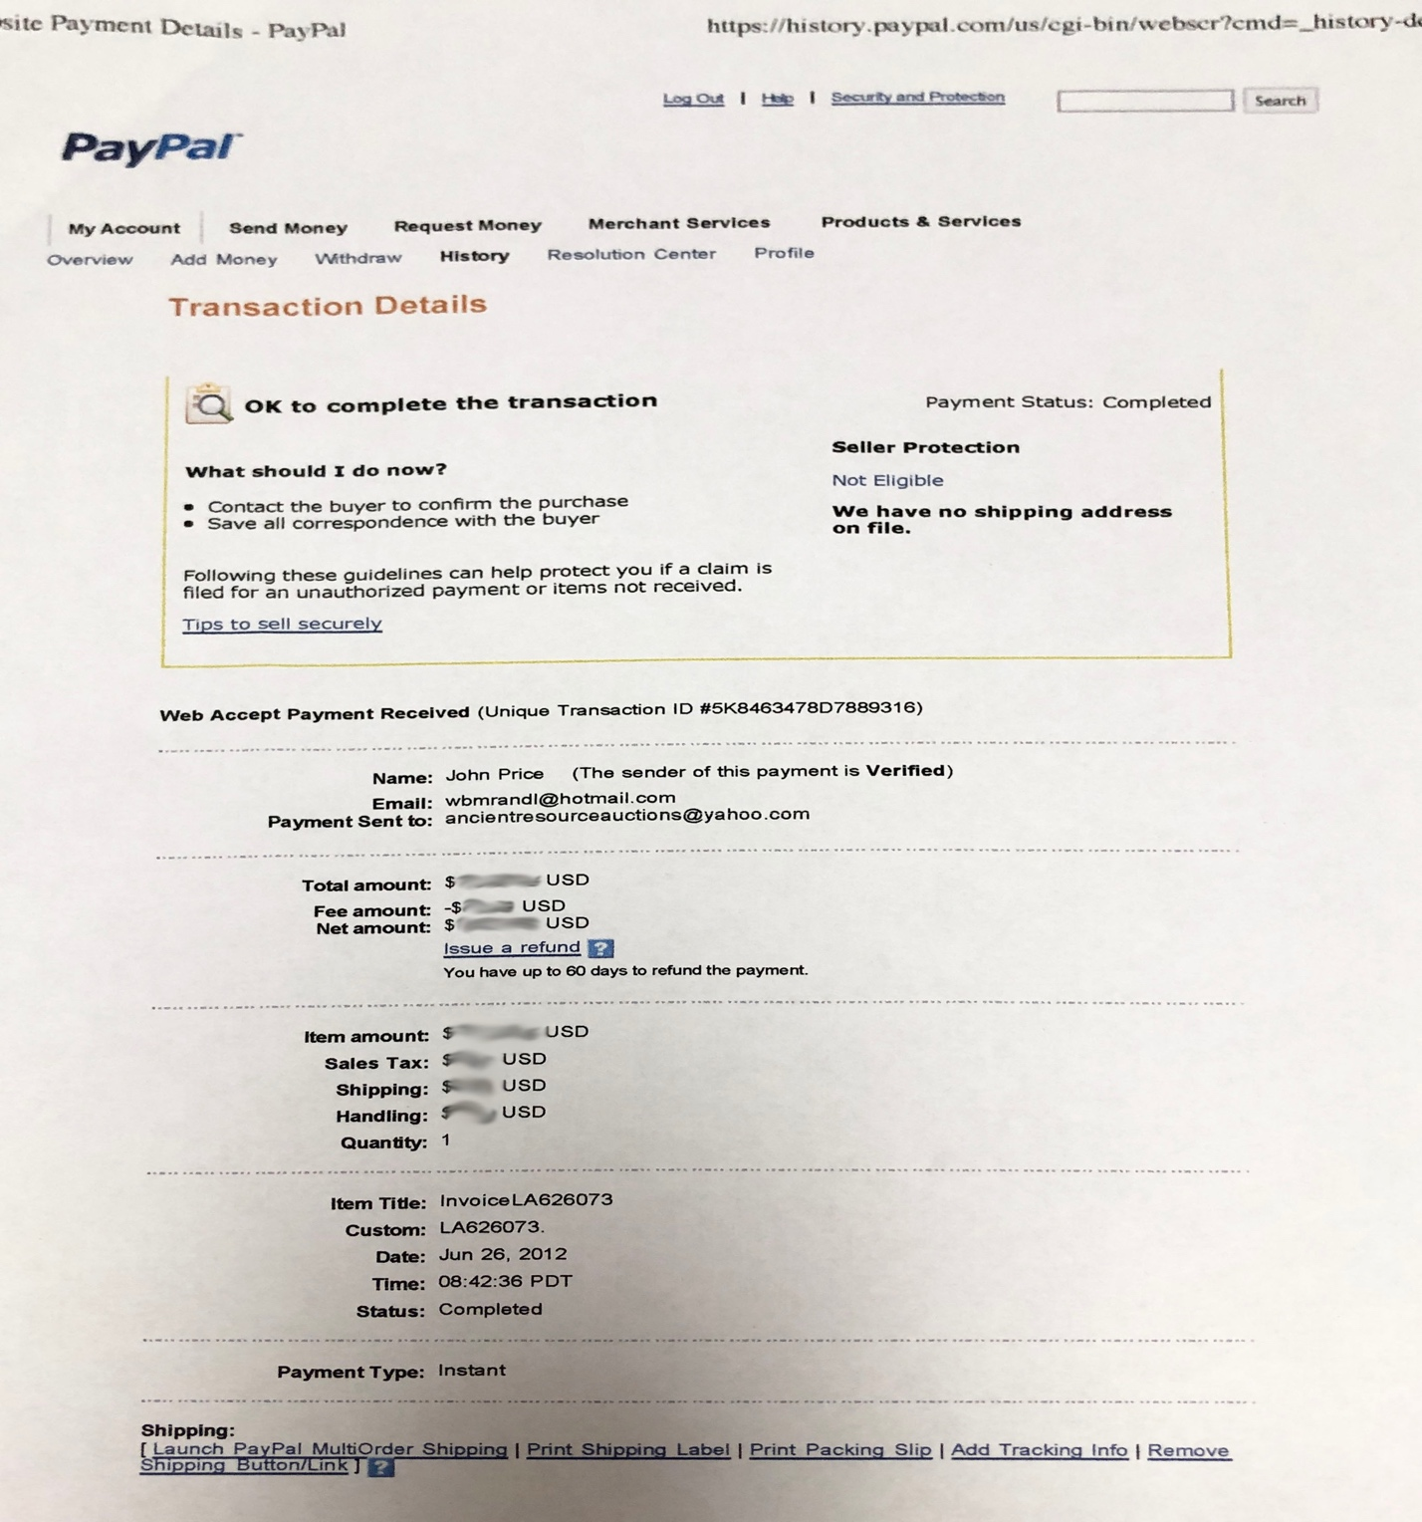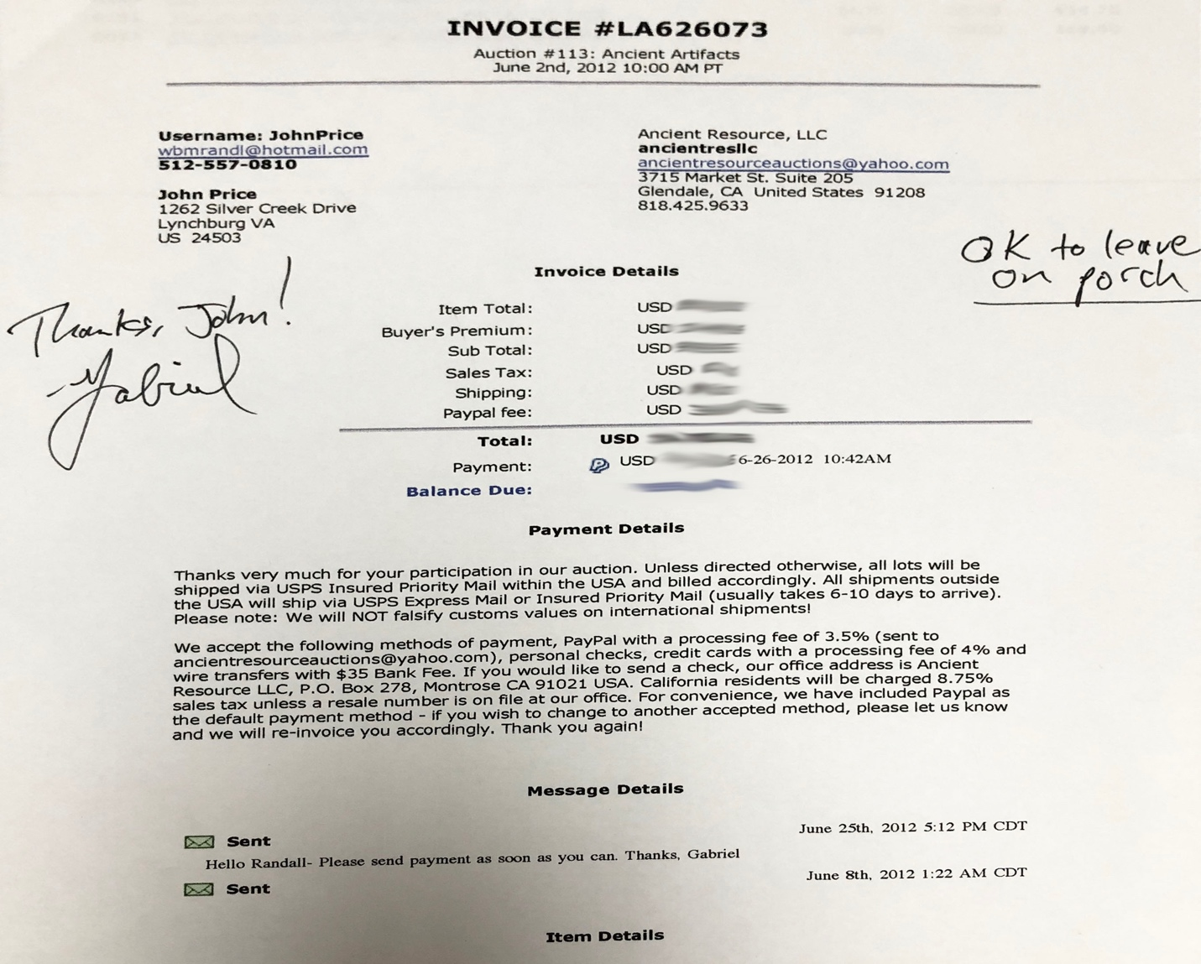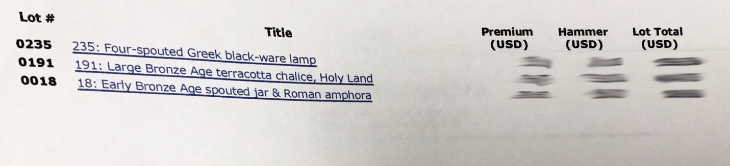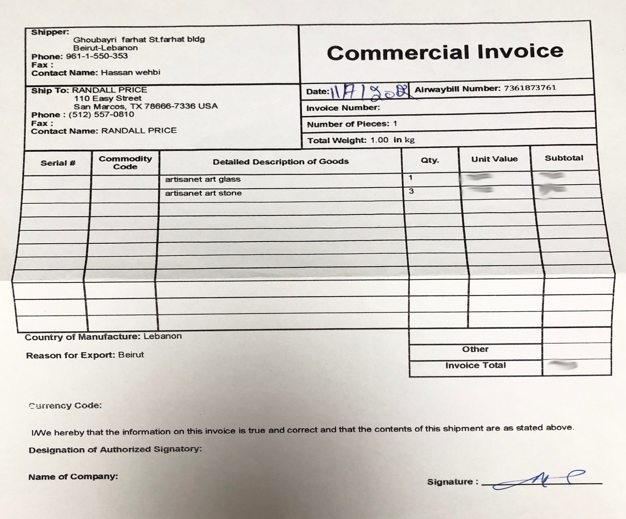

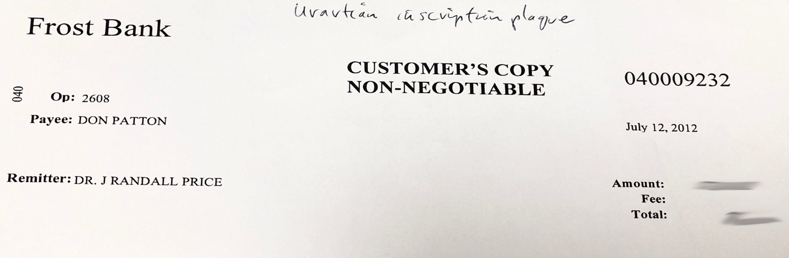
Payment for bronze cuneiform plaque purchased in Van, Turkey (owed to Dr. Don Patton who bought the piece and sold to me).
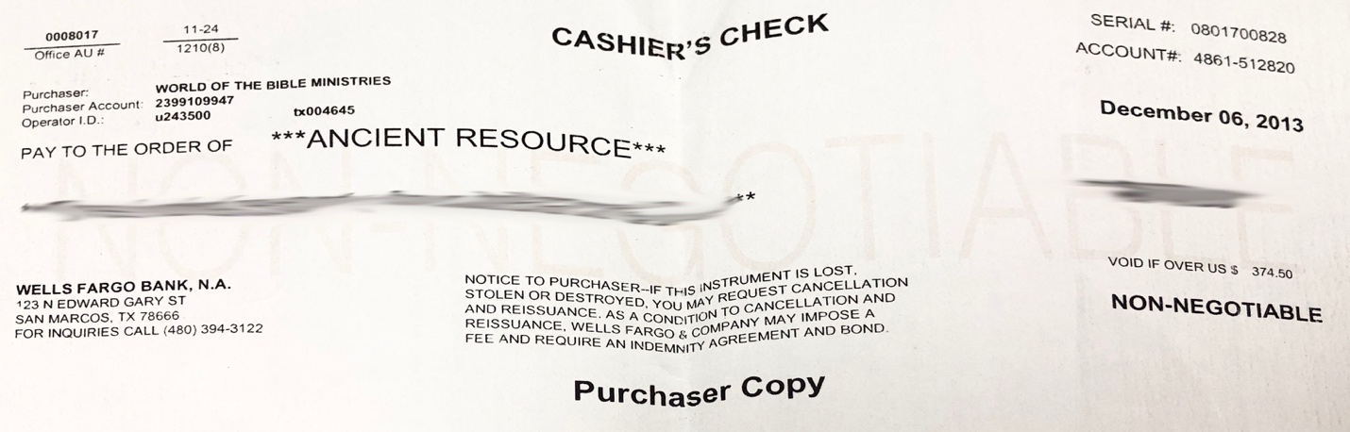
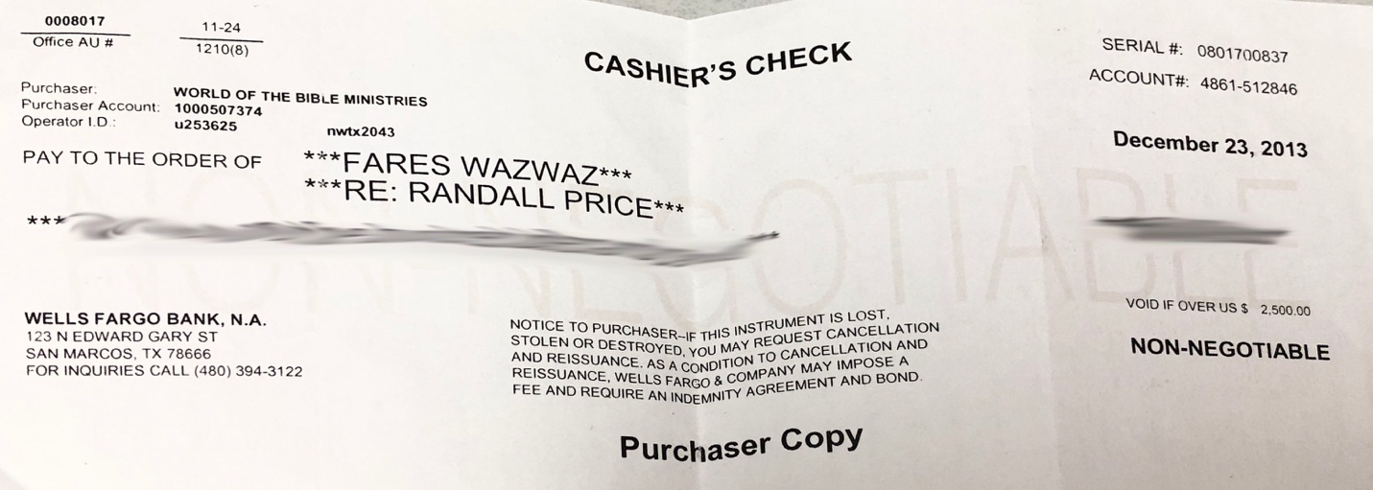
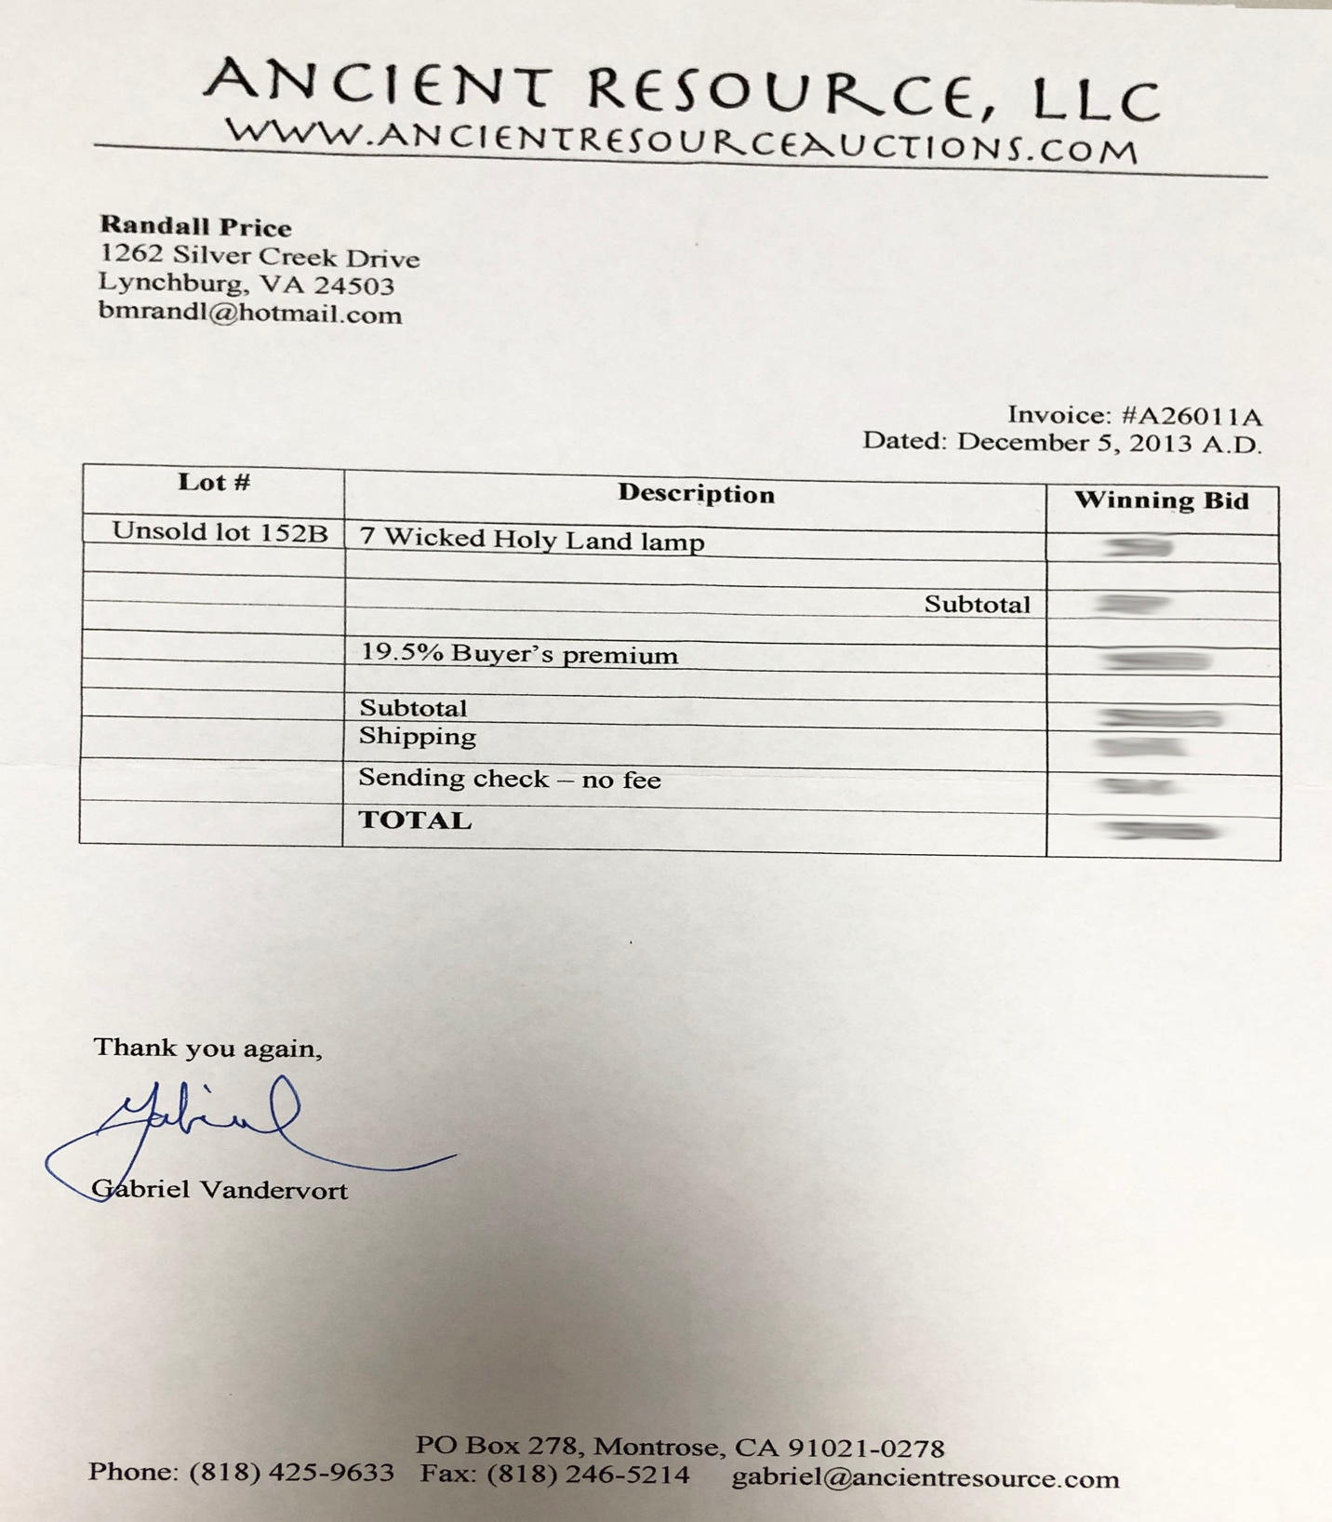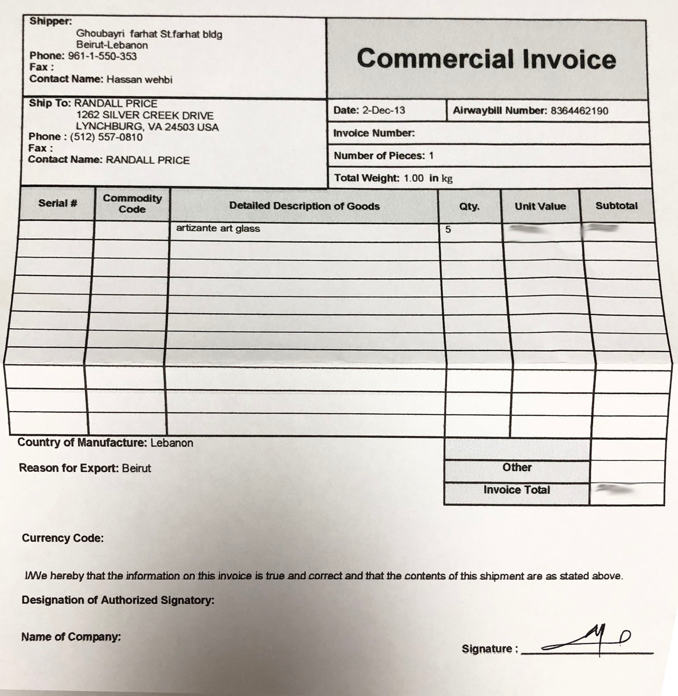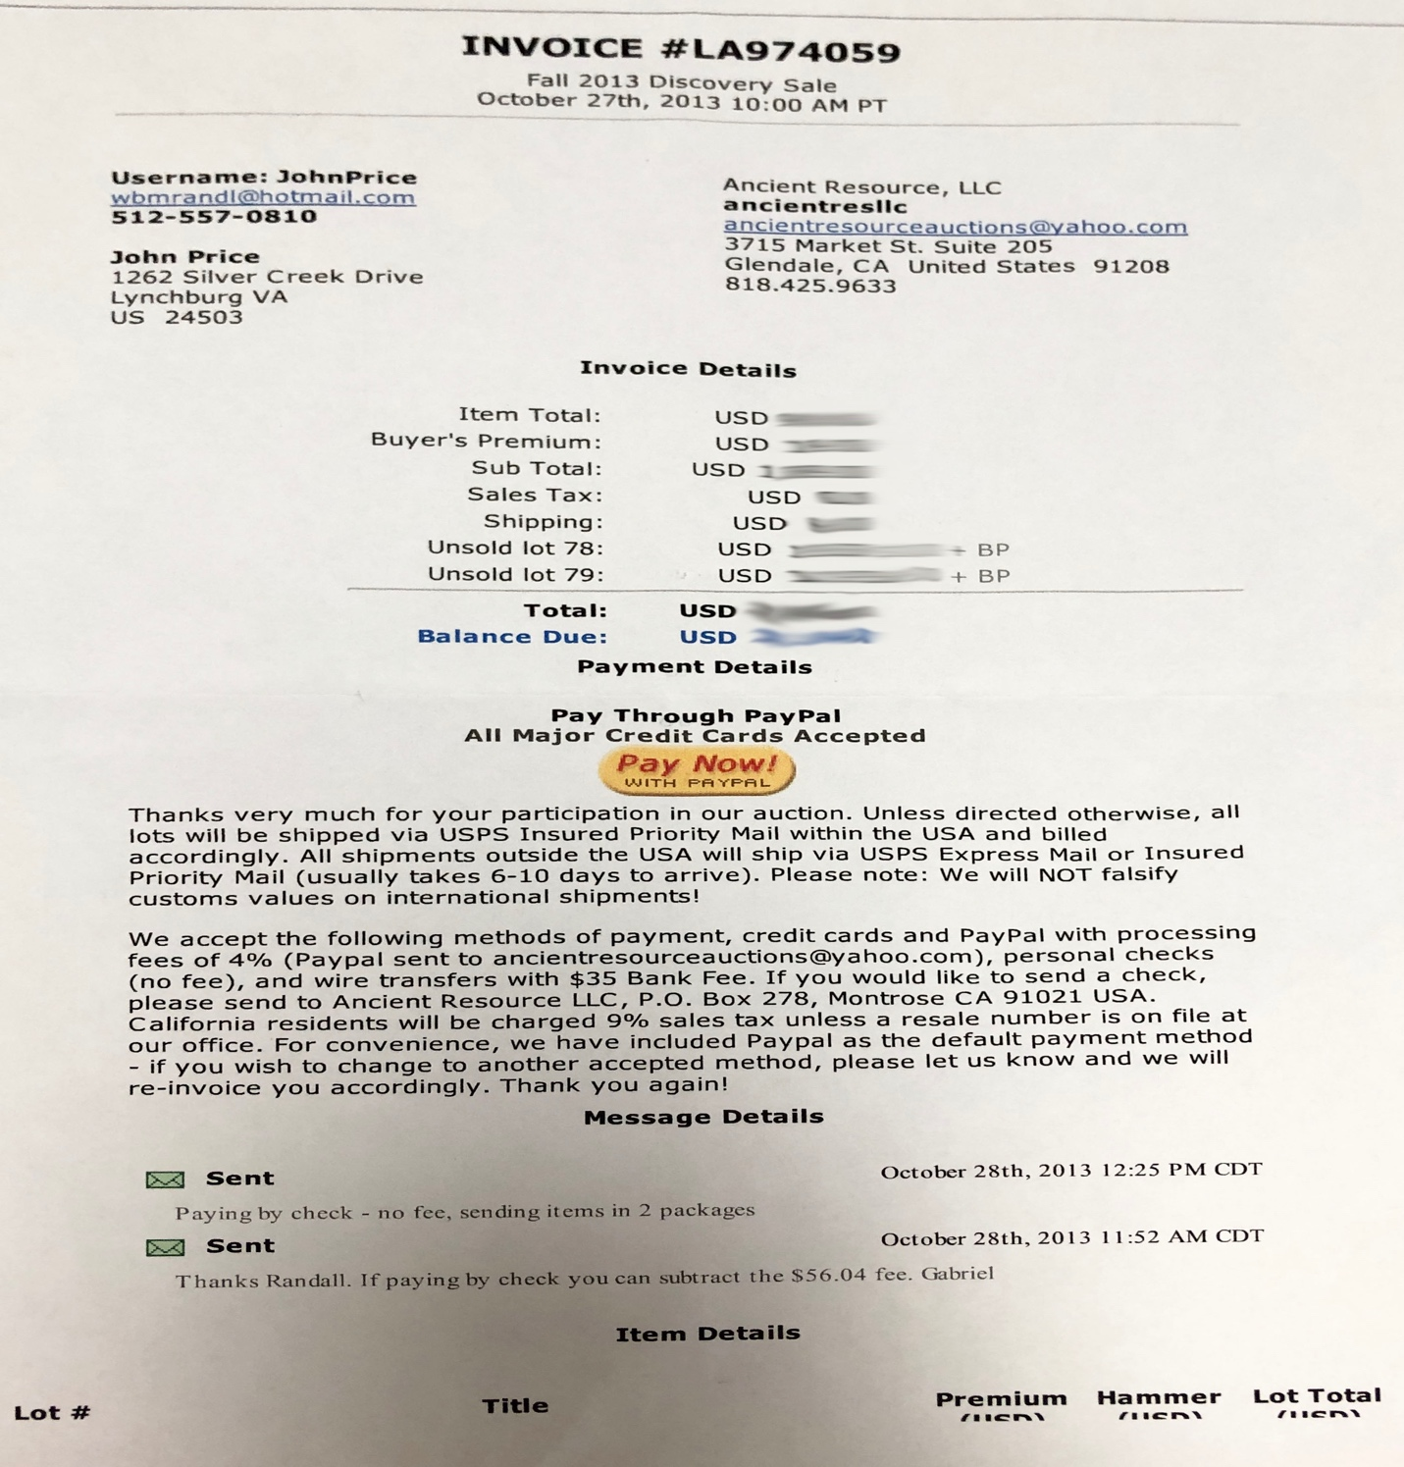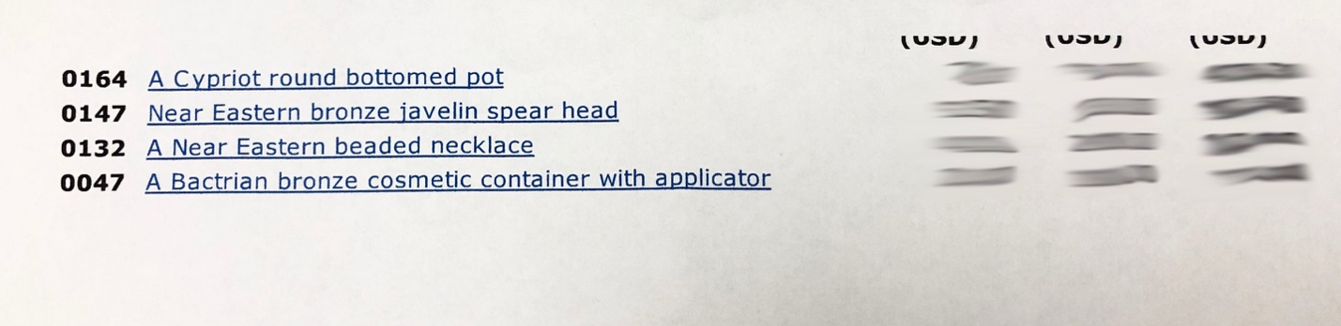

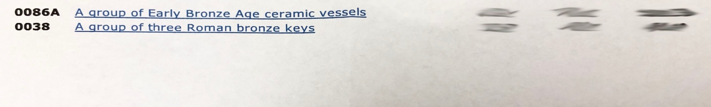
Coin certification for ancient Greek silver coins

Sold by Gabriel Vandervort of Ancient Resources, LLC

Receipt for donation of Jerusalem artist sbiblical scene sculptures to accompany exhibits

These are original IAA registration numbers and sellers of items to Fares Antiquities

